Function Group Spec
Stowable Steering and Deployable Tray System
<<Logical>> (Allocated)
Document Type | Function Specification
Template Version | 6.0
SysML Report Template Version | O Beta (11/6/2019)
Document ID | functionspec_sysmlreporttemplate
Document Location
Document Owner | MyName
Document Revision | FGS0
Document Status | Draft
Date Issued | 2021-02-24
Date Revised | 2021-02-24
Document Classification | GIS1 Item Number: | 27.60/35
Document Classification | GIS2 Classification: | Confidential
Document Approval
Name | Role |  | Email Confirmation | Date

Auto-Generated by MagicDraw
Printed Copies are Uncontrolled

Disclaimer

This document contains Ford Motor Company Confidential information. Disclosure of the information contained in any portion of this document is not permitted without the expressed, written consent of a duly authorized representative of Ford Motor Company, Dearborn, Michigan, U.S.A.

Copyright, Ó 2016 Ford Motor Company

This document contains information developed and accumulated by and for FORD MOTOR COMPANY. As such, it is a proprietary document, which, if disseminated to unauthorized persons, would provide others with restricted information, data, or procedures not otherwise available, exposing the FORD MOTOR COMPANY to potential harm.

Employees and suppliers having custody of this specification or authorized to use it must be cognizant of its proprietary nature and ensure that the information herein is not made available to unauthorized persons.

FORD MOTOR COMPANY reserves the right to protect this work as an unpublished copyrighted work in the event of an inadvertent or deliberate unauthorized publication. FORD MOTOR COMPANY also reserves its rights under copyright laws to protect this work as a published work.

This document or portions thereof shall not be distributed outside FORD MOTOR COMPANY without prior written consent. Refer all questions concerning disclosure to the author(s) or to any duly authorized representative of Ford Motor Company.

Contents

1.1.1 Decomposition of 4
Disclaimer 16
Contents 17
2 Introduction 19
2.1 Document Purpose 19
2.2 Document Scope 19
2.3 Document Audience 19
2.3.1 Stakeholder List 19
2.4 Document Organization 19
2.4.1 Document Context 19
2.4.2 Document Structure 19
2.5 Document Conventions 20
2.5.1 Requirements Templates 20
3 Function Group Description 21
4 Functional Architecture 22
4.1 Description 22
4.2 Function List 22
4.3 Signal List 22
5 Function Specifications 23
5.1 23
5.1.1 Function Overview 23
5.1.2 Function Scope 25
5.1.3 Function Interfaces 26
5.1.4 Function Modeling 28
5.1.5 Function Requirements 28
6 Open Concerns 32
7 Revision History 33
8 Appendix 34
8.1 Data Dictionary 34
8.1.1 Logical Signals 34
8.1.2 Logical Parameters 34
8.1.3 Encoding Types 34
8.2 Glossary 34
8.2.1 Definitions 34
8.2.2 Abbreviations 35

List of Figures
Figure 1 Activity diagram “” depicting black box behavior collaboration 22
Figure 2: Activity Diagram of “” calling “” 26
Figure 3: 28

List of Tables
Table 1: - Decomposition Table 5
Table 2: Functions described in this specification 19
Table 3: List of Logical Functions 22
Table 4: Ford internal Documents 25
Table 5: Ford internal Documents (not specified in model) 25
Table 6: External documents and publications 25
Table 7: External documents and publications (not specified in model) 25
Table 8: Open Concerns (Not supported by MagicDraw report generation.) 32
Table 9: Definitions used in this document 35
Table 10: Abbreviations used in this document 35

Introduction

Document Purpose
The Function (Group) Specification (FS) specifies an individual function / a group of functions.

To get more information about the concept of feature, function and component level abstraction refer to the Ford RE Wiki.

Document Scope
The following set of functions from the Global Feature & Function List is described in this specification.

Function ID | Function Name | Owner | Reference
Table 2: Functions described in this specification

Document Audience
The FS is authored by the owners of the individual functions. All Stakeholders, i.e., all people who have a valid interest in the functions and their behavior should read and, if possible, review the FS. It needs to be guaranteed, that all stakeholders have access to the currently valid version of the FS.
#Hint: The FS template has the IP Classification “Proprietary” by default. IP Classification “Confidential” might be required in some cases, e.g. by Ford Functional Safety.

Stakeholder List
For the latest list of the feature stakeholder and their roles & responsibilities refer to <Put VSEM Link here>.
#Hint: Refer to Ford RE Wiki – Stakeholder List on how to create a stakeholder list. The stakeholder list should be stored in VSEM in the pseudo folder “General Data Artifacts” of the corresponding function.

Document Organization

Document Context
Refer to the Specification Structure page in the Ford RE Wiki to understand how the FS relates to other Ford Requirements Documents and Specifications.

Document Structure
The structure of this document is explained below:
Section 1 – Introduction how to use this document including responsibilities and requisite documents. Explains the terminology. Gives a clarification of the definitions, concepts and abbreviations used in the document.
Section 2 – Function Group Description. Gives an overview and the purpose of the function group.
Section 3 – Functional Architecture: Specifies the overall functional architecture of the function group
Section 4 – Function Specifications: Specifies the logical functions of the function group in detail
Section 5 – List of Open Concerns
Section 6 Revision history including a list of new or modified requirements. The requirements in this document are tagged, and this section contains different types of tables listing all, new, or changed requirements by their title and page no.
Section 7 – Appendix: Presenting additional data mainly in a tabular form, e.g., a data dictionary

#Hint: All sections are mandatory, unless explicitly marked by the tag “#Classification” as “optional” or as applicable e.g. to certain domains like “Functional Safety”.

Document Conventions

Requirements Templates
Each requirement, use case or scenario in this specification shall follow the corresponding template given in the document template Specification_Macros.dotm at RE Wiki - Specification Templates.

Identification of Requirements

Requirements Attributes
The templates provided by Specification_Macros.dotm define a list of attributes for each requirement. This helps to classify the requirement. The attributes are explained at RE Wiki - Requirements Attributes.

Function Group Description
#Classification: Function Group only (remove section, if only a single Function is specified in this document)
#Hint: Provide an overview / a description of the Function Group

This Function Group consists of all functions allocated to Stowable Steering and Deployable Tray System <<Logical>> including all functions in their corresponding call trees.

Description of Stowable Steering and Deployable Tray System:
Logical Realization of the Conceptual Feature Entity

Functional Architecture
#Classification: Function Group only (remove section, if only a single Function is specified in this document)
#Hint: The Functional Architecture shall reflect the result of the functional decomposition for a given feature or parts of it.
Refer to the RE Wiki – Functional Decomposition for some guidance on how to decompose a feature into functions, i.e., how to find the right functional partitioning for the function level. The functions shown here are those, which are specified in section 5 “Function Specifications”.

Description
#Hint: Provide some informal description of the characteristics of the chosen architecture. Also give some graphical representation of the Functional Architecture. Either SysML Internal Block diagrams or Data Flow Diagrams could be used to depict such a Functional Architecture.
#Link: SysML – Internal Block Diagrams or RE Wiki - Data Flow Diagrams

Function List

Function ID | Function Name | Function Description | ASIL
 | Request Airbag Enabling <<Subsystem Function>> | Depending upon State Selection Signal this function sends a request to DeInhibit Airbag
 | Check Feature Availability <<Subsystem Function>> | This function checks the vehicle configuration and sends the State Selection Signal
 | provide cause of failure <<Subsystem Function>> | Based on Termination signal Information ,the cause of failure is conveyed to the Driver through this function
 | Check for Transition Termination <<System Function>> | This system Functions check all the terminate signals information from Seat , steering Column and Tray Table and verifies if termination of transition is necessary
 | Request Tray Arbitration <<System Function>> | This System Function is responsible for preparing the Tray to Arbitrate and send the respective command for Arbitrating tray to other functions
 | Request Locomotion Disabling <<Subsystem Function>> | Depending upon State Selection Signal this function sends a request to Inhibit Locomotion
 | Check Inhibit status <<Subsystem Function>> | This Subsystem function verifies the Locomotion and Air bag Inhibit status and Outputs the Inhibit status
 | Request Tray Deployment <<Subsystem Function>> | This System Function is responsible for preparing the Tray to Arbitrate and send the respective command to Arbitrate tray to next functions
 | Issue Termination Signal <<Subsystem Function>> | This subsystem function issues Terminate signal based on other status
 | Provide Tray Stow Instructions <<Subsystem Function>> | A subsystem Function which provides instructions to HMI when User requests stow or to exit work mode
 | Request Seat Arbitration <<System Function>> | This System Function responsible for preparing the Seat to Arbitrate and send the respective request to Driver Seat System
 | Control SSC Functionality <<System Function>> | When received State selection signal for mode transition , this function issues individual requests to Seat, steering Column and Tray Table after verifying the Inhibit status and Provide a cause of Failure if the transition is not possible
 | Request Tray Unlock <<Subsystem Function>> | A subsystem Function which sends Tray Unlock request based on its inputs
 | Request Airbag Disabling <<Subsystem Function>> | Depending upon State Selection Signal this function sends a request to Inhibit Airbag
 | Request Drive Control Inhibition <<System Function>> | Depending upon State Selection Signal this function sends a request to Inhibit Drive Control
 | Request SteeringColumn Deployment <<Subsystem Function>> | This Sub System Function is responsible for sending Steering Column Stow Request based on its Inputs requests
 | Request to Move Seat <<Subsystem Function>> | This Sub System Function is responsible for sending Seat Movement Request based on its Inputs requests
 | Request Steering Column Arbitration <<System Function>> | A System Function responsible for preparing the Steering Column to Arbitrate and send the respective command to Arbitrate Steering Column to next functions
 | Arbitrate SSC Functionality <<Subsystem Function>> | Arbitrate SSC Functionality requests the other sub systems in the systems when state selection signal is received for Mode transition
 | Provide HMI Feedback <<Subsystem Function>> | This Function Checks the Vehicle Validity and state selection signal and provide User his selected Mode and Vehicle status Validity
 | Verify Feature Status <<System Function>> | This Function verifies the User Input , vehicle Status and Vehicle Configuration and provides State Selection signal and HMI Feedback
 | Check Tray Status <<Subsystem Function>> | This sub system Function checks the status of Tray upon receiving the move request and issue request respectively
 | Request Drive Control DeInhibition <<System Function>> | Depending upon State Selection Signal this function sends a request to DeInhibit Drive Control
 | Verify Drive Control Status <<System Function>> | System Function responsible for Verify the Drive Control Status Before Actuating the feature
 | Request SteeringColumn Stowing <<Subsystem Function>> | This Sub System Function is responsible for sending Steering Column Stow Request based on its Inputs requests
 | Check vehicle status <<Subsystem Function>> | This Function checks the Vehicle status and outputs the Vehicle status Validity
 | Evaluate Drivability status <<Subsystem Function>> | This function checks all the status ( Tray , Steering Column, Driver seat) before sending a request to enable the drive control( Locomotion and Driver Airbag)
 | Request Tray Lock <<Subsystem Function>> | A subsystem Function which sends Tray Lock request based on its inputs
 | Request Locomotion Enabling <<Subsystem Function>> | Depending upon State Selection Signal this function sends a request to DeInhibit Locomotion
Table 3: List of Logical Functions

Signal List

Refer to the Data Dictionary - Logical Signals.

Function Specifications

Arbitrate SSC Functionality

Function Overview

Description
#Hint: Some descriptive text to explain the purpose and functionality of the function.

Function is allocated to:
- Stowable Feature Controller <<Logical>>

Arbitrate SSC Functionality requests the other sub systems in the systems when state selection signal is received for Mode transition

Variants
#Classification: Mandatory (State “Not applicable”, if not used)
#Hint: If different variants of the same function are specified in this section, list those variants in the table below.
Variants on Function level could be driven technology or feature content. Example: There could be a “Low Content” and a “High Content” variant of some exterior lighting function. The Low Content variant applies for Conventional Headlight technology, the High Content variant applies for LED and Xenon technology. In this case we call the different technologies the Variant Options (for the time being you could think of them as Logical Parameters) which the Variant depends on. The optional column “Variant condition” allows to express the dependency of a Variant based on Variant Options/Logical Parameters.

If requirements/signals are not applicable for all variants/variant options, those requirements should state explicitly, which function variant/variant option they apply to.
#Link: RE Wiki – Variant Management.

Not supported by MagicDraw report generation.

Input Requirements
#Classification: Mandatory (State “Not applicable”, if not used)
#Hint: List any input requirements here (legal, Trustmark), which need to be taken into account, beyond what is specified in the corresponding Feature Documents.

Not supported by MagicDraw report generation.

Assumptions
#Classification: Mandatory (State “Not applicable”, if not used)
#Hint: A list of known assumptions concerning the effects of the function’s behavior on other functions or elements (i.e., dependencies) as well as assumptions on the behavior expected by the function (e.g. known limitations). During the course of the development most of those assumptions are typically either converted into actual requirements or discarded at some point – such that this chapter remains mostly empty.

No assumptions specified for this function.

References

Ford Documents
List here all Ford internal documents, which are directly related to the feature.

Reference | Title | Doc. ID | Revision
Table 5: Ford internal Documents (not specified in model)

External Documents and Publications
The list of external documents could include books, reports and online sources.
#Hint: You may refer to IEEE Citation Reference on how to format a reference.

Reference | Document / Publication
Table 7: External documents and publications (not specified in model)

Glossary
See Appendix for Definitions and Abbreviations.

Function Scope

The – “Arbitrate SSC Functionality” function is called by the following functions:
- – “Control SSC Functionality”

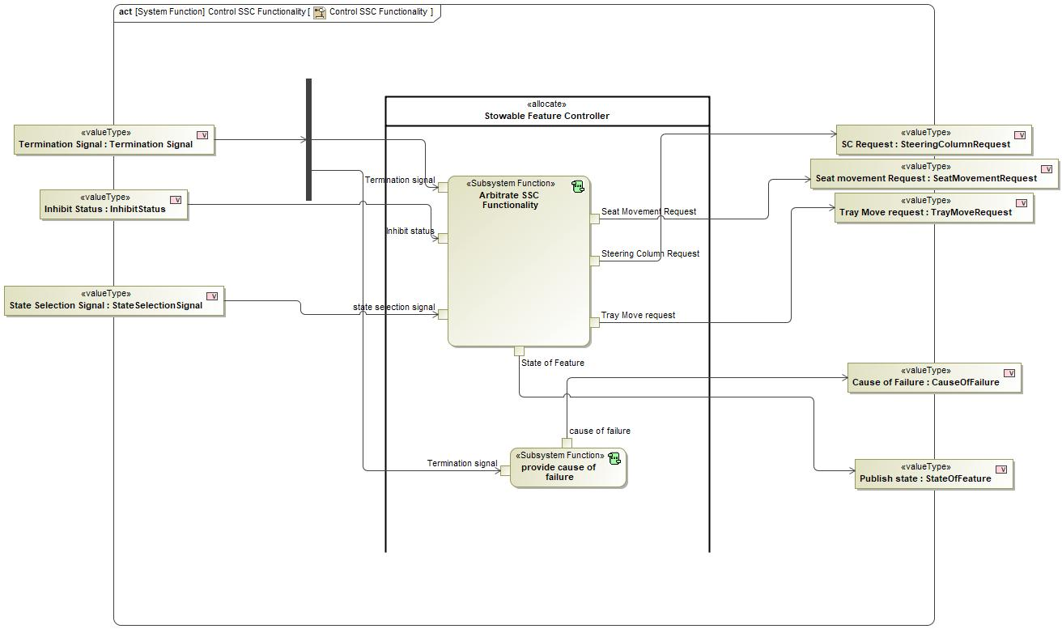
Figure 2: Activity Diagram of “Control SSC Functionality” calling “Arbitrate SSC Functionality”

Function Interfaces
#Link: RE Wiki – Adding a Logical Signal or Parameter

Logical Inputs
Signal Name | Description
Inhibit status  Type:  InhibitStatus | Signal Description:  Inhibit status of driver control which is verified by the feature systems  Received from:  - Activity Parameter Node: Inhibit Status
state selection signal  Type:  StateSelectionSignal | Signal Description:  Signal which contains the Mode that User selected after the Vehicle status is Valid  Received from:  - Activity Parameter Node: State Selection Signal
Termination signal  Type:  Termination Signal | Signal Description:  Logical signal for termination of Mode Arbitration when system did not act according to requests  Received from:  - Activity Parameter Node: Termination Signal

Logical Outputs
Signal Name | Description
Tray Move request  Type:  TrayMoveRequest | Signal Description:  Internal Request of Feature Controller to Move Tray Table  Sent to:  - Activity Parameter Node: Tray Move request
Seat Movement Request  Type:  SeatMovementRequest | Signal Description:  Command to Move seat which goes to the Driver seat System  Sent to:  - Activity Parameter Node: Seat movement Request
Steering Column Request  Type:  SteeringColumnRequest | Signal Description:  Request to Move steering Column with respect to selected Mode  Sent to:  - Activity Parameter Node: SC Request
State of Feature  Type:  StateOfFeature | Signal Description:  Current state of Feature and other warnings  Sent to:  - Activity Parameter Node: Publish state

Logical Parameters
#Hint: Put requirements for parameters here, which are implemented as configuration parameters using Method 2 or 3 or as parameters for calibration.

Not supported by MagicDraw report generation.

Function Modeling
#Classification: Mandatory
#Hint: Typical modeling artifacts in this section are State Machines, Activity Diagrams / Flow Charts, Decision Tables, and possibly Sequence Diagrams, which can all be used as techniques to analyze the function requirements.
#Links: Analyze / Model Requirements: RE Wiki – Analyze / Model Requirements

Use Cases
#Classification: Infotainment Only (remove section, if not used)
#Hint: Some Domains (e.g. Infotainment) use not only Customer Use Cases (in the Feature Doc), but refine Use Case descriptions down to function level. In general, the RE approach encourages the use of Use Cases on Feature Level but not on Function Level. Activity Diagrams are a more suitable way to express the same on Function Level.
#Links: Infotainment – “Harmony Systems Engineering” Approach

Not supported by MagicDraw report generation.

State Charts / Activity Diagrams / Sequence Diagrams / Decision Tables
#Classification: Mandatory
#Hint: It is highly recommended to use at least one of the following modeling techniques for modeling and analyzing the Function behavior and derived requirements (refer to sample diagrams below):
State Machines, Activity Diagrams / Flow Charts, or Decision Tables
Optionally, Sequence Diagrams might help to analyze the interaction between Functions.
#Links: Analyze / Model Requirements: RE Wiki – Analyze / Model Requirements
State Charts RE Wiki – State Charts
Activity Diagrams: RE Wiki – Activity Diagram, SysML User Group – Activity Diagram Basics
Sequence Diagrams: RE Wiki – Sequence Chart, SysML User Group – Sequence Diagram Basics

No diagrams internal to function specified.

Function Requirements
#Link: RE Wiki – How to write good requirements

Functional Requirements
#Hint: Please also consider specific situations like Initialization (Startup) and Deinitialization (Shutdown) apart from Normal Operation and Error Handling. E.g. a state chart or activity diagram might help for better understanding.

Normal Operation

Maintain Seat in Drive Position
WHEN Inhibit Status is DC_DEINHIBITED AND Termination Signal is NONE THE Arbitrate SSC Functionality Subfunction SHALL set Seat Request to MOVE_DRIVE

Requirement ID:
Rationale
Acceptance Criteria
Notes
Source |  |  |  |  |  | Owner
Source Req. | - Set Seat Movement status |  |  |  |  | V&V Method
Type |  |  |  | Priority |  | Status
Req. Template Version |  | 6.0 | End of Requirement

Deploy Tray
WHEN Inhibit Status is DC_INHIBITED AND State Selection Signal is NOT DRIVE AND Termination Signal is NONE THE Arbitrate SSC Functionality Subfunction SHALL set Tray Request to Unlock+Deploy

Requirement ID:
Rationale
Acceptance Criteria
Notes
Source |  |  |  |  |  | Owner
Source Req. | - Tray Movement Functionality |  |  |  |  | V&V Method
Type |  |  |  | Priority |  | Status
Req. Template Version |  | 6.0 | End of Requirement

Return Seat to Safe State
IF Termination Signal is TERMINATE_TRAY OR Termination Signal is TERMINATE_SC THEN Arbitrate SSC Functionality Subfunction SHALL set Seat Request to MOVE_DRIVE

Requirement ID:
Rationale
Acceptance Criteria
Notes
Source |  |  |  |  |  | Owner
Source Req. | - Column Movement Functionality  - Tray Movement Functionality  - Set Seat Movement status |  |  |  |  | V&V Method
Type |  |  |  | Priority |  | Status
Req. Template Version |  | 6.0 | End of Requirement

Normal Rest Mode Entry
WHEN Inhibit Status is DC_INHIBITED AND State Selection Signal is REST AND Termination Signal is NONE THE Arbitrate SSC Functionality Subfunction SHALL set State of Feature to REST_STATE_ENTERED

Requirement ID:
Rationale
Acceptance Criteria
Notes
Source |  |  |  |  |  | Owner
Source Req. | - Verify Feature Status |  |  |  |  | V&V Method
Type |  |  |  | Priority |  | Status
Req. Template Version |  | 6.0 | End of Requirement

Normal Work Mode Entry
WHEN Inhibit Status is DC_INHIBITED AND State Selection Signal is WORK AND Termination Signal is NONE THE Arbitrate SSC Functionality Subfunction SHALL set State of Feature to DRIVE_STATE_ENTERED

Requirement ID:
Rationale
Acceptance Criteria
Notes
Source |  |  |  |  |  | Owner
Source Req. | - Verify Feature Status |  |  |  |  | V&V Method
Type |  |  |  | Priority |  | Status
Req. Template Version |  | 6.0 | End of Requirement

End Seat Deployment
WHEN Inhibit Status is DC_INHIBITED AND State Selection Signal is DRIVE AND Termination Signal is NONE THE Arbitrate SSC Functionality Subfunction SHALL set Seat Request to MOVE_DRIVE

Requirement ID:
Rationale
Acceptance Criteria
Notes
Source |  |  |  |  |  | Owner
Source Req. | - Column Movement Functionality  - Tray Movement Functionality  - Set Seat Movement status |  |  |  |  | V&V Method
Type |  |  |  | Priority |  | Status
Req. Template Version |  | 6.0 | End of Requirement

Arbitrate SSC Functionality function output Seat Request Definition
The Arbitrate SSC Functionality function output Seat Request shall define output states NONE, MOVE_WORK, MOVE_REST and MOVE_DRIVE

Requirement ID:
Rationale
Acceptance Criteria
Notes
Source |  |  |  |  |  | Owner
Source Req. | - Set Seat Movement status |  |  |  |  | V&V Method
Type |  |  |  | Priority |  | Status
Req. Template Version |  | 6.0 | End of Requirement

Arbitrate SSC Functionality TrayRequest Output Definition
The Arbitrate SSC Functionality function output Tray Request shall define states NONE, LOCK and Unlock+Deploy or UC.

Requirement ID:
Rationale
Acceptance Criteria
Notes
Source |  |  |  |  |  | Owner
Source Req. | - Tray Movement Functionality |  |  |  |  | V&V Method
Type |  |  |  | Priority |  | Status
Req. Template Version |  | 6.0 | End of Requirement

Return Tray to Safe State
IF Termination Signal is TERMINATE_SC OR Termination Signal is TERMINATE_SEAT THEN the Arbitrate SSC Functionality Subfunction SHALL set the Tray Request to LOCK

Requirement ID:
Rationale
Acceptance Criteria
Notes
Source |  |  |  |  |  | Owner
Source Req. | - Tray Movement Functionality |  |  |  |  | V&V Method
Type |  |  |  | Priority |  | Status
Req. Template Version |  | 6.0 | End of Requirement

Start Steering Column Stow
WHEN Inhibit Status is DC_INHIBITED AND State Selection Signal is NOT DRIVE AND Termination Signal is NONE THEN Arbitrate SSC Functionality Subfunction SHALL set SC Request to STOW

Requirement ID:
Rationale
Acceptance Criteria
Notes
Source |  |  |  |  |  | Owner
Source Req. | - Column Movement Functionality  - Tray Movement Functionality  - Set Seat Movement status |  |  |  |  | V&V Method
Type |  |  |  | Priority |  | Status
Req. Template Version |  | 6.0 | End of Requirement

Failed to Enter Drive State
IF Inhibit Status is DC_DEINHIBITED AND Termination Signal is NOT NONE THEN the Arbitrate SSC Functionality Subfunction SHALL set State of Feature to FAILED_TO_ENTER_DRIVE_STATE

Requirement ID:
Rationale
Acceptance Criteria
Notes
Source |  |  |  |  |  | Owner
Source Req. | - Verify Feature Status |  |  |  |  | V&V Method
Type |  |  |  | Priority |  | Status
Req. Template Version |  | 6.0 | End of Requirement

Failed to Enter Work State
IF Inhibit Status is DC_INHIBITED AND State Selection Signal is WORK AND Termination Signal is NOT NONE THEN the Arbitrate SSC Functionality Subfunction SHALL set State of Feature to FAILED_TO_ENTER_WORK_STATE

Requirement ID:
Rationale
Acceptance Criteria
Notes
Source |  |  |  |  |  | Owner
Source Req. | - Verify Feature Status |  |  |  |  | V&V Method
Type |  |  |  | Priority |  | Status
Req. Template Version |  | 6.0 | End of Requirement

Return Steering Column to Safe State
IF Termination Signal is TERMINATE_TRAY OR Termination Signal is TERMINATE_SEAT THEN Arbitrate SSC Functionality Subfunction SHALL set SC Request to DEPLOY

Requirement ID:
Rationale
Acceptance Criteria
Notes
Source |  |  |  |  |  | Owner
Source Req. | - Column Movement Functionality  - Tray Movement Functionality  - Set Seat Movement status |  |  |  |  | V&V Method
Type |  |  |  | Priority |  | Status
Req. Template Version |  | 6.0 | End of Requirement

Failed to Enter Rest State
IF Inhibit Status is DC_INHIBITED AND State Selection Signal is REST AND Termination Signal is NOT NONE THEN the Arbitrate SSC Functionality Subfunction SHALL set State of Feature to FAILED_TO_ENTER_REST_STATE

Requirement ID:
Rationale
Acceptance Criteria
Notes
Source |  |  |  |  |  | Owner
Source Req. | - Verify Feature Status |  |  |  |  | V&V Method
Type |  |  |  | Priority |  | Status
Req. Template Version |  | 6.0 | End of Requirement

Maintain Steering Column in Drive Mode
WHEN Inhibit Status is DC_DEINHIBITED AND Termination Signal is NONE THEN Arbitrate SSC Functionality Subfunction SHALL set SC Request to DEPLOY

Requirement ID:
Rationale
Acceptance Criteria
Notes
Source |  |  |  |  |  | Owner
Source Req. | - Column Movement Functionality  - Tray Movement Functionality  - Set Seat Movement status |  |  |  |  | V&V Method
Type |  |  |  | Priority |  | Status
Req. Template Version |  | 6.0 | End of Requirement

Drive State Entered
WHEN Inhibit Status is DC_DEINHIBITED AND Termination Signal is NONE THE Arbitrate SSC Functionality Subfunction SHALL set State of Feature to DRIVE_STATE_ENTERED

Requirement ID:
Rationale
Acceptance Criteria
Notes
Source |  |  |  |  |  | Owner
Source Req. | - Verify Feature Status |  |  |  |  | V&V Method
Type |  |  |  | Priority |  | Status
Req. Template Version |  | 6.0 | End of Requirement

Failed to End Deployment
IF Inhibit Status is DC_INHIBITED AND State Selection Signal is DRIVE AND Termination Signal is NOT NONE THEN the Arbitrate SSC Functionality Subfunction SHALL set State of Feature to FAILED_TO_ENTER_DRIVE_STATE

Requirement ID:
Rationale
Acceptance Criteria
Notes
Source |  |  |  |  |  | Owner
Source Req. | - Verify Feature Status |  |  |  |  | V&V Method
Type |  |  |  | Priority |  | Status
Req. Template Version |  | 6.0 | End of Requirement

End Steering Column Stow
WHEN Inhibit Status is DC_INHIBITED AND State Selection Signal is DRIVE AND Termination Signal is NONE THE Arbitrate SSC Functionality Subfunction SHALL set SC Request to DEPLOY

Requirement ID:
Rationale
Acceptance Criteria
Notes
Source |  |  |  |  |  | Owner
Source Req. | - Column Movement Functionality  - Tray Movement Functionality  - Set Seat Movement status |  |  |  |  | V&V Method
Type |  |  |  | Priority |  | Status
Req. Template Version |  | 6.0 | End of Requirement

Normal End of Deployment
WHEN Inhibit Status is DC_INHIBITED AND State Selection Signal is DRIVE AND Termination Signal is NONE THE Arbitrate SSC Functionality Subfunction SHALL set State of Feature to DRIVE_STATE_ENTERED

Requirement ID:
Rationale
Acceptance Criteria
Notes
Source |  |  |  |  |  | Owner
Source Req. | - Verify Feature Status |  |  |  |  | V&V Method
Type |  |  |  | Priority |  | Status
Req. Template Version |  | 6.0 | End of Requirement

Halt SC Movement
IF Termination Signal is TERMINATE_SC THEN Arbitrate SSC Functionality Subfunction SHALL set SC Request to NONE

Requirement ID:
Rationale
Acceptance Criteria
Notes
Source |  |  |  |  |  | Owner
Source Req. | - Column Movement Functionality  - Tray Movement Functionality  - Set Seat Movement status |  |  |  |  | V&V Method
Type |  |  |  | Priority |  | Status
Req. Template Version |  | 6.0 | End of Requirement

Maintain Tray in Drive Position
WHEN Inhibit Status is DC_DEINHIBITED AND Termination Signal is NONE THE Arbitrate SSC Functionality Subfunction SHALL set Tray Request to LOCK

Requirement ID:
Rationale
Acceptance Criteria
Notes
Source |  |  |  |  |  | Owner
Source Req. | - Tray Movement Functionality |  |  |  |  | V&V Method
Type |  |  |  | Priority |  | Status
Req. Template Version |  | 6.0 | End of Requirement

Arbitrate SSC Functionality function Output State of Feature Definition
The Arbitrate SSC Functionality function output State of Feature shall define states WORK_STATE_ENTERED, FAILED_TO_ENTER_WORK_STATE, REST_STATE_ENTERED, FAILED_TO_ENTER_REST_STATE and DRIVE_STATE_ENTERED, FAILED_TO_ENTER_DRIVE_STATE

Requirement ID:
Rationale
Acceptance Criteria
Notes
Source |  |  |  |  |  | Owner
Source Req. | - Verify Feature Status |  |  |  |  | V&V Method
Type |  |  |  | Priority |  | Status
Req. Template Version |  | 6.0 | End of Requirement

Halt Tray Movement
IF Termination Signal is TERMINATE_TRAY THEN the Arbitrate SSC Functionality Subfunction SHALL set Tray Request to NONE

Requirement ID:
Rationale
Acceptance Criteria
Notes
Source |  |  |  |  |  | Owner
Source Req. | - Tray Movement Functionality |  |  |  |  | V&V Method
Type |  |  |  | Priority |  | Status
Req. Template Version |  | 6.0 | End of Requirement

Deploy Seat
WHEN Inhibit Status is DC_INHIBITED AND State Selection Signal is NOT DRIVE AND Termination Signal is NOT TERMINATE_SEAT THE Arbitrate SSC Functionality Subfunction SHALL set Seat Request to MOVE_REST

Requirement ID:
Rationale
Acceptance Criteria
Notes
Source |  |  |  |  |  | Owner
Source Req. | - Set Seat Movement status |  |  |  |  | V&V Method
Type |  |  |  | Priority |  | Status
Req. Template Version |  | 6.0 | End of Requirement

Halt Seat Movement
IF Termination Signal is TERMINATE_SEAT THEN Arbitrate SSC Functionality Subfunction SHALL set Seat Request to NONE

Requirement ID:
Rationale
Acceptance Criteria
Notes
Source |  |  |  |  |  | Owner
Source Req. | - Column Movement Functionality  - Tray Movement Functionality  - Set Seat Movement status |  |  |  |  | V&V Method
Type |  |  |  | Priority |  | Status
Req. Template Version |  | 6.0 | End of Requirement

End Tray Deployment
WHEN Inhibit Status is DC_INHIBITED AND State Selection Signal is DRIVE AND Termination Signal is NONE THE Arbitrate SSC Functionality Subfunction SHALL set Tray Request to LOCK

Requirement ID:
Rationale
Acceptance Criteria
Notes
Source |  |  |  |  |  | Owner
Source Req. | - Tray Movement Functionality |  |  |  |  | V&V Method
Type |  |  |  | Priority |  | Status
Req. Template Version |  | 6.0 | End of Requirement

Error Handling
#Hint: FMEA counter measures could be considered as requirements in this chapter

No Error Handling Requirements specified.

Non-Functional Requirements
#Hint: Non-functional requirements specify some performance criteria in addition to the functional behavior given defined by the functional requirements. Timing (if not already included in the functional requirements), security details (e.g. how secure does an algorithm have to be) or reliability (e.g. mean time between failure) could be specified in this section.

No Non-Functional Requirements specified.

Functional Safety Requirements
#Classification: Functional Safety only – If not used, remove content and state “Not Applicable”
#Hint: Add Functional Safety Requirements (FSRs) derived for this function.
#Link: Functional Safety Sharepoint – Functional Safety Concept
RE Wiki - Requirements Attributes

No Functional Safety Requirements specified.

ASIL Decomposition of Functional Safety Requirements
#Classification: Functional Safety only – If not used, remove content and state “Not Applicable”
#Hint: Sometimes an ASIL decomposition of Functional Safety Requirements is required. The decomposed FSRs should be listed beneath each ASIL Decomposition table below and referenced inside the table by ID and Title
#Link: Functional Safety Sharepoint – Functional Safety Concept

No Functional Safety Requirements with ASIL Decompositions specified.

Other Requirements

Design Requirements
#Hint: Requirements of a Logical Function should be typically agnostic of their SW/HW implementation. If for specific reasons the function owner needs to define explicitly design constraints, it can be done in this chapter.

No Design Requirements specified.

Uncategorized Requirements
#Hint: Requirements that are allocated to this function but do not fit in any of the previous categories are populated below.

Arbitrate SSC Functionality Steering Column Request Output
The Arbitrate SSC Functionality function output Steering Column Request or SC Request shall define NONE, STOW and DEPLOY

Requirement ID:
Rationale
Acceptance Criteria
Notes
Source |  |  |  |  |  | Owner
Source Req. | - Column Movement Functionality |  |  |  |  | V&V Method
Type |  |  |  | Priority |  | Status
Req. Template Version |  | 6.0 | End of Requirement

Check Feature Availability

Function Overview

Description

Function is allocated to:
- Indicate Reason Of State Unavailability <<Logical>>
- Stowable Feature Controller <<Logical>>

This function checks the vehicle configuration and sends the State Selection Signal

Variants

Not supported by MagicDraw report generation.

Input Requirements

Not supported by MagicDraw report generation.

Assumptions

No assumptions specified for this function.

References

Ford Documents
List here all Ford internal documents, which are directly related to the feature.

Reference | Title | Doc. ID | Revision
Table 5: Ford internal Documents (not specified in model)

External Documents and Publications
The list of external documents could include books, reports and online sources.

Reference | Document / Publication
Table 7: External documents and publications (not specified in model)

Glossary
See Appendix for Definitions and Abbreviations.

Function Scope

The – “Check Feature Availability” function is called by the following functions:
- – “Verify Feature Status”

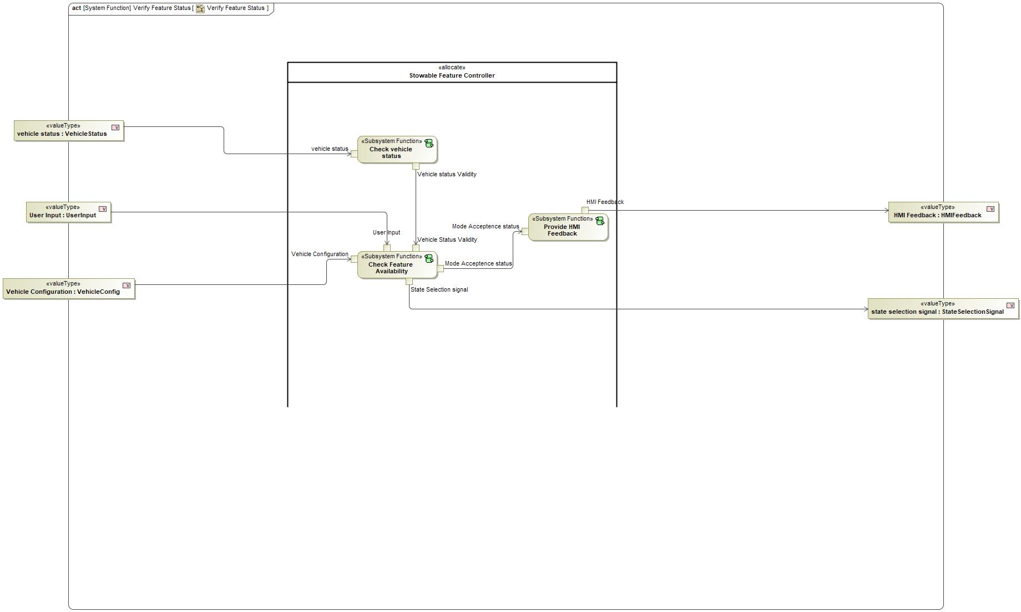
Figure 2: Activity Diagram of “Verify Feature Status” calling “Check Feature Availability”

Function Interfaces

Logical Inputs
Signal Name | Description
Vehicle Configuration  Type:  VehicleConfig | Signal Description:  Configuration of the Feature and Vehicle Specific  Received from:  - Activity Parameter Node: Vehicle Configuration
User Input  Type:  UserInput | Signal Description:  Input given by user through HMI  Received from:  - Activity Parameter Node: User Input
Vehicle Status Validity  Type:  VehicleStatusValidity | Signal Description:  This is the signal which contains the validity of the Vehicle status before Arbitrating into any Mode  Received from:  - Check vehicle status

Logical Outputs
Signal Name | Description
Unavailabilty  Type:  ModeAcceptenceStatus | Signal Description:  This signal contains the information whats not available in the vehicle configuration  Sent to:  - Provide HMI Feedback
State Selection signal  Type:  StateSelectionSignal | Signal Description:  Signal which contains the Mode that User selected after the Vehicle status is Valid  Sent to:  - Activity Parameter Node: state selection signal

Logical Parameters

Not supported by MagicDraw report generation.

Function Modeling

Use Cases

Not supported by MagicDraw report generation.

State Charts / Activity Diagrams / Sequence Diagrams / Decision Tables

No diagrams internal to function specified.

Function Requirements

Functional Requirements

Normal Operation

Check Feature Availability User Input Set to NOT_AVAILABLE
The Check Feature Availability function shall set State Selection Signal to DRIVE when User Input is set to NOT_AVAILABLE

Requirement ID:
Rationale
Acceptance Criteria
Notes
Source |  |  |  |  |  | Owner
Source Req. |  |  |  |  |  | V&V Method
Type |  |  |  | Priority |  | Status
Req. Template Version |  | 6.0 | End of Requirement

Check Feature Availability Vehicle SConfiguration Set to DISABLE
The Check Feature Availability function shall set State Selection Signal to DRIVE when Vehicle Configuration is set to DISABLE

Requirement ID:
Rationale
Acceptance Criteria
Notes
Source |  |  |  |  |  | Owner
Source Req. |  |  |  |  |  | V&V Method
Type |  |  |  | Priority |  | Status
Req. Template Version |  | 6.0 | End of Requirement

Check Feature Availability User Input Set to RESET
The Check Feature Availability function shall set State Selection Signal to DRIVE when User Input is set to RESET

Requirement ID:
Rationale
Acceptance Criteria
Notes
Source |  |  |  |  |  | Owner
Source Req. |  |  |  |  |  | V&V Method
Type |  |  |  | Priority |  | Status
Req. Template Version |  | 6.0 | End of Requirement

Check Feature Availability User Input Set to NONE
The Check Feature Availability function shall set State Selection Signal to DRIVE when User Input is set to NONE

Requirement ID:
Rationale
Acceptance Criteria
Notes
Source |  |  |  |  |  | Owner
Source Req. |  |  |  |  |  | V&V Method
Type |  |  |  | Priority |  | Status
Req. Template Version |  | 6.0 | End of Requirement

Check Feature Availability State Selection Signal Set Work State
The Check Feature Availability function shall set State Selection Signal to WORK when User Input is set to WORKMODE AND Vehicle Configuration is set to ENABLE AND Vehicle Status Validity is set to VALID

Requirement ID:
Rationale
Acceptance Criteria
Notes
Source |  |  |  |  |  | Owner
Source Req. |  |  |  |  |  | V&V Method
Type |  |  |  | Priority |  | Status
Req. Template Version |  | 6.0 | End of Requirement

Check Feature Availability State Selection Signal Set Play State
The Check Feature Availability function shall set State Selection Signal to PLAY when User Input is set to PLAYMODE AND Vehicle Configuration is set to ENABLE AND Vehicle Status Validity is set to VALID

Requirement ID:
Rationale
Acceptance Criteria
Notes
Source |  |  |  |  |  | Owner
Source Req. |  |  |  |  |  | V&V Method
Type |  |  |  | Priority |  | Status
Req. Template Version |  | 6.0 | End of Requirement

Check Feature Availability Vehicle Status Validity Set to INVALID
The Check Feature Availability function shall set State Selection Signal to DRIVE when Vehicle Status Validity is set to INVALID

Requirement ID:
Rationale
Acceptance Criteria
Notes
Source |  |  |  |  |  | Owner
Source Req. |  |  |  |  |  | V&V Method
Type |  |  |  | Priority |  | Status
Req. Template Version |  | 6.0 | End of Requirement

Check Feature Availability State Selection Signal Set Rest State
The Check Feature Availability function shall set State Selection Signal to REST when User Input is set to RESTMODE AND Vehicle Configuration is set to ENABLE AND Vehicle Status Validity is set to VALID

Requirement ID:
Rationale
Acceptance Criteria
Notes
Source |  |  |  |  |  | Owner
Source Req. |  |  |  |  |  | V&V Method
Type |  |  |  | Priority |  | Status
Req. Template Version |  | 6.0 | End of Requirement

Error Handling

No Error Handling Requirements specified.

Non-Functional Requirements

No Non-Functional Requirements specified.

Functional Safety Requirements

No Functional Safety Requirements specified.

ASIL Decomposition of Functional Safety Requirements

No Functional Safety Requirements with ASIL Decompositions specified.

Other Requirements

Design Requirements

No Design Requirements specified.

Check for Transition Termination

Function Overview

Description

Function is allocated to:
- Stowable Steering and Deployable Tray System <<Logical>>

This system Functions check all the terminate signals information from Seat , steering Column and Tray Table and verifies if termination of transition is necessary

Variants

Not supported by MagicDraw report generation.

Input Requirements

Not supported by MagicDraw report generation.

Assumptions

No assumptions specified for this function.

References

Ford Documents
List here all Ford internal documents, which are directly related to the feature.

Reference | Title | Doc. ID | Revision
Table 5: Ford internal Documents (not specified in model)

External Documents and Publications
The list of external documents could include books, reports and online sources.

Reference | Document / Publication
Table 7: External documents and publications (not specified in model)

Glossary
See Appendix for Definitions and Abbreviations.

Function Scope

The – “Check for Transition Termination” function is called by the following functions:
- – “Make Rest space Available”
- – “Make Work Space Available”

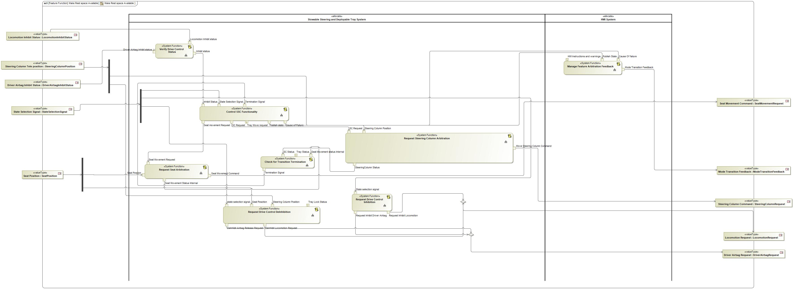
Figure 2: Activity Diagram of “Make Rest space Available” calling “Check for Transition Termination”

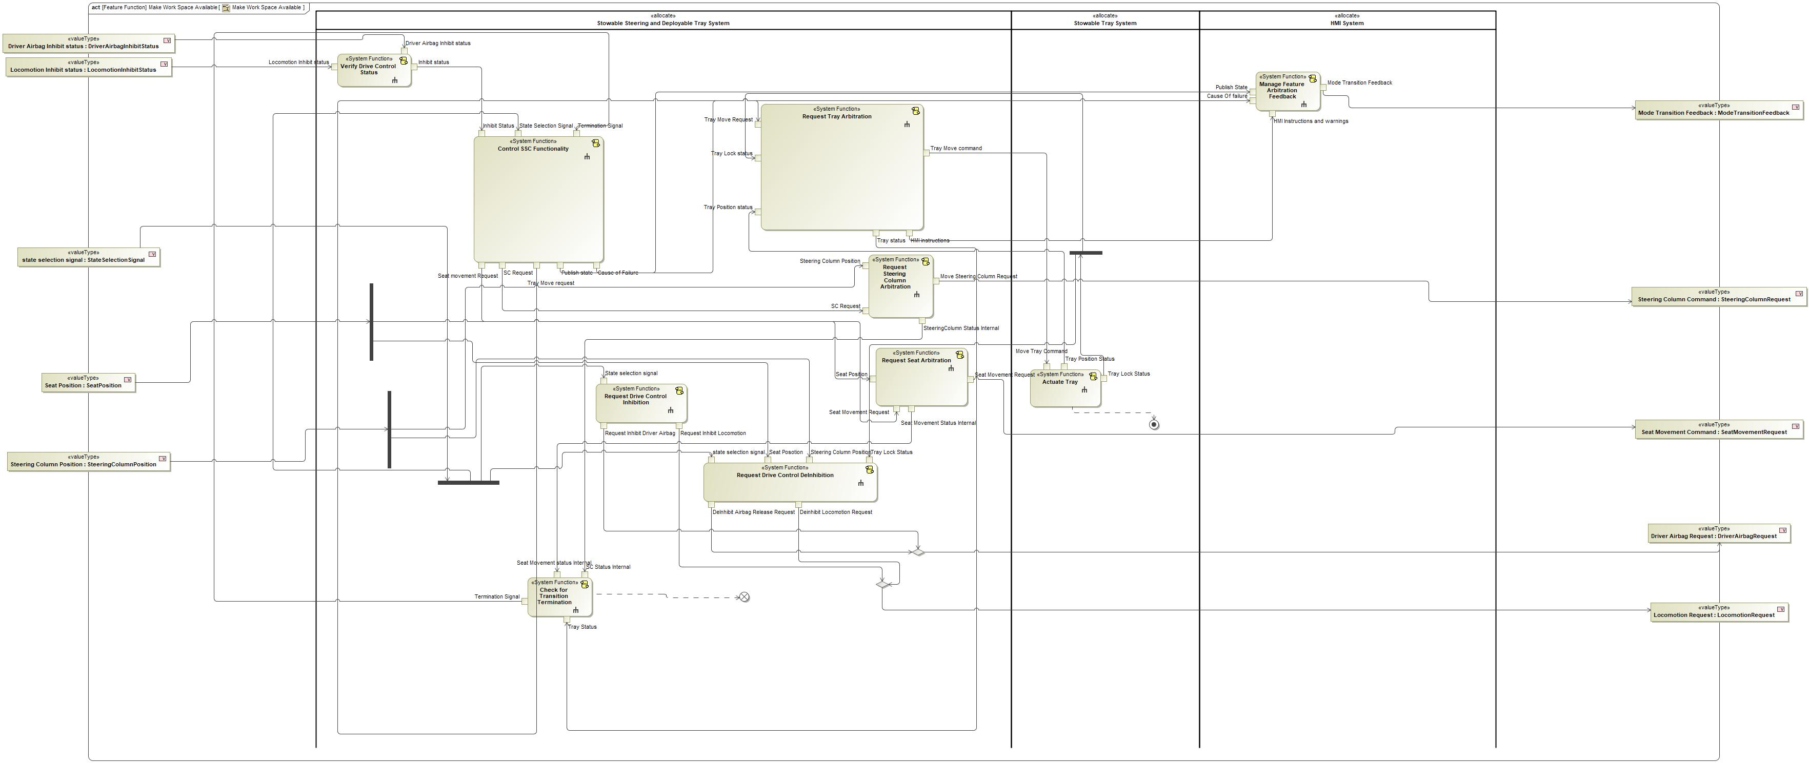
Figure 2: Activity Diagram of “Make Work Space Available” calling “Check for Transition Termination”

Function Interfaces

Logical Inputs
Signal Name | Description
Seat Movement status Internal  Type:  SeatMovementStatusInternal | Signal Description:  Status of the Seat movement according to the current position and external position  Received from:  - Request Seat Arbitration
SC Status  Type:  SteeringColumnStatusInternal | Signal Description:  Status of SteeringColumn based on Feature Decisions and current steering Column Position  Received from:  - Request Steering Column Arbitration
Tray Status  Type:  TrayStatus | Signal Description:  This status is decided and fed by the Feature systems based on Requests and Input feedbacks fed  Received from:  - Request Tray Arbitration

Logical Outputs
Signal Name | Description
Termination Signal  Type:  Termination Signal | Signal Description:  Logical signal for termination of Mode Arbitration when system did not act according to requests  Sent to:  - Control SSC Functionality

Logical Parameters

Not supported by MagicDraw report generation.

Function Modeling

Use Cases

Not supported by MagicDraw report generation.

State Charts / Activity Diagrams / Sequence Diagrams / Decision Tables

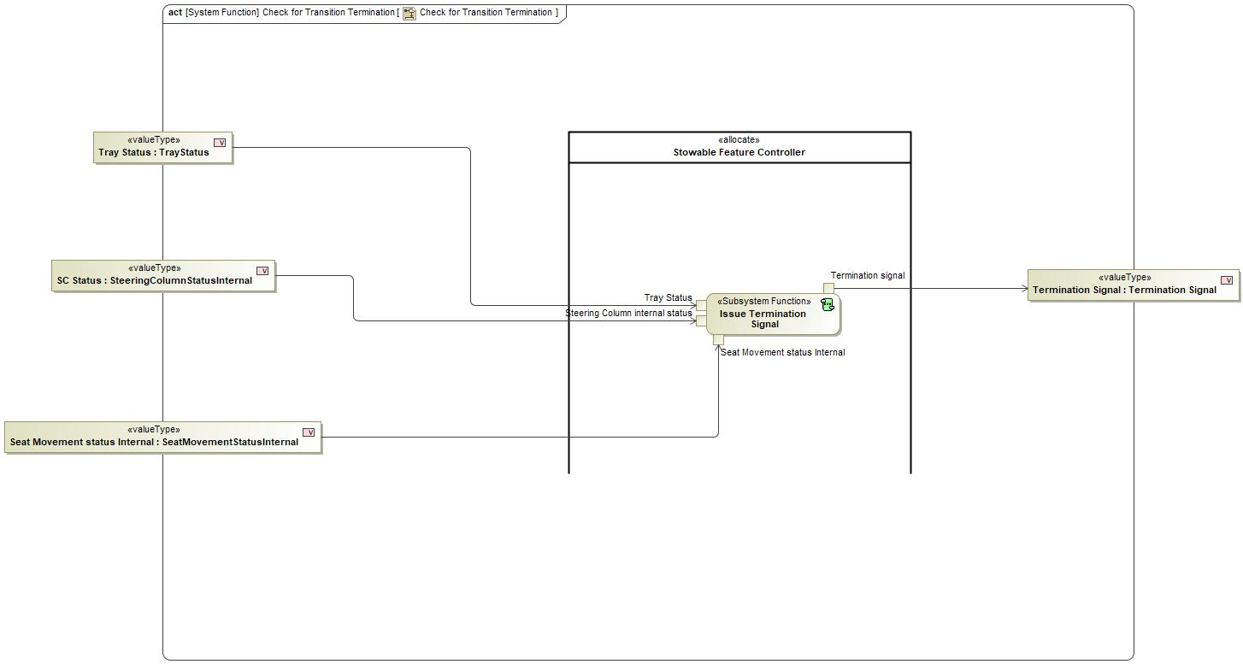
Figure 3: Check for Transition Termination

Function Requirements

Functional Requirements

Normal Operation

No Normal Operation Requirements specified.

Error Handling

No Error Handling Requirements specified.

Non-Functional Requirements

No Non-Functional Requirements specified.

Functional Safety Requirements

No Functional Safety Requirements specified.

ASIL Decomposition of Functional Safety Requirements

No Functional Safety Requirements with ASIL Decompositions specified.

Other Requirements

Design Requirements

No Design Requirements specified.

Check Inhibit status

Function Overview

Description

Function is allocated to:
- check Inhibit Status <<Logical>>
- Stowable Feature Controller <<Logical>>

This Subsystem function verifies the Locomotion and Air bag Inhibit status and Outputs the Inhibit status

Variants

Not supported by MagicDraw report generation.

Input Requirements

Not supported by MagicDraw report generation.

Assumptions

No assumptions specified for this function.

References

Ford Documents
List here all Ford internal documents, which are directly related to the feature.

Reference | Title | Doc. ID | Revision
Table 5: Ford internal Documents (not specified in model)

External Documents and Publications
The list of external documents could include books, reports and online sources.

Reference | Document / Publication
Table 7: External documents and publications (not specified in model)

Glossary
See Appendix for Definitions and Abbreviations.

Function Scope

The – “Check Inhibit status” function is called by the following functions:
- – “Verify Drive Control Status”

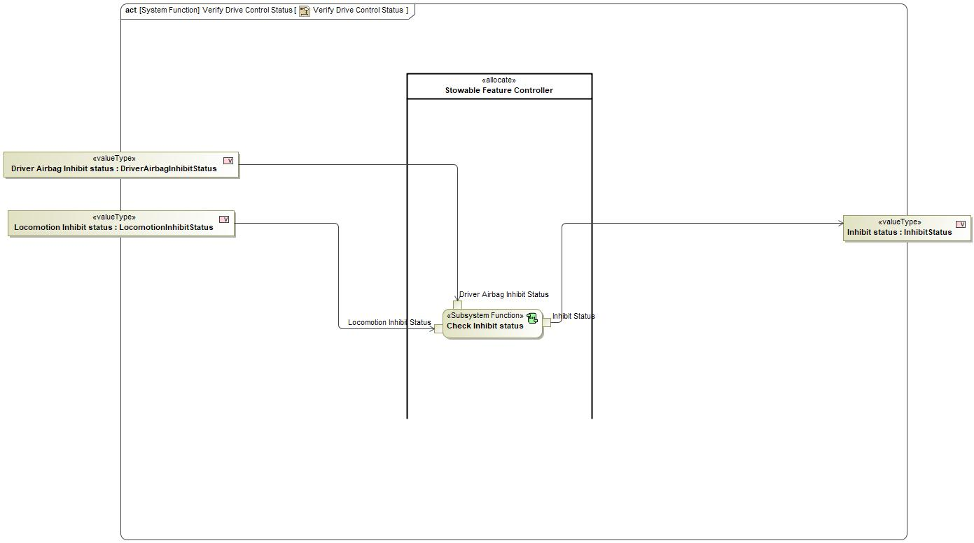
Figure 2: Activity Diagram of “Verify Drive Control Status” calling “Check Inhibit status”

Function Interfaces

Logical Inputs
Signal Name | Description
Locmotion Inhibit Status  Type:  LocomotionInhibitStatus | Signal Description:  Status of the Locomotion Inhibition  Received from:  - Activity Parameter Node: Locomotion Inhibit status
Driver Airbag Inhibit Status  Type:  DriverAirbagInhibitStatus | Signal Description:  Status of the Driver Airbag Inhibition  Received from:  - Activity Parameter Node: Driver Airbag Inhibit status

Logical Outputs
Signal Name | Description
Inhibit Status  Type:  InhibitStatus | Signal Description:  Inhibit status of driver control which is verified by the feature systems  Sent to:  - Activity Parameter Node: Inhibit status

Logical Parameters

Not supported by MagicDraw report generation.

Function Modeling

Use Cases

Not supported by MagicDraw report generation.

State Charts / Activity Diagrams / Sequence Diagrams / Decision Tables

No diagrams internal to function specified.

Function Requirements

Functional Requirements

Normal Operation

Check Inhibit status Function Inhibit Status DEINHIBITED
The Check Inhibit status Function shall set the Inhibit Status to DC_DEINHIBITED when Driver Airbag Inhibit Status is set to DEINHIBITED AND Locomotion Inhibit Status is set to DEINHIBITED

Requirement ID:
Rationale
Acceptance Criteria
Notes
Source |  |  |  |  |  | Owner
Source Req. | - Drive Control Inhibit Status Verification |  |  |  |  | V&V Method
Type |  |  |  | Priority |  | Status
Req. Template Version |  | 6.0 | End of Requirement

The Check Inhibit status function State Memory Definition
The Check Inhibit status function State Memory shall store the current DC_INHIBITED, DC_FAILED_TO_INHIBIT, DC_DEINHIBITED or DC_FAILED_TO_DEINHIBIT value output by Inhibit Status

Requirement ID:
Rationale
Acceptance Criteria
Notes
Source |  |  |  |  |  | Owner
Source Req. |  |  |  |  |  | V&V Method
Type |  |  |  | Priority |  | Status
Req. Template Version |  | 6.0 | End of Requirement

Check Inhibit status Funciton Inhibit Status Failed to De-Inhibit
The Check Inhibit status Function shall set the Inhibit Status to DC_FAILED_TO_DEINHIBITED when Driver Airbag Inhibit Status and Locomotion Inhibit Status are NOT equal AND State Memory is set to DC_FAILED_TO_DEINHIBIT and Timer is set to TIMEOUT.

Requirement ID:
Rationale
Acceptance Criteria
Notes
Source |  |  |  |  |  | Owner
Source Req. | - Drive Control Inhibit Status Verification |  |  |  |  | V&V Method
Type |  |  |  | Priority |  | Status
Req. Template Version |  | 6.0 | End of Requirement

Check Inhibit status Timer TIMEOUT
The Check Inhibit status Function shall set the Next Timer to INIT when Timer is set to TIMEOUT

Requirement ID:
Rationale
Acceptance Criteria
Notes
Source |  |  |  |  |  | Owner
Source Req. | - Drive Control Inhibit Status Verification |  |  |  |  | V&V Method
Type |  |  |  | Priority |  | Status
Req. Template Version |  | 6.0 | End of Requirement

The Check Inhibit status function Inhibit Status Definition
The Check Inhibit status function Inhibit Status shall indicate DC_INHIBITED, DC_FAILED_TO_INHIBIT, DC_DEINHIBITED and DC_FAILED_TO_DEINHIBIT

Requirement ID:
Rationale
Acceptance Criteria
Notes
Source |  |  |  |  |  | Owner
Source Req. |  |  |  |  |  | V&V Method
Type |  |  |  | Priority |  | Status
Req. Template Version |  | 6.0 | End of Requirement

Check Inhibit status Function Inhibit Status transition to De-Inhibit
The Check Inhibit status Function shall set the Inhibit Status to DC_FAILED_TO_DEINHIBITED when Driver Airbag Inhibit Status and Locomotion Inhibit Status are NOT equal AND State Memory is set to DC_INHIBIT and Timer is set to TIMEOUT.

Requirement ID:
Rationale
Acceptance Criteria
Notes
Source |  |  |  |  |  | Owner
Source Req. | - Drive Control Inhibit Status Verification |  |  |  |  | V&V Method
Type |  |  |  | Priority |  | Status
Req. Template Version |  | 6.0 | End of Requirement

The Manage Seat Save Request function Save Seat Request Definition
The Manage Seat Save Request function Save Seat Request shall indicate REQUEST_SEAT_SAVE and NO_REQUEST.

Requirement ID:
Rationale
Acceptance Criteria
Notes
Source |  |  |  |  |  | Owner
Source Req. |  |  |  |  |  | V&V Method
Type |  |  |  | Priority |  | Status
Req. Template Version |  | 6.0 | End of Requirement

Check Inhibit status Function Inhibit Status transition to Inhibit
The Check Inhibit status Function shall set the Inhibit Status to DC_FAILED_TO_INHIBITED when Driver Airbag Inhibit Status and Locomotion Inhibit Status are NOT equal AND State Memory is set to DC_FAILED_TO_INHIBIT and Timer is set to TIMEOUT.

Requirement ID:
Rationale
Acceptance Criteria
Notes
Source |  |  |  |  |  | Owner
Source Req. | - Drive Control Inhibit Status Verification |  |  |  |  | V&V Method
Type |  |  |  | Priority |  | Status
Req. Template Version |  | 6.0 | End of Requirement

Check Inhibit status Timer INHIBITED
The Check Inhibit status Function shall set the Next Timer to INIT when Driver Airbag Inhibit Status is set to INHIBITED AND Locomotion Inhibit Status is set to INHIBITED

Requirement ID:
Rationale
Acceptance Criteria
Notes
Source |  |  |  |  |  | Owner
Source Req. | - Drive Control Inhibit Status Verification |  |  |  |  | V&V Method
Type |  |  |  | Priority |  | Status
Req. Template Version |  | 6.0 | End of Requirement

Check Inhibit status Timer DEINHIBITED
The Check Inhibit status Function shall set the Next Timer to INIT when Driver Airbag Inhibit Status is set to DEINHIBITED AND Locomotion Inhibit Status is set to DEINHIBITED

Requirement ID:
Rationale
Acceptance Criteria
Notes
Source |  |  |  |  |  | Owner
Source Req. | - Drive Control Inhibit Status Verification |  |  |  |  | V&V Method
Type |  |  |  | Priority |  | Status
Req. Template Version |  | 6.0 | End of Requirement

The Check Inhibit status functions Timer Time-Out Definition
The Check Inhibit status function Timer shall indicate TIMEOUT when the timer reaches its stored limit time.

Requirement ID:
Rationale
Acceptance Criteria
Notes
Source |  |  |  |  |  | Owner
Source Req. |  |  |  |  |  | V&V Method
Type |  |  |  | Priority |  | Status
Req. Template Version |  | 6.0 | End of Requirement

Check Inhibit status Function Inhibit Status Failed to Inhibit
The Check Inhibit status Function shall set the Inhibit Status to DC_FAILED_TO_INHIBIT when Timer is set to TIMEOUT.

Requirement ID:
Rationale
Acceptance Criteria
Notes
Source |  |  |  |  |  | Owner
Source Req. | - Drive Control Inhibit Status Verification |  |  |  |  | V&V Method
Type |  |  |  | Priority |  | Status
Req. Template Version |  | 6.0 | End of Requirement

Check Inhibit status Function Timer Not TIMEOUT
The Check Inhibit status Function shall set the Inhibit Status to the current State Memory value when Driver Airbag Inhibit Status is not set equal to Locomotion Inhibit Status AND the Timer is NOT TIMEOUT

Requirement ID:
Rationale
Acceptance Criteria
Notes
Source |  |  |  |  |  | Owner
Source Req. | - Drive Control Inhibit Status Verification |  |  |  |  | V&V Method
Type |  |  |  | Priority |  | Status
Req. Template Version |  | 6.0 | End of Requirement

The Check Inhibit status functions Timer Definition
The Check Inhibit status function Timer shall indicate INIT, PENDING and TIMEOUT.

Requirement ID:
Rationale
Acceptance Criteria
Notes
Source |  |  |  |  |  | Owner
Source Req. |  |  |  |  |  | V&V Method
Type |  |  |  | Priority |  | Status
Req. Template Version |  | 6.0 | End of Requirement

Check Inhibit status Function Inhibit Status INHIBITED
The Check Inhibit status Function shall set the Inhibit Status to DC_INHIBITED when Driver Airbag Inhibit Status is set to INHIBITED AND Locomotion Inhibit Status is set to INHIBITED

Requirement ID:
Rationale
Acceptance Criteria
Notes
Source |  |  |  |  |  | Owner
Source Req. | - Drive Control Inhibit Status Verification |  |  |  |  | V&V Method
Type |  |  |  | Priority |  | Status
Req. Template Version |  | 6.0 | End of Requirement

Check Inhibit status Timer PENDING
The Check Inhibit status Function shall set the Next Timer to PENDING when Driver Airbag Inhibit Status is not set equal to Locomotion Inhibit Status

Requirement ID:
Rationale
Acceptance Criteria
Notes
Source |  |  |  |  |  | Owner
Source Req. | - Drive Control Inhibit Status Verification |  |  |  |  | V&V Method
Type |  |  |  | Priority |  | Status
Req. Template Version |  | 6.0 | End of Requirement

Error Handling

No Error Handling Requirements specified.

Non-Functional Requirements

No Non-Functional Requirements specified.

Functional Safety Requirements

No Functional Safety Requirements specified.

ASIL Decomposition of Functional Safety Requirements

No Functional Safety Requirements with ASIL Decompositions specified.

Other Requirements

Design Requirements

No Design Requirements specified.

Check Tray Status

Function Overview

Description

Function is allocated to:
- Stowable Feature Controller <<Logical>>

This sub system Function checks the status of Tray upon receiving the move request and issue request respectively

Variants

Not supported by MagicDraw report generation.

Input Requirements

Not supported by MagicDraw report generation.

Assumptions

No assumptions specified for this function.

References

Ford Documents
List here all Ford internal documents, which are directly related to the feature.

Reference | Title | Doc. ID | Revision
Table 5: Ford internal Documents (not specified in model)

External Documents and Publications
The list of external documents could include books, reports and online sources.

Reference | Document / Publication
Table 7: External documents and publications (not specified in model)

Glossary
See Appendix for Definitions and Abbreviations.

Function Scope

The – “Check Tray Status” function is called by the following functions:
- – “Request Tray Arbitration”

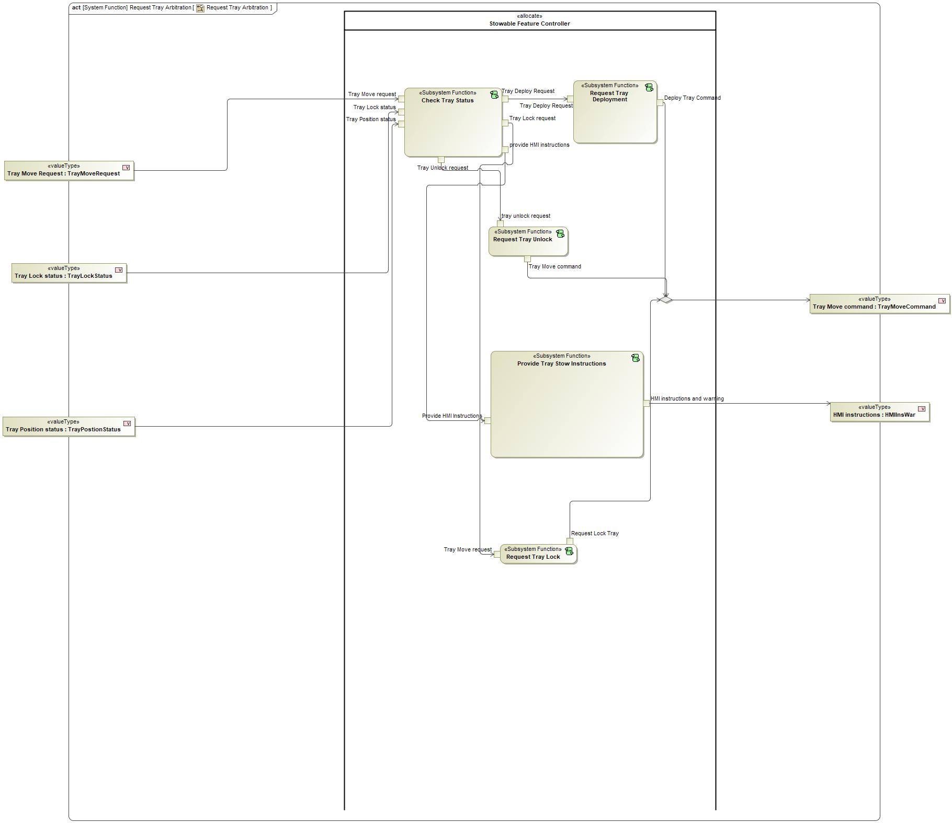
Figure 2: Activity Diagram of “Request Tray Arbitration” calling “Check Tray Status”

Function Interfaces

Logical Inputs
Signal Name | Description
Tray Lock status  Type:  TrayLockStatus | Signal Description:  Tray lock status is given by Tray Lock sensor  Received from:  - Activity Parameter Node: Tray Lock status
Tray Position status  Type:  TrayPostionStatus | Signal Description:  Tray Position status is the feedback for Tray position given by Tray position Sensor  Received from:  - Activity Parameter Node: Tray Position status
Tray Move request  Type:  TrayMoveRequest | Signal Description:  Internal Request of Feature Controller to Move Tray Table  Received from:  - Activity Parameter Node: Tray Move Request

Logical Outputs
Signal Name | Description
Tray Lock request  Type:  TrayMoveRequest | Signal Description:  Internal Request of Feature Controller to Move Tray Table  Sent to:  - Request Tray Lock
Tray Unlock request  Type:  TrayMoveRequest | Signal Description:  Internal Request of Feature Controller to Move Tray Table  Sent to:  - Request Tray Unlock
provide HMI instructions  Type:  HMIInsWar | Signal Description:  HMI Instructions to Stow and Warning display if Tray is not pushed in properly  Sent to:  - Provide Tray Stow Instructions
Tray Deploy Request  Type:  TrayMoveRequest | Signal Description:  Internal Request of Feature Controller to Move Tray Table  Sent to:  - Request Tray Deployment

Logical Parameters

Not supported by MagicDraw report generation.

Function Modeling

Use Cases

Not supported by MagicDraw report generation.

State Charts / Activity Diagrams / Sequence Diagrams / Decision Tables

No diagrams internal to function specified.

Function Requirements

Functional Requirements

Normal Operation

Tray Locked With Position Error
WHEN Tray Move Request is DEPLOY AND Tray Lock Status is TRAY_LOCKED THE Check Tray Status Subfunction SHALL set Tray Deploy Request to NONE

Requirement ID:
Rationale
Acceptance Criteria
Notes
Source |  |  |  |  |  | Owner
Source Req. | - Tray Movement Functionality |  |  |  |  | V&V Method
Type |  |  |  | Priority |  | Status
Req. Template Version |  | 6.0 | End of Requirement

Provide HMI Tray Fully Deployed
WHEN Tray Move Request is DEPLOY AND Tray Lock Status is TRAY_UNLOCKED AND Tray Position Status is DEPLOYED THE Check Tray Status Subfunction SHALL set Provide HMI Instructions is Tray Fully Deployed

Requirement ID:
Rationale
Acceptance Criteria
Notes
Source |  |  |  |  |  | Owner
Source Req. | - Tray Movement Functionality |  |  |  |  | V&V Method
Type |  |  |  | Priority |  | Status
Req. Template Version |  | 6.0 | End of Requirement

HMI Tray Locked With Position Error
WHEN Tray Move Request is DEPLOY AND Tray Lock Status is TRAY_LOCKED THE Check Tray Status Subfunction SHALL set Provide HMI Instructions is Tray Locked With Position Error

Requirement ID:
Rationale
Acceptance Criteria
Notes
Source |  |  |  |  |  | Owner
Source Req. | - Tray Movement Functionality |  |  |  |  | V&V Method
Type |  |  |  | Priority |  | Status
Req. Template Version |  | 6.0 | End of Requirement

Tray Failed to Lock and Going to Safe State
IF Tray Lock Status is EITHER TRAY_FAILED_TO_LOCK OR TRAY_FAILED_TO_UNLOCK AND Tray Position Status is NEITHER FAILED_TO_DEPLOY NOR FAILED_TO_STOW THEN Check Tray Status Subfunction SHALL set Deploy Request to STOW

Requirement ID:
Rationale
Acceptance Criteria
Notes
Source |  |  |  |  |  | Owner
Source Req. | - Tray Movement Functionality |  |  |  |  | V&V Method
Type |  |  |  | Priority |  | Status
Req. Template Version |  | 6.0 | End of Requirement

Tray Locked Request Failed to Lock and Halt Motion
IF Tray Move Request is STOW AND Tray Lock Status is TRAY_UNLOCKED AND Tray Position Status is FAILED_TO_DEPLOY THEN Check Tray Status Subfunction SHALL set Tray Lock Request to NONE

Requirement ID:
Rationale
Acceptance Criteria
Notes
Source |  |  |  |  |  | Owner
Source Req. | - Tray Movement Functionality |  |  |  |  | V&V Method
Type |  |  |  | Priority |  | Status
Req. Template Version |  | 6.0 | End of Requirement

Tray Unlock Request is Unlocked and Fully Deployed
WHEN Tray Move Request is DEPLOY AND Tray Lock Status is TRAY_UNLOCKED THE Check Tray Status Subfunction SHALL set Tray Lock Request to TRAY_UNLOCKED

Requirement ID:
Rationale
Acceptance Criteria
Notes
Source |  |  |  |  |  | Owner
Source Req. | - Tray Movement Functionality |  |  |  |  | V&V Method
Type |  |  |  | Priority |  | Status
Req. Template Version |  | 6.0 | End of Requirement

Tray Locked and Waiting to Unlock
WHEN Tray Move Request is DEPLOY AND Tray Lock Status is TRAY_LOCKED AND Tray Position Status is IN_MOTION THE Check Tray Status Subfunction SHALL set Tray Deploy Request to NONE

Requirement ID:
Rationale
Acceptance Criteria
Notes
Source |  |  |  |  |  | Owner
Source Req. | - Tray Movement Functionality |  |  |  |  | V&V Method
Type |  |  |  | Priority |  | Status
Req. Template Version |  | 6.0 | End of Requirement

Tray Unlock Request is Locking but Tray Stowed
WHEN Tray Move Request is STOW AND Tray Lock Status is TRAY_UNLOCKED AND Tray Position Status is STOWED THE Check Tray Status Subfunction SHALL set Tray Lock Request to NONE

Requirement ID:
Rationale
Acceptance Criteria
Notes
Source |  |  |  |  |  | Owner
Source Req. | - Tray Movement Functionality |  |  |  |  | V&V Method
Type |  |  |  | Priority |  | Status
Req. Template Version |  | 6.0 | End of Requirement

Tray Unlock Request is Tray Locked and Waiting to Unlock
WHEN Tray Move Request is DEPLOY AND Tray Lock Status is TRAY_LOCKED AND Tray Position Status is EITHER STOWED OR IN_MOTION THE Check Tray Status Subfunction SHALL set Tray Lock Request to TRAY_UNLOCKED

Requirement ID:
Rationale
Acceptance Criteria
Notes
Source |  |  |  |  |  | Owner
Source Req. | - Tray Movement Functionality |  |  |  |  | V&V Method
Type |  |  |  | Priority |  | Status
Req. Template Version |  | 6.0 | End of Requirement

Check Tray Status Function Output Provide HMI Instructions Definition
Check Tray Status Function Output Provide HMI Instructions shall define States 'Tray Locked With Position Error, 'Tray Locked and Waiting to Unlock'', 'Tray Fully Deployed', 'Tray Unlocked and Deploying', 'Tray Failed to Lock and Halting Motion', 'Tray Failed to Lock and Going to Safe State', 'Tray Failed to Unlock and Going to Safe State', 'Tray Fully Stowed', 'Tray Unlocked and Tray Stowing'

Requirement ID:
Rationale
Acceptance Criteria
Notes
Source |  |  |  |  |  | Owner
Source Req. | - Tray Movement Functionality |  |  |  |  | V&V Method
Type |  |  |  | Priority |  | Status
Req. Template Version |  | 6.0 | End of Requirement

Tray Locked Request to Lock and Halt Motion Again
IF Tray Move Request is STOW AND Tray Lock Status is TRAY_FAILED_TO_LOCK AND Tray Position Status is FAILED_TO_STOW THEN Check Tray Status Subfunction SHALL set Tray Lock Request to TRAY_FAILED_TO_LOCK

Requirement ID:
Rationale
Acceptance Criteria
Notes
Source |  |  |  |  |  | Owner
Source Req. | - Tray Movement Functionality |  |  |  |  | V&V Method
Type |  |  |  | Priority |  | Status
Req. Template Version |  | 6.0 | End of Requirement

Tray Unlock Request is Tray Failed to Lock and Go to Safe State
IF Tray Lock Status is TRAY_FAILED_TO_LOCK THEN Check Tray Status Subfunction SHALL set Tray Unlock Request to NONE

Requirement ID:
Rationale
Acceptance Criteria
Notes
Source |  |  |  |  |  | Owner
Source Req. | - Tray Movement Functionality |  |  |  |  | V&V Method
Type |  |  |  | Priority |  | Status
Req. Template Version |  | 6.0 | End of Requirement

Tray Unlock Request is None and Fully Stowed
WHEN Tray Move Request is STOW AND Tray Lock Status is TRAY_LOCKED AND Tray Position Status is EITHER STOWED OR IN_MOTION THE Check Tray Status Subfunction SHALL set Tray Lock Request to NONE

Requirement ID:
Rationale
Acceptance Criteria
Notes
Source |  |  |  |  |  | Owner
Source Req. | - Tray Movement Functionality |  |  |  |  | V&V Method
Type |  |  |  | Priority |  | Status
Req. Template Version |  | 6.0 | End of Requirement

Tray Lock Request is Failed to Lock and Go to Safe State
IF Tray Move Request is DEPLOY AND Tray Lock Status is TRAY_FAILED_TO_LOCK THEN Check Tray Status Subfunction SHALL set Tray Lock Request to TRAY_FAILED_TO_LOCK

Requirement ID:
Rationale
Acceptance Criteria
Notes
Source |  |  |  |  |  | Owner
Source Req. | - Tray Movement Functionality |  |  |  |  | V&V Method
Type |  |  |  | Priority |  | Status
Req. Template Version |  | 6.0 | End of Requirement

Tray Unlock Request is Tray Failed to Unlock and Go to Safe State
IF Tray Lock Status is TRAY_FAILED_TO_UNLOCK THEN Check Tray Status Subfunction SHALL set Tray Unlock Request to TRAY_FAILED_TO_UNLOCK

Requirement ID:
Rationale
Acceptance Criteria
Notes
Source |  |  |  |  |  | Owner
Source Req. | - Tray Movement Functionality |  |  |  |  | V&V Method
Type |  |  |  | Priority |  | Status
Req. Template Version |  | 6.0 | End of Requirement

Provide HMI Tray Unlocked and Deploying
WHEN Tray Move Request is DEPLOY AND Tray Lock Status is TRAY_UNLOCKED AND Tray Position Status is EITHER IN_MOTION OR STOWED THE Check Tray Status Subfunction SHALL set Provide HMI Instructions is Tray Unlocked and Deploying

Requirement ID:
Rationale
Acceptance Criteria
Notes
Source |  |  |  |  |  | Owner
Source Req. | - Tray Movement Functionality |  |  |  |  | V&V Method
Type |  |  |  | Priority |  | Status
Req. Template Version |  | 6.0 | End of Requirement

Tray Unlock Request is Locked But Failed to Stow
IF Tray Lock Status is TRAY_LOCKED AND Tray Position Status is FAILED_TO_STOW THEN Check Tray Status Subfunction SHALL set Tray Unlock Request to NONE

Requirement ID:
Rationale
Acceptance Criteria
Notes
Source |  |  |  |  |  | Owner
Source Req. | - Tray Movement Functionality |  |  |  |  | V&V Method
Type |  |  |  | Priority |  | Status
Req. Template Version |  | 6.0 | End of Requirement

Tray Lock Request is None with Position Error
IF Tray Lock Status is TRAY_LOCKED AND Tray Position Status is DEPLOYED THEN Check Tray Status Subfunction SHALL set Tray Lock Request to NONE

Requirement ID:
Rationale
Acceptance Criteria
Notes
Source |  |  |  |  |  | Owner
Source Req. | - Tray Movement Functionality |  |  |  |  | V&V Method
Type |  |  |  | Priority |  | Status
Req. Template Version |  | 6.0 | End of Requirement

Tray Unlock Request is Unlocked and Tray Stowing
WHEN Tray Move Request is STOW AND Tray Lock Status is TRAY_LOCKED AND Tray Position Status is NEITHER STOWED NOR FAILED_TO_STOW THE Check Tray Status Subfunction SHALL set Tray Lock Request to TRAY_UNLOCKED

Requirement ID:
Rationale
Acceptance Criteria
Notes
Source |  |  |  |  |  | Owner
Source Req. | - Tray Movement Functionality |  |  |  |  | V&V Method
Type |  |  |  | Priority |  | Status
Req. Template Version |  | 6.0 | End of Requirement

Tray Locked Request Failed to Unlock and Tray Failed to Stow
IF Tray Move Request is STOW AND Tray Lock Status is TRAY_FAILED_TO_UNLOCK THEN Check Tray Status Subfunction SHALL set Tray Lock Request to NONE

Requirement ID:
Rationale
Acceptance Criteria
Notes
Source |  |  |  |  |  | Owner
Source Req. | - Tray Movement Functionality |  |  |  |  | V&V Method
Type |  |  |  | Priority |  | Status
Req. Template Version |  | 6.0 | End of Requirement

Tray Lock Request is Locked and Failed to Stow
WHEN Tray Move Request is DEPLOY AND Tray Lock Status is TRAY_LOCKED AND Tray Position Status is FAILED_TO_STOW THE Check Tray Status Subfunction SHALL set Tray Lock Request to TRAY_LOCKED

Requirement ID:
Rationale
Acceptance Criteria
Notes
Source |  |  |  |  |  | Owner
Source Req. | - Tray Movement Functionality |  |  |  |  | V&V Method
Type |  |  |  | Priority |  | Status
Req. Template Version |  | 6.0 | End of Requirement

Tray Unlocked and Deploying
WHEN Tray Move Request is DEPLOY AND Tray Lock Status is TRAY_UNLOCKED AND Tray Position Status is EITHER IN_MOTION OR STOWED THE Check Tray Status Subfunction SHALL set Tray Deploy Request to DEPLOY

Requirement ID:
Rationale
Acceptance Criteria
Notes
Source |  |  |  |  |  | Owner
Source Req. | - Tray Movement Functionality |  |  |  |  | V&V Method
Type |  |  |  | Priority |  | Status
Req. Template Version |  | 6.0 | End of Requirement

Tray Unlocked and Tray Stowing
WHEN Tray Move Request is STOW AND Tray Lock Status is TRAY_UNLOCKED AND Tray Position Status is EITHER DEPLOYED OR IN_MOTION THE Check Tray Status Subfunction SHALL set Tray Deploy Request to STOW

Requirement ID:
Rationale
Acceptance Criteria
Notes
Source |  |  |  |  |  | Owner
Source Req. | - Tray Movement Functionality |  |  |  |  | V&V Method
Type |  |  |  | Priority |  | Status
Req. Template Version |  | 6.0 | End of Requirement

Define Check Tray Status Function Output Tray Deploy Request
The Check Tray Status Function Output Tray Deploy Request shall define values NONE, STOW and DEPLOY.

Requirement ID:
Rationale
Acceptance Criteria
Notes
Source |  |  |  |  |  | Owner
Source Req. | - Tray Movement Functionality |  |  |  |  | V&V Method
Type |  |  |  | Priority |  | Status
Req. Template Version |  | 6.0 | End of Requirement

Provide HMI Tray Failed to Unlock and Going to Safe State
WHEN Tray Move Request is STOW AND Tray Lock Status is TRAY_LOCKED AND Tray Position Status is EITHER DEPLOYED OR IN_MOTION THE Check Tray Status Subfunction SHALL set Provide HMI Instructions is Tray Failed to Unlock and Going to Safe State

Requirement ID:
Rationale
Acceptance Criteria
Notes
Source |  |  |  |  |  | Owner
Source Req. | - Tray Movement Functionality |  |  |  |  | V&V Method
Type |  |  |  | Priority |  | Status
Req. Template Version |  | 6.0 | End of Requirement

Provide HMI Tray Fully Stowed
WHEN Tray Move Request is STOW AND Tray Lock Status is EITHER TRAY_LOCKED OR TRAY_UNLOCKED AND Tray Position Status is STOWED THE Check Tray Status Subfunction SHALL set Provide HMI Instructions is Tray Fully Stowed

Requirement ID:
Rationale
Acceptance Criteria
Notes
Source |  |  |  |  |  | Owner
Source Req. | - Tray Movement Functionality |  |  |  |  | V&V Method
Type |  |  |  | Priority |  | Status
Req. Template Version |  | 6.0 | End of Requirement

Tray Failed to Unlock and Going to Safe State
WHEN Tray Move Request is STOW AND Tray Lock Status is TRAY_LOCKED AND Tray Position Status is EITHER DEPLOYED OR IN_MOTION THE Check Tray Status Subfunction SHALL set Tray Deploy Request to STOW

Requirement ID:
Rationale
Acceptance Criteria
Notes
Source |  |  |  |  |  | Owner
Source Req. | - Tray Movement Functionality |  |  |  |  | V&V Method
Type |  |  |  | Priority |  | Status
Req. Template Version |  | 6.0 | End of Requirement

Tray Locked Request Unlocked and Tray Stowing
WHEN Tray Move Request is STOW AND Tray Lock Status is TRAY_UNLOCKED AND Tray Position Status is DEPLOYED THE Check Tray Status Subfunction SHALL set Tray Lock Request to NONE

Requirement ID:
Rationale
Acceptance Criteria
Notes
Source |  |  |  |  |  | Owner
Source Req. | - Tray Movement Functionality |  |  |  |  | V&V Method
Type |  |  |  | Priority |  | Status
Req. Template Version |  | 6.0 | End of Requirement

Check Tray Status Output Tray Unlock Request State Definition
Check Tray Status Function Output Tray Unlock Request States SHALL define NONE, TRAY_UNLOCKED and TRAY_FAILED_TO_UNLOCK

Requirement ID:
Rationale
Acceptance Criteria
Notes
Source |  |  |  |  |  | Owner
Source Req. | - Tray Movement Functionality |  |  |  |  | V&V Method
Type |  |  |  | Priority |  | Status
Req. Template Version |  | 6.0 | End of Requirement

Tray Fully Stowed
WHEN Tray Move Request is STOW AND Tray Lock Status is EITHER TRAY_LOCKED OR TRAY_UNLOCKED AND Tray Position Status is STOWED THE Check Tray Status Subfunction SHALL set Tray Deploy Request to NONE

Requirement ID:
Rationale
Acceptance Criteria
Notes
Source |  |  |  |  |  | Owner
Source Req. | - Tray Movement Functionality |  |  |  |  | V&V Method
Type |  |  |  | Priority |  | Status
Req. Template Version |  | 6.0 | End of Requirement

Tray Unlock Request is Failed to Lock and Go to Safe State
IF Tray Move Request is DEPLOY AND Tray Lock Status is TRAY_FAILED_TO_UNLOCK THEN Check Tray Status Subfunction SHALL set Tray Lock Request to NONE

Requirement ID:
Rationale
Acceptance Criteria
Notes
Source |  |  |  |  |  | Owner
Source Req. | - Tray Movement Functionality |  |  |  |  | V&V Method
Type |  |  |  | Priority |  | Status
Req. Template Version |  | 6.0 | End of Requirement

Tray Failed to Lock and Halting Motion
IF Tray Position Status is EITHER FAILED_TO_DEPLOY OR FAILED_TO_STOW THEN Check Tray Status Subfunction SHALL set Tray Deploy Request to NONE

Requirement ID:
Rationale
Acceptance Criteria
Notes
Source |  |  |  |  |  | Owner
Source Req. | - Tray Movement Functionality |  |  |  |  | V&V Method
Type |  |  |  | Priority |  | Status
Req. Template Version |  | 6.0 | End of Requirement

Tray Lock Request is Fully Deployed
WHEN Tray Move Request is DEPLOY AND Tray Lock Status is TRAY_UNLOCKED THE Check Tray Status Subfunction SHALL set Tray Lock Request to NONE

Requirement ID:
Rationale
Acceptance Criteria
Notes
Source |  |  |  |  |  | Owner
Source Req. | - Tray Movement Functionality |  |  |  |  | V&V Method
Type |  |  |  | Priority |  | Status
Req. Template Version |  | 6.0 | End of Requirement

Tray Fully Deployed
WHEN Tray Move Request is DEPLOY AND Tray Lock Status is TRAY_UNLOCKED AND Tray Position Status is DEPLOYED THE Check Tray Status Subfunction SHALL set Tray Deploy Request to NONE

Requirement ID:
Rationale
Acceptance Criteria
Notes
Source |  |  |  |  |  | Owner
Source Req. | - Tray Movement Functionality |  |  |  |  | V&V Method
Type |  |  |  | Priority |  | Status
Req. Template Version |  | 6.0 | End of Requirement

Tray Lock Request is None and Waiting to Unlock
WHEN Tray Move Request is DEPLOY AND Tray Lock Status is TRAY_LOCKED AND Tray Position Status is EITHER STOWED OR IN_MOTION OR FAILED_TO_DEPLOY THE Check Tray Status Subfunction SHALL set Tray Lock Request to NONE

Requirement ID:
Rationale
Acceptance Criteria
Notes
Source |  |  |  |  |  | Owner
Source Req. | - Tray Movement Functionality |  |  |  |  | V&V Method
Type |  |  |  | Priority |  | Status
Req. Template Version |  | 6.0 | End of Requirement

Provide HMI Tray Failed to Lock and Going to Safe State
IF Tray Lock Status is EITHER TRAY_FAILED_TO_LOCK OR TRAY_FAILED_TO_UNLOCK AND Tray Position Status is NEITHER FAILED_TO_DEPLOY NOR FAILED_TO_STOW THEN Check Tray Status Subfunction SHALL set Provide HMI Instructions is Tray Failed to Lock and Going to Safe State

Requirement ID:
Rationale
Acceptance Criteria
Notes
Source |  |  |  |  |  | Owner
Source Req. | - Tray Movement Functionality |  |  |  |  | V&V Method
Type |  |  |  | Priority |  | Status
Req. Template Version |  | 6.0 | End of Requirement

Provide HMI Tray Unlocked and Tray Stowing
WHEN Tray Move Request is STOW AND Tray Lock Status is TRAY_UNLOCKED AND Tray Position Status is EITHER DEPLOYED OR IN_MOTION THE Check Tray Status Subfunction SHALL set Provide HMI Instructions is Tray Unlocked and Tray Stowing

Requirement ID:
Rationale
Acceptance Criteria
Notes
Source |  |  |  |  |  | Owner
Source Req. | - Tray Movement Functionality |  |  |  |  | V&V Method
Type |  |  |  | Priority |  | Status
Req. Template Version |  | 6.0 | End of Requirement

Check Tray Status Function Output Tray Lock Request Definition
The Check Tray Status Function Output Tray Lock Request Shall Define States NONE, TRAY_LOCKED and TRAY_FAILED_TO_LOCK

Requirement ID:
Rationale
Acceptance Criteria
Notes
Source |  |  |  |  |  | Owner
Source Req. | - Tray Movement Functionality |  |  |  |  | V&V Method
Type |  |  |  | Priority |  | Status
Req. Template Version |  | 6.0 | End of Requirement

Tray Locked Request Locked and Fully Stowed
WHEN Tray Move Request is STOW AND Tray Lock Status is TRAY_LOCKED AND Tray Position Status is EITHER STOWED OR IN_MOTION OR FAILED_TO_DEPLOY THE Check Tray Status Subfunction SHALL set Tray Lock Request to TRAY_LOCKED

Requirement ID:
Rationale
Acceptance Criteria
Notes
Source |  |  |  |  |  | Owner
Source Req. | - Tray Movement Functionality |  |  |  |  | V&V Method
Type |  |  |  | Priority |  | Status
Req. Template Version |  | 6.0 | End of Requirement

HMI Tray Fully Deployed
WHEN Tray Move Request is DEPLOY AND Tray Lock Status is TRAY_LOCKED AND Tray Position Status is IN_MOTION THE Check Tray Status Subfunction SHALL set Provide HMI Instructions is Tray Locked and Waiting to Unlock

Requirement ID:
Rationale
Acceptance Criteria
Notes
Source |  |  |  |  |  | Owner
Source Req. | - Tray Movement Functionality |  |  |  |  | V&V Method
Type |  |  |  | Priority |  | Status
Req. Template Version |  | 6.0 | End of Requirement

Tray Unlock Request is Tray Failed to Unlock with Position Error
IF Tray Lock Status is TRAY_LOCKED AND Tray Position Status is EITHER DEPLOYED OR FAILED_TO_DEPLOY THEN Check Tray Status Subfunction SHALL set Tray Unlock Request to TRAY_FAILED_TO_UNLOCK

Requirement ID:
Rationale
Acceptance Criteria
Notes
Source |  |  |  |  |  | Owner
Source Req. | - Tray Movement Functionality |  |  |  |  | V&V Method
Type |  |  |  | Priority |  | Status
Req. Template Version |  | 6.0 | End of Requirement

Tray Locked Request Locked and Tray Stowed
WHEN Tray Move Request is STOW AND Tray Lock Status is TRAY_UNLOCKED AND Tray Position Status is STOWED THE Check Tray Status Subfunction SHALL set Tray Lock Request to TRAY_LOCKED

Requirement ID:
Rationale
Acceptance Criteria
Notes
Source |  |  |  |  |  | Owner
Source Req. | - Tray Movement Functionality |  |  |  |  | V&V Method
Type |  |  |  | Priority |  | Status
Req. Template Version |  | 6.0 | End of Requirement

Provide HMI Tray Failed to Lock and Halting Motion
IF Tray Position Status is EITHER FAILED_TO_DEPLOY OR FAILED_TO_STOW THEN Check Tray Status Subfunction SHALL set Provide HMI Instructions is Tray Failed to Lock and Halting Motion

Requirement ID:
Rationale
Acceptance Criteria
Notes
Source |  |  |  |  |  | Owner
Source Req. | - Tray Movement Functionality |  |  |  |  | V&V Method
Type |  |  |  | Priority |  | Status
Req. Template Version |  | 6.0 | End of Requirement

Error Handling

No Error Handling Requirements specified.

Non-Functional Requirements

No Non-Functional Requirements specified.

Functional Safety Requirements

No Functional Safety Requirements specified.

ASIL Decomposition of Functional Safety Requirements

No Functional Safety Requirements with ASIL Decompositions specified.

Other Requirements

Design Requirements

No Design Requirements specified.

Check vehicle status

Function Overview

Description

Function is allocated to:
- Stowable Feature Controller <<Logical>>
- Verify Availability of Drive State <<Logical>>
- Verify Availability of Rest State <<Logical>>
- Verify Availabilty of Work State <<Logical>>

This Function checks the Vehicle status and outputs the Vehicle status Validity

Variants

Not supported by MagicDraw report generation.

Input Requirements

Not supported by MagicDraw report generation.

Assumptions

No assumptions specified for this function.

References

Ford Documents
List here all Ford internal documents, which are directly related to the feature.

Reference | Title | Doc. ID | Revision
Table 5: Ford internal Documents (not specified in model)

External Documents and Publications
The list of external documents could include books, reports and online sources.

Reference | Document / Publication
Table 7: External documents and publications (not specified in model)

Glossary
See Appendix for Definitions and Abbreviations.

Function Scope

The – “Check vehicle status” function is called by the following functions:
- – “Verify Feature Status”

Figure 2: Activity Diagram of “Verify Feature Status” calling “Check vehicle status”

Function Interfaces

Logical Inputs
Signal Name | Description
vehicle status  Type:  VehicleStatus | Signal Description:  This Signal is the collectivity approval signal which includes Parking status, battery state of charge and Vehicle Speed  Received from:  - Activity Parameter Node: vehicle status

Logical Outputs
Signal Name | Description
Vehicle status Validity  Type:  VehicleStatusValidity | Signal Description:  This is the signal which contains the validity of the Vehicle status before Arbitrating into any Mode  Sent to:  - Check Feature Availability

Logical Parameters

Not supported by MagicDraw report generation.

Function Modeling

Use Cases

Not supported by MagicDraw report generation.

State Charts / Activity Diagrams / Sequence Diagrams / Decision Tables

No diagrams internal to function specified.

Function Requirements

Functional Requirements

Normal Operation

Check Vehicle Status Function Vehicle Status Validity Definition
The Check Vehicle Status Function Vehicle Status Validity Definition

Requirement ID:
Rationale
Acceptance Criteria
Notes
Source |  |  |  |  |  | Owner
Source Req. |  |  |  |  |  | V&V Method
Type |  |  |  | Priority |  | Status
Req. Template Version |  | 6.0 | End of Requirement

Check Vehicle Status Vehicle Status Validity Valid Criteria
The Check Vehicle Status function shall set Vehicle Status Validity to VALID when Vehicle Status is set to PARKED.

Requirement ID:
Rationale
Acceptance Criteria
Notes
Source |  |  |  |  |  | Owner
Source Req. |  |  |  |  |  | V&V Method
Type |  |  |  | Priority |  | Status
Req. Template Version |  | 6.0 | End of Requirement

Vehicle Speed
Stowable Feature Controller shall Inhibit Work,Play and Rest Modes if Vehicle Speed is not Idle

Requirement ID:
Rationale
Acceptance Criteria
Notes
Source |  |  |  |  |  | Owner
Source Req. | - Verify Feature Status |  |  |  |  | V&V Method
Type |  |  |  | Priority |  | Status
Req. Template Version |  | 6.0 | End of Requirement

Check Vehicle Status Vehicle Status Validity Invalid Criteria
The Check Vehicle Status function shall set Vehicle Status Validity to INVALID when Vehicle Status is NOT set to PARKED.

Requirement ID:
Rationale
Acceptance Criteria
Notes
Source |  |  |  |  |  | Owner
Source Req. |  |  |  |  |  | V&V Method
Type |  |  |  | Priority |  | Status
Req. Template Version |  | 6.0 | End of Requirement

Error Handling

No Error Handling Requirements specified.

Non-Functional Requirements

No Non-Functional Requirements specified.

Functional Safety Requirements

No Functional Safety Requirements specified.

ASIL Decomposition of Functional Safety Requirements

No Functional Safety Requirements with ASIL Decompositions specified.

Other Requirements

Design Requirements

No Design Requirements specified.

Control SSC Functionality

Function Overview

Description

Function is allocated to:
- Stowable Steering and Deployable Tray System <<Logical>>

When received State selection signal for mode transition , this function issues individual requests to Seat, steering Column and Tray Table after verifying the Inhibit status and Provide a cause of Failure if the transition is not possible

Variants

Not supported by MagicDraw report generation.

Input Requirements

Not supported by MagicDraw report generation.

Assumptions

No assumptions specified for this function.

References

Ford Documents
List here all Ford internal documents, which are directly related to the feature.

Reference | Title | Doc. ID | Revision
Table 5: Ford internal Documents (not specified in model)

External Documents and Publications
The list of external documents could include books, reports and online sources.

Reference | Document / Publication
Table 7: External documents and publications (not specified in model)

Glossary
See Appendix for Definitions and Abbreviations.

Function Scope

The – “Control SSC Functionality” function is called by the following functions:
- – “Drive to Rest”
- – “Make Rest space Available”
- – “Make Work Space Available”
- – “Request Work Mode”

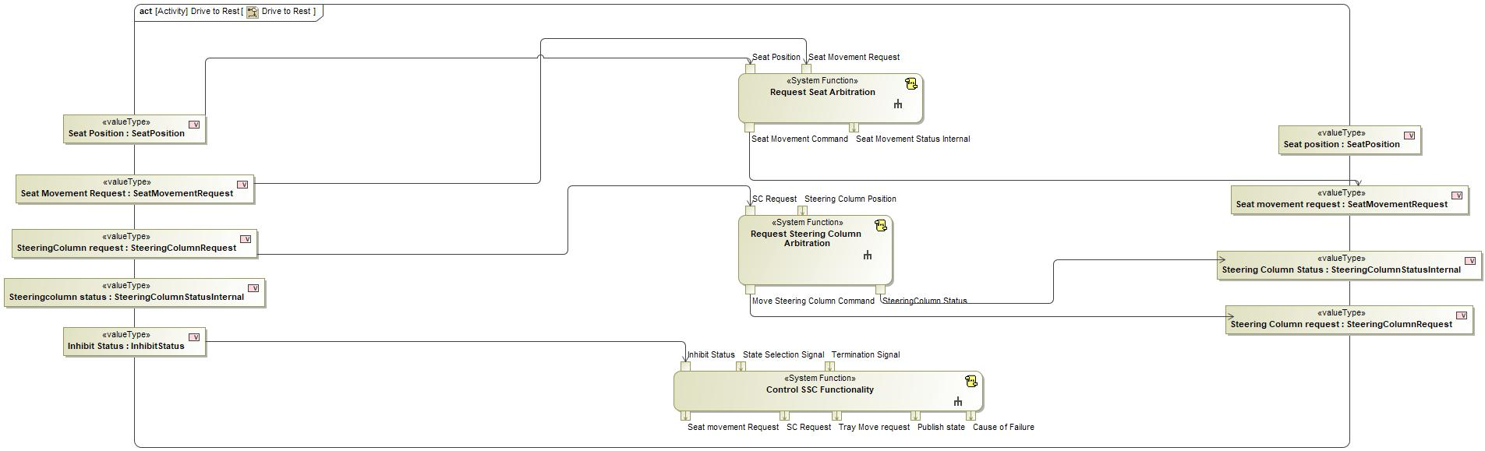
Figure 2: Activity Diagram of “Drive to Rest” calling “Control SSC Functionality”

Figure 2: Activity Diagram of “Make Rest space Available” calling “Control SSC Functionality”

Figure 2: Activity Diagram of “Make Work Space Available” calling “Control SSC Functionality”

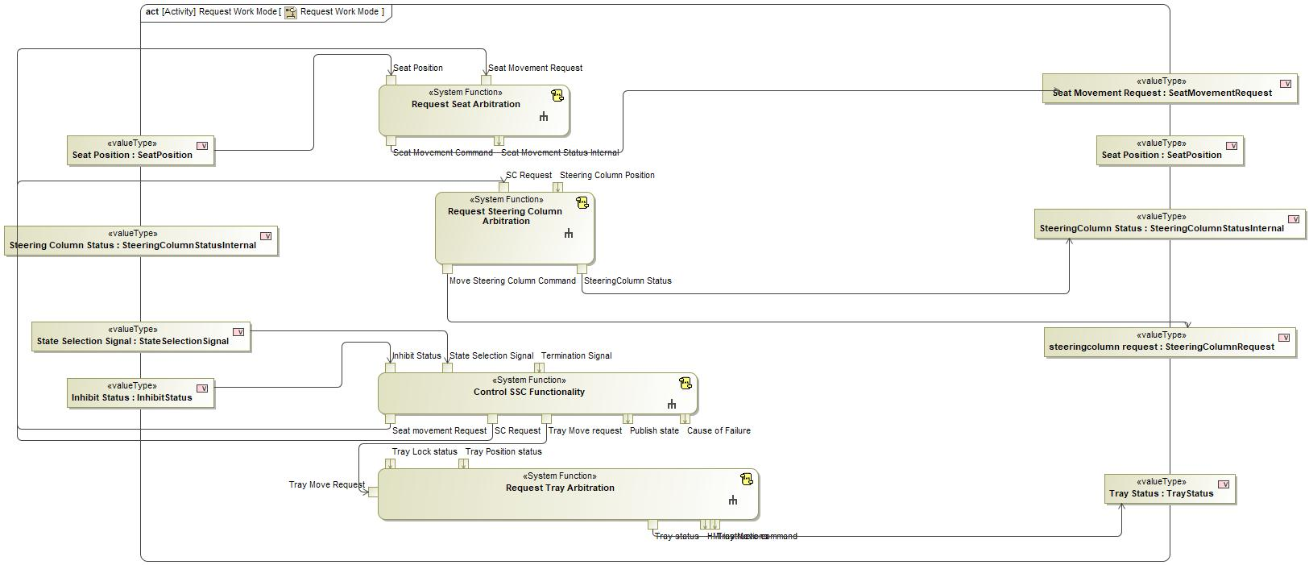
Figure 2: Activity Diagram of “Request Work Mode” calling “Control SSC Functionality”

Function Interfaces

Logical Inputs
Signal Name | Description
Inhibit Status  Type:  InhibitStatus | Signal Description:  Inhibit status of driver control which is verified by the feature systems  Received from:  - Activity Parameter Node: Inhibit Status  - Verify Drive Control Status  - Activity Parameter Node: Inhibit Status
Termination Signal  Type:  Termination Signal | Signal Description:  Logical signal for termination of Mode Arbitration when system did not act according to requests  Received from:  - Check for Transition Termination
State Selection Signal  Type:  StateSelectionSignal | Signal Description:  Signal which contains the Mode that User selected after the Vehicle status is Valid  Received from:  - Activity Parameter Node: state selection signal  - Activity Parameter Node: State Selection Signal  - Activity Parameter Node: State Selection Signal

Logical Outputs
Signal Name | Description
Seat movement Request  Type:  SeatMovementRequest | Signal Description:  Command to Move seat which goes to the Driver seat System  Sent to:  - Request Seat Arbitration
SC Request  Type:  SteeringColumnRequest | Signal Description:  Request to Move steering Column with respect to selected Mode  Sent to:  - Request Steering Column Arbitration
Tray Move request  Type:  TrayMoveRequest | Signal Description:  Internal Request of Feature Controller to Move Tray Table  Sent to:  - Request Tray Arbitration
Cause of Failure  Type:  CauseOfFailure | Signal Description:  Cause for which status is not appropriate in the vehicle to arbitrate the feature mode  Sent to:  - Manage Feature Arbitration Feedback
Publish state  Type:  StateOfFeature | Signal Description:  Current state of Feature and other warnings  Sent to:  - Manage Feature Arbitration Feedback

Logical Parameters

Not supported by MagicDraw report generation.

Function Modeling

Use Cases

Not supported by MagicDraw report generation.

State Charts / Activity Diagrams / Sequence Diagrams / Decision Tables

Figure 3: Control SSC Functionality

Function Requirements

Functional Requirements

Normal Operation

No Normal Operation Requirements specified.

Error Handling

No Error Handling Requirements specified.

Non-Functional Requirements

No Non-Functional Requirements specified.

Functional Safety Requirements

No Functional Safety Requirements specified.

ASIL Decomposition of Functional Safety Requirements

No Functional Safety Requirements with ASIL Decompositions specified.

Other Requirements

Design Requirements

No Design Requirements specified.

Evaluate Drivability status

Function Overview

Description

Function is allocated to:
- Stowable Feature Controller <<Logical>>
- Verify Availability of Drive State <<Logical>>

This function checks all the status ( Tray , Steering Column, Driver seat) before sending a request to enable the drive control( Locomotion and Driver Airbag)

Variants

Not supported by MagicDraw report generation.

Input Requirements

Not supported by MagicDraw report generation.

Assumptions

No assumptions specified for this function.

References

Ford Documents
List here all Ford internal documents, which are directly related to the feature.

Reference | Title | Doc. ID | Revision
Table 5: Ford internal Documents (not specified in model)

External Documents and Publications
The list of external documents could include books, reports and online sources.

Reference | Document / Publication
Table 7: External documents and publications (not specified in model)

Glossary
See Appendix for Definitions and Abbreviations.

Function Scope

The – “Evaluate Drivability status” function is called by the following functions:
- – “Request Drive Control DeInhibition”

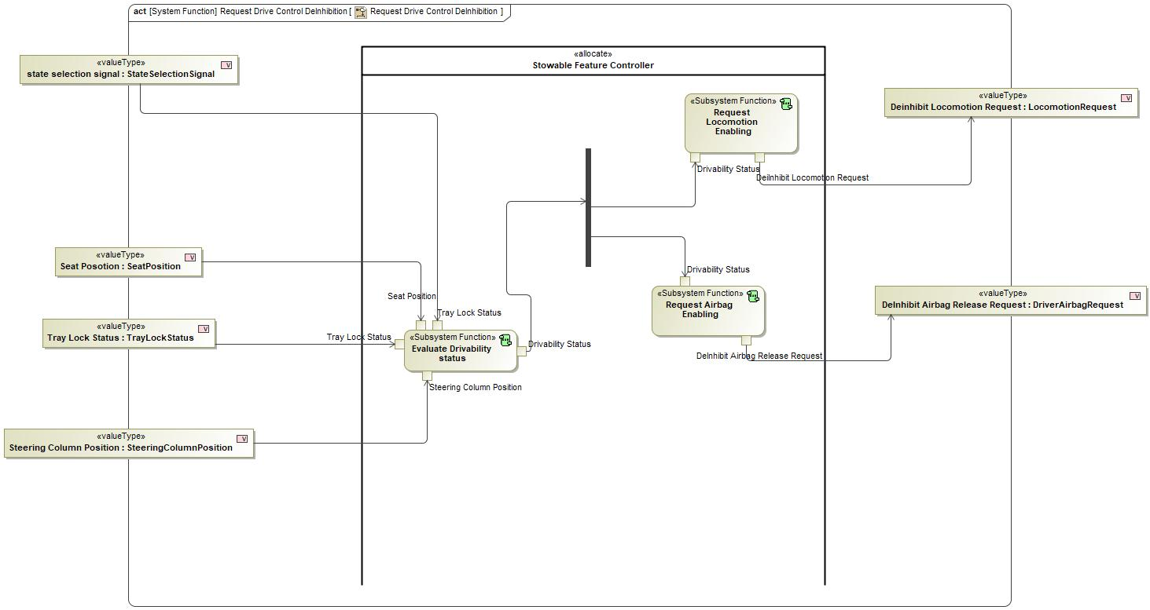
Figure 2: Activity Diagram of “Request Drive Control DeInhibition” calling “Evaluate Drivability status”

Function Interfaces

Logical Inputs
Signal Name | Description
Seat Position  Type:  SeatPosition | Signal Description:  Current Seat Position from the Driver Seat System  Received from:  - Activity Parameter Node: Seat Posotion
Tray Lock Status  Type:  TrayLockStatus | Signal Description:  Tray lock status is given by Tray Lock sensor  Received from:  - Activity Parameter Node: Tray Lock Status
Tray Lock Status  Type:  StateSelectionSignal | Signal Description:  Signal which contains the Mode that User selected after the Vehicle status is Valid  Received from:  - Activity Parameter Node: state selection signal
Steering Column Position  Type:  SteeringColumnPosition | Signal Description:  Position of the Steering Column provided by the steering column system  Received from:  - Activity Parameter Node: Steering Column Position

Logical Outputs
Signal Name | Description
Drivability Status  Type:  Drivability Status | Signal Description:  The logical signal which validates all systems component status and has the calculated the validity to enter into drive mode  Sent to:  - Request Airbag Enabling  - Request Locomotion Enabling

Logical Parameters

Not supported by MagicDraw report generation.

Function Modeling

Use Cases

Not supported by MagicDraw report generation.

State Charts / Activity Diagrams / Sequence Diagrams / Decision Tables

No diagrams internal to function specified.

Function Requirements

Functional Requirements

Normal Operation

Normal Disallow De-Inhibition
The Evaluate Drivability Status function shall set Drivability Status to DON’T_ALLOW_DC_DEINHIBITION when Tray Lock Status is set to NORMAL AND Steering Column Status is set to NORMAL AND Seat Position is NOT set to ERROR AND State Selection Signal is NOT set to STOW

Requirement ID:
Rationale
Acceptance Criteria
Notes
Source |  |  |  |  |  | Owner
Source Req. |  |  |  |  |  | V&V Method
Type |  |  |  | Priority |  | Status
Req. Template Version |  | 6.0 | End of Requirement

Do Not Allow De-Inhibition
The Evaluate Drivability Status function shall set Drivability Status to DON’T_ALLOW_DC_DEINHIBITION when Tray Lock Status is set to ERROR OR Steering Column Status is set to ERROR OR Seat Position is set to ERROR.

Requirement ID:
Rationale
Acceptance Criteria
Notes
Source |  |  |  |  |  | Owner
Source Req. | - Tray Lock Functionality |  |  |  |  | V&V Method
Type |  |  |  | Priority |  | Status
Req. Template Version |  | 6.0 | End of Requirement

Normal De-Inhibit on Stow
The Evaluate Drivability Status function shall set Drivability Status to DON’T_ALLOW_DC_DEINHIBITION when Tray Lock Status is set to NORMAL AND Steering Column Status is set to NORMAL AND Seat Position is NOT set to ERROR AND State Selection Signal is set to STOW

Requirement ID:
Rationale
Acceptance Criteria
Notes
Source |  |  |  |  |  | Owner
Source Req. |  |  |  |  |  | V&V Method
Type |  |  |  | Priority |  | Status
Req. Template Version |  | 6.0 | End of Requirement

Error Handling

No Error Handling Requirements specified.

Non-Functional Requirements

No Non-Functional Requirements specified.

Functional Safety Requirements

No Functional Safety Requirements specified.

ASIL Decomposition of Functional Safety Requirements

No Functional Safety Requirements with ASIL Decompositions specified.

Other Requirements

Design Requirements

No Design Requirements specified.

Issue Termination Signal

Function Overview

Description

Function is allocated to:
- Stowable Feature Controller <<Logical>>

This subsystem function issues Terminate signal based on other status

Variants

Not supported by MagicDraw report generation.

Input Requirements

Not supported by MagicDraw report generation.

Assumptions

No assumptions specified for this function.

References

Ford Documents
List here all Ford internal documents, which are directly related to the feature.

Reference | Title | Doc. ID | Revision
Table 5: Ford internal Documents (not specified in model)

External Documents and Publications
The list of external documents could include books, reports and online sources.

Reference | Document / Publication
Table 7: External documents and publications (not specified in model)

Glossary
See Appendix for Definitions and Abbreviations.

Function Scope

The – “Issue Termination Signal” function is called by the following functions:
- – “Check for Transition Termination”

Figure 2: Activity Diagram of “Check for Transition Termination” calling “Issue Termination Signal”

Function Interfaces

Logical Inputs
Signal Name | Description
Steering Column internal status  Type:  SteeringColumnStatusInternal | Signal Description:  Status of SteeringColumn based on Feature Decisions and current steering Column Position  Received from:  - Activity Parameter Node: SC Status
Tray Status  Type:  TrayStatus | Signal Description:  This status is decided and fed by the Feature systems based on Requests and Input feedbacks fed  Received from:  - Activity Parameter Node: Tray Status
Seat Movement status Internal  Type:  SeatMovementStatusInternal | Signal Description:  Status of the Seat movement according to the current position and external position  Received from:  - Activity Parameter Node: Seat Movement status Internal

Logical Outputs
Signal Name | Description
Termination signal  Type:  Termination Signal | Signal Description:  Logical signal for termination of Mode Arbitration when system did not act according to requests  Sent to:  - Activity Parameter Node: Termination Signal

Logical Parameters

Not supported by MagicDraw report generation.

Function Modeling

Use Cases

Not supported by MagicDraw report generation.

State Charts / Activity Diagrams / Sequence Diagrams / Decision Tables

No diagrams internal to function specified.

Function Requirements

Functional Requirements

Normal Operation

No Normal Operation Requirements specified.

Error Handling

No Error Handling Requirements specified.

Non-Functional Requirements

No Non-Functional Requirements specified.

Functional Safety Requirements

No Functional Safety Requirements specified.

ASIL Decomposition of Functional Safety Requirements

No Functional Safety Requirements with ASIL Decompositions specified.

Other Requirements

Design Requirements

No Design Requirements specified.

provide cause of failure

Function Overview

Description

Function is allocated to:
- Stowable Feature Controller <<Logical>>

Based on Termination signal Information ,the cause of failure is conveyed to the Driver through this function

Variants

Not supported by MagicDraw report generation.

Input Requirements

Not supported by MagicDraw report generation.

Assumptions

No assumptions specified for this function.

References

Ford Documents
List here all Ford internal documents, which are directly related to the feature.

Reference | Title | Doc. ID | Revision
Table 5: Ford internal Documents (not specified in model)

External Documents and Publications
The list of external documents could include books, reports and online sources.

Reference | Document / Publication
Table 7: External documents and publications (not specified in model)

Glossary
See Appendix for Definitions and Abbreviations.

Function Scope

The – “provide cause of failure” function is called by the following functions:
- – “Control SSC Functionality”

Figure 2: Activity Diagram of “Control SSC Functionality” calling “provide cause of failure”

Function Interfaces

Logical Inputs
Signal Name | Description
Termination signal  Type:  Termination Signal | Signal Description:  Logical signal for termination of Mode Arbitration when system did not act according to requests  Received from:  - Activity Parameter Node: Termination Signal

Logical Outputs
Signal Name | Description
cause of failure  Type:  CauseOfFailure | Signal Description:  Cause for which status is not appropriate in the vehicle to arbitrate the feature mode  Sent to:  - Activity Parameter Node: Cause of Failure

Logical Parameters

Not supported by MagicDraw report generation.

Function Modeling

Use Cases

Not supported by MagicDraw report generation.

State Charts / Activity Diagrams / Sequence Diagrams / Decision Tables

No diagrams internal to function specified.

Function Requirements

Functional Requirements

Normal Operation

No Normal Operation Requirements specified.

Error Handling

No Error Handling Requirements specified.

Non-Functional Requirements

No Non-Functional Requirements specified.

Functional Safety Requirements

No Functional Safety Requirements specified.

ASIL Decomposition of Functional Safety Requirements

No Functional Safety Requirements with ASIL Decompositions specified.

Other Requirements

Design Requirements

No Design Requirements specified.

Provide HMI Feedback

Function Overview

Description

Function is allocated to:
- Indicate Reason Of State Unavailability <<Logical>>
- Notify User to Low Sli SOC <<Logical>>
- Stowable Feature Controller <<Logical>>

This Function Checks the Vehicle Validity and state selection signal and provide User his selected Mode and Vehicle status Validity

Variants

Not supported by MagicDraw report generation.

Input Requirements

Not supported by MagicDraw report generation.

Assumptions

No assumptions specified for this function.

References

Ford Documents
List here all Ford internal documents, which are directly related to the feature.

Reference | Title | Doc. ID | Revision
Table 5: Ford internal Documents (not specified in model)

External Documents and Publications
The list of external documents could include books, reports and online sources.

Reference | Document / Publication
Table 7: External documents and publications (not specified in model)

Glossary
See Appendix for Definitions and Abbreviations.

Function Scope

The – “Provide HMI Feedback” function is called by the following functions:
- – “Verify Feature Status”

Figure 2: Activity Diagram of “Verify Feature Status” calling “Provide HMI Feedback”

Function Interfaces

Logical Inputs
Signal Name | Description
Unavailabality  Type:  ModeAcceptenceStatus | Signal Description:  This signal contains the information whats not available in the vehicle configuration  Received from:  - Check Feature Availability

Logical Outputs
Signal Name | Description
HMI Feedback  Type:  HMIFeedback | Signal Description:  Feedback given to HMI  Sent to:  - Activity Parameter Node: HMI Feedback

Logical Parameters

Not supported by MagicDraw report generation.

Function Modeling

Use Cases

Not supported by MagicDraw report generation.

State Charts / Activity Diagrams / Sequence Diagrams / Decision Tables

No diagrams internal to function specified.

Function Requirements

Functional Requirements

Normal Operation

Provide HMI Feedback function HMI Feedback Message
The Provide HMI Feedback Function shall set HMI_Feedback to VEHICLE_STATUS_MESSAGE when Vehicle Status Validity is set to VALID

Requirement ID:
Rationale
Acceptance Criteria
Notes
Source |  |  |  |  |  | Owner
Source Req. |  |  |  |  |  | V&V Method
Type |  |  |  | Priority |  | Status
Req. Template Version |  | 6.0 | End of Requirement

Provide HMI Feedback function HMI Feedback Definition
The Provide HMI Feedback Function HMI Feedback shall indicate by an HMI message that the Stowable Steering Column and Deployable Tray feature is availavle when HMI Feedback is set to VEHICLE_STATUS_MESSAGE and shall produce no HMI message when it is NO_VEHICLE_STATUS_MESSAGE

Requirement ID:
Rationale
Acceptance Criteria
Notes
Source |  |  |  |  |  | Owner
Source Req. |  |  |  |  |  | V&V Method
Type |  |  |  | Priority |  | Status
Req. Template Version |  | 6.0 | End of Requirement

NO_VEHICLE_STATUS_MESSAGE
The Provide HMI Feedback Function shall set HMI_Feedback to NO_VEHICLE_STATUS_MESSAGE when Vehicle Status Validity is set to INVALID

Requirement ID:
Rationale
Acceptance Criteria
Notes
Source |  |  |  |  |  | Owner
Source Req. |  |  |  |  |  | V&V Method
Type |  |  |  | Priority |  | Status
Req. Template Version |  | 6.0 | End of Requirement

Error Handling

No Error Handling Requirements specified.

Non-Functional Requirements

No Non-Functional Requirements specified.

Functional Safety Requirements

No Functional Safety Requirements specified.

ASIL Decomposition of Functional Safety Requirements

No Functional Safety Requirements with ASIL Decompositions specified.

Other Requirements

Design Requirements

No Design Requirements specified.

Provide Tray Stow Instructions

Function Overview

Description

Function is allocated to:
- Command Tray Table Stow <<Logical>>
- Stowable Feature Controller <<Logical>>

A subsystem Function which provides instructions to HMI when User requests stow or to exit work mode

Variants

Not supported by MagicDraw report generation.

Input Requirements

Not supported by MagicDraw report generation.

Assumptions

No assumptions specified for this function.

References

Ford Documents
List here all Ford internal documents, which are directly related to the feature.

Reference | Title | Doc. ID | Revision
Table 5: Ford internal Documents (not specified in model)

External Documents and Publications
The list of external documents could include books, reports and online sources.

Reference | Document / Publication
Table 7: External documents and publications (not specified in model)

Glossary
See Appendix for Definitions and Abbreviations.

Function Scope

The – “Provide Tray Stow Instructions” function is called by the following functions:
- – “Request Tray Arbitration”

Figure 2: Activity Diagram of “Request Tray Arbitration” calling “Provide Tray Stow Instructions”

Function Interfaces

Logical Inputs
Signal Name | Description
Provide HMI Instructions  Type:  HMIInsWar | Signal Description:  HMI Instructions to Stow and Warning display if Tray is not pushed in properly  Received from:  - Check Tray Status

Logical Outputs
Signal Name | Description
HMI instructions and warning  Type:  HMIInsWar | Signal Description:  HMI Instructions to Stow and Warning display if Tray is not pushed in properly  Sent to:  - Activity Parameter Node: HMI instructions

Logical Parameters

Not supported by MagicDraw report generation.

Function Modeling

Use Cases

Not supported by MagicDraw report generation.

State Charts / Activity Diagrams / Sequence Diagrams / Decision Tables

No diagrams internal to function specified.

Function Requirements

Functional Requirements

Normal Operation

Request Tray Stowing function Tray Status Deploying Case One
The Request Tray Deployment function Shall Set Tray Status to TRAY_DEPLOYING when State Selection Signal is set to NOT_DRIVE AND Tray Table Position is set to STOWED AND Tray Obstruction Status is set to NO_OBSTACLE_DETECTED

Requirement ID:
Rationale
Acceptance Criteria
Notes
Source |  |  |  |  |  | Owner
Source Req. | - Request Tray Arbitration |  |  |  |  | V&V Method
Type |  |  |  | Priority |  | Status
Req. Template Version |  | 6.0 | End of Requirement

Request Tray Stowing function Tray Status Stowing Case One
The Request Tray Stowing function Shall Set Tray Status to TRAY_STOWING when State Selection Signal is set to DRIVE AND Tray Table Position is set to DEPLOYED AND Tray Obstruction Status is set to NO_OBSTACLE_DETECTED

Requirement ID:
Rationale
Acceptance Criteria
Notes
Source |  |  |  |  |  | Owner
Source Req. | - Request Tray Arbitration |  |  |  |  | V&V Method
Type |  |  |  | Priority |  | Status
Req. Template Version |  | 6.0 | End of Requirement

Request Tray Stowing function Tray Status Deployed
The Request Tray Deployment function Shall Set Tray Status to TRAY_DEPLOYED when State Selection Signal is set to NOT_DRIVE AND Tray Table Position is set to DEPLOYED

Requirement ID:
Rationale
Acceptance Criteria
Notes
Source |  |  |  |  |  | Owner
Source Req. | - Request Tray Arbitration |  |  |  |  | V&V Method
Type |  |  |  | Priority |  | Status
Req. Template Version |  | 6.0 | End of Requirement

Request Tray Stowing function Tray Status Failed To Deploy Case Two
The Request Tray Deployment function Shall Set Tray Status to TRAY_DEPLOYING when State Selection Signal is set to NOT_ DRIVE AND Tray Table Position is set to IN_MOTION AND Tray Obstruction Status is set to NO_OBSTACLE_DETECTED

Requirement ID:
Rationale
Acceptance Criteria
Notes
Source |  |  |  |  |  | Owner
Source Req. | - Request Tray Arbitration |  |  |  |  | V&V Method
Type |  |  |  | Priority |  | Status
Req. Template Version |  | 6.0 | End of Requirement

Request Tray Stowing function Stow Tray Command Halt Due to Obstacle Detection
The Request Tray Stowing function Shall Set Stow Tray Command to NONE when Tray Obstruction Status NOT set to NO_OBSTACLE_DETECTED

Requirement ID:
Rationale
Acceptance Criteria
Notes
Source |  |  |  |  |  | Owner
Source Req. | - Request Tray Arbitration |  |  |  |  | V&V Method
Type |  |  |  | Priority |  | Status
Req. Template Version |  | 6.0 | End of Requirement

Request Tray Stowing Function Stow Tray Command Normal Start of Stowing
The Request Tray Stowing function Shall Set Stow Tray Command is STOW when State Selection Signal is set to DRIVE AND Tray Table Position is set to DEPLOYED AND Tray Obstruction Status is set to NO_OBSTACLE_DETECTED

Requirement ID:
Rationale
Acceptance Criteria
Notes
Source |  |  |  |  |  | Owner
Source Req. | - Request Tray Arbitration |  |  |  |  | V&V Method
Type |  |  |  | Priority |  | Status
Req. Template Version |  | 6.0 | End of Requirement

Request Tray Stowing function Stow Tray Command Normal Progress of Stowing
The Request Tray Stowing function Shall Set Stow Tray Command is set to STOW when State Selection Signal is set to DRIVE AND Tray Table Position is set to IN_MOTION AND Tray Obstruction Status is set to NO_OBSTACLE_DETECTED

Requirement ID:
Rationale
Acceptance Criteria
Notes
Source |  |  |  |  |  | Owner
Source Req. | - Request Tray Arbitration |  |  |  |  | V&V Method
Type |  |  |  | Priority |  | Status
Req. Template Version |  | 6.0 | End of Requirement

Request Tray Stowing function Tray Status Failed To Deploy Case One
The Request Tray Deployment function Shall Set Tray Status to TRAY_FAILED_TO_DEPLOY when State Selection Signal is set to NOT_DRIVE AND Tray Table Position NOT set to DEPLOYED AND Tray Obstruction Status NOT set to NO_OBSTACLE_DETECTED

Requirement ID:
Rationale
Acceptance Criteria
Notes
Source |  |  |  |  |  | Owner
Source Req. | - Request Tray Arbitration |  |  |  |  | V&V Method
Type |  |  |  | Priority |  | Status
Req. Template Version |  | 6.0 | End of Requirement

Request Tray Stowing function Tray Status Failed To Stow Case One
The Request Tray Stowing function Shall Set Tray Status to TRAY_FAILED_TO_STOW when State Selection Signal is set to DRIVE AND Tray Table Position NOT set to STOWED AND Tray Obstruction Status NOT set to NO_OBSTACLE_DETECTED

Requirement ID:
Rationale
Acceptance Criteria
Notes
Source |  |  |  |  |  | Owner
Source Req. | - Request Tray Arbitration |  |  |  |  | V&V Method
Type |  |  |  | Priority |  | Status
Req. Template Version |  | 6.0 | End of Requirement

Request Tray Stowing function Tray Status Stowed
The Request Tray Stowing function Shall Set Tray Status to TRAY_STOWED when State Selection Signal is set to DRIVE and Tray Table Position is set to STOWED

Requirement ID:
Rationale
Acceptance Criteria
Notes
Source |  |  |  |  |  | Owner
Source Req. | - Request Tray Arbitration |  |  |  |  | V&V Method
Type |  |  |  | Priority |  | Status
Req. Template Version |  | 6.0 | End of Requirement

Request Tray Stowing function Stow Tray Command Successful Completion of Drive Request
The Request Tray Stowing function Shall Set Stow Tray Command to NONE when Tray Table Position is set to STOWED AND Tray Obstruction Status is set to NO_OBSTACLE_DETECTED

Requirement ID:
Rationale
Acceptance Criteria
Notes
Source |  |  |  |  |  | Owner
Source Req. | - Request Tray Arbitration |  |  |  |  | V&V Method
Type |  |  |  | Priority |  | Status
Req. Template Version |  | 6.0 | End of Requirement

Request Tray Stowing function Tray Status Failed To Stow Case Two
The Request Tray Stowing function Shall Set Tray Status to TRAY_STOWING when State Selection Signal is set to DRIVE AND Tray Table Position is set to IN_MOTION AND Tray Obstruction Status is set to NO_OBSTACLE_DETECTED

Requirement ID:
Rationale
Acceptance Criteria
Notes
Source |  |  |  |  |  | Owner
Source Req. | - Request Tray Arbitration |  |  |  |  | V&V Method
Type |  |  |  | Priority |  | Status
Req. Template Version |  | 6.0 | End of Requirement

Request Tray Stowing function Tray Status Stowed Definition
The Request Tray Stowing function Tray Status Stowed Output shall indicate Tray DEPLOYED, FAILED_TO_DEPLOY, STOWED, FAILED_TO_STOW, DEPLOYING and STOWING

Requirement ID:
Rationale
Acceptance Criteria
Notes
Source |  |  |  |  |  | Owner
Source Req. | - Request Tray Arbitration |  |  |  |  | V&V Method
Type |  |  |  | Priority |  | Status
Req. Template Version |  | 6.0 | End of Requirement

Error Handling

No Error Handling Requirements specified.

Non-Functional Requirements

No Non-Functional Requirements specified.

Functional Safety Requirements

No Functional Safety Requirements specified.

ASIL Decomposition of Functional Safety Requirements

No Functional Safety Requirements with ASIL Decompositions specified.

Other Requirements

Design Requirements

No Design Requirements specified.

Request Airbag Disabling

Function Overview

Description

Function is allocated to:
- Request Airbag Inhibit Release <<Logical>>
- Stowable Feature Controller <<Logical>>

Depending upon State Selection Signal this function sends a request to Inhibit Airbag

Variants

Not supported by MagicDraw report generation.

Input Requirements

Not supported by MagicDraw report generation.

Assumptions

No assumptions specified for this function.

References

Ford Documents
List here all Ford internal documents, which are directly related to the feature.

Reference | Title | Doc. ID | Revision
Table 5: Ford internal Documents (not specified in model)

External Documents and Publications
The list of external documents could include books, reports and online sources.

Reference | Document / Publication
Table 7: External documents and publications (not specified in model)

Glossary
See Appendix for Definitions and Abbreviations.

Function Scope

The – “Request Airbag Disabling” function is called by the following functions:
- – “Request Drive Control Inhibition”

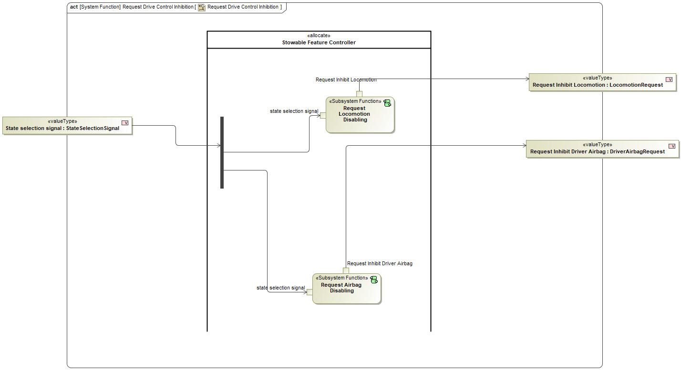
Figure 2: Activity Diagram of “Request Drive Control Inhibition” calling “Request Airbag Disabling”

Function Interfaces

Logical Inputs
Signal Name | Description
state selection signal  Type:  StateSelectionSignal | Signal Description:  Signal which contains the Mode that User selected after the Vehicle status is Valid  Received from:  - Activity Parameter Node: State selection signal

Logical Outputs
Signal Name | Description
Request Inhibit Driver Airbag  Type:  DriverAirbagRequest | Signal Description:  Request sent to the Driver Airbag system / Passive Restraint System for either Inhibit or Deinhibit  Sent to:  - Activity Parameter Node: Inhibit Driver Airbag

Logical Parameters

Not supported by MagicDraw report generation.

Function Modeling

Use Cases

Not supported by MagicDraw report generation.

State Charts / Activity Diagrams / Sequence Diagrams / Decision Tables

No diagrams internal to function specified.

Function Requirements

Functional Requirements

Normal Operation

Request Driver_Airbag Disabling De-Inhibit
The Request DRIVER_AIRBAG Disabling function shall set Request Inhibit DRIVER_AIRBAG to DEINHIBIT_DRIVER_AIRBAG_REQUEST when State Selection Signal is set to DRIVE.

Requirement ID:
Rationale
Acceptance Criteria
Notes
Source |  |  |  |  |  | Owner
Source Req. | - Provide Airbag Inhibit/ DeInhibit Functionality |  |  |  |  | V&V Method
Type |  |  |  | Priority |  | Status
Req. Template Version |  | 6.0 | End of Requirement

The Request Driver_Airbag Disabling function Request Inhibit Driver_Airbag Definition
The Request DRIVER_AIRBAG Disabling function shall set the Request Inhibit DRIVER_AIRBAG to INHIBIT_DRIVER_AIRBAG_REQUEST, DEINHIBIT_DRIVER_AIRBAG_REQUEST

Requirement ID:
Rationale
Acceptance Criteria
Notes
Source |  |  |  |  |  | Owner
Source Req. | - Provide Airbag Inhibit/ DeInhibit Functionality |  |  |  |  | V&V Method
Type |  |  |  | Priority |  | Status
Req. Template Version |  | 6.0 | End of Requirement

Request Driver_Airbag Disabling Inhibit
The Request DRIVER_AIRBAG Disabling function shall set Request Inhibit DRIVER_AIRBAG to INHIBIT_DRIVER_AIRBAG_REQUEST when State Selection Signal is NOT set to DRIVE.

Requirement ID:
Rationale
Acceptance Criteria
Notes
Source |  |  |  |  |  | Owner
Source Req. | - Provide Airbag Inhibit/ DeInhibit Functionality |  |  |  |  | V&V Method
Type |  |  |  | Priority |  | Status
Req. Template Version |  | 6.0 | End of Requirement

Request Driver_Airbag Enabling Inhibit
The Request DRIVER_AIRBAG Disabling function shall set Request Inhibit DRIVER_AIRBAG to INHIBIT_DRIVER_AIRBAG_REQUEST when State Selection Signal is NOT set to DRIVE.

Requirement ID:
Rationale
Acceptance Criteria
Notes
Source |  |  |  |  |  | Owner
Source Req. | - Provide Airbag Inhibit/ DeInhibit Functionality |  |  |  |  | V&V Method
Type |  |  |  | Priority |  | Status
Req. Template Version |  | 6.0 | End of Requirement

Error Handling

No Error Handling Requirements specified.

Non-Functional Requirements

No Non-Functional Requirements specified.

Functional Safety Requirements

No Functional Safety Requirements specified.

ASIL Decomposition of Functional Safety Requirements

No Functional Safety Requirements with ASIL Decompositions specified.

Other Requirements

Design Requirements

No Design Requirements specified.

Request Airbag Enabling

Function Overview

Description

Function is allocated to:
- Request Driver Airbag DisInhibit <<Logical>>
- Stowable Feature Controller <<Logical>>

Depending upon State Selection Signal this function sends a request to DeInhibit Airbag

Variants

Not supported by MagicDraw report generation.

Input Requirements

Not supported by MagicDraw report generation.

Assumptions

No assumptions specified for this function.

References

Ford Documents
List here all Ford internal documents, which are directly related to the feature.

Reference | Title | Doc. ID | Revision
Table 5: Ford internal Documents (not specified in model)

External Documents and Publications
The list of external documents could include books, reports and online sources.

Reference | Document / Publication
Table 7: External documents and publications (not specified in model)

Glossary
See Appendix for Definitions and Abbreviations.

Function Scope

The – “Request Airbag Enabling” function is called by the following functions:
- – “Request Drive Control DeInhibition”

Figure 2: Activity Diagram of “Request Drive Control DeInhibition” calling “Request Airbag Enabling”

Function Interfaces

Logical Inputs
Signal Name | Description
Drivability Status  Type:  Drivability Status | Signal Description:  The logical signal which validates all systems component status and has the calculated the validity to enter into drive mode  Received from:  - Evaluate Drivability status

Logical Outputs
Signal Name | Description
DeInhibit Airbag Release Request  Type:  DriverAirbagRequest | Signal Description:  Request sent to the Driver Airbag system / Passive Restraint System for either Inhibit or Deinhibit  Sent to:  - Activity Parameter Node: DeInhibit Airbag Release Request

Logical Parameters

Not supported by MagicDraw report generation.

Function Modeling

Use Cases

Not supported by MagicDraw report generation.

State Charts / Activity Diagrams / Sequence Diagrams / Decision Tables

No diagrams internal to function specified.

Function Requirements

Functional Requirements

Normal Operation

The Request Driver_Airbag Enabling function Request Inhibit Driver_Airbag Definition
The Request DRIVER_AIRBAG Enabling function shall set the Request Inhibit DRIVER_AIRBAG to INHIBIT_DRIVER_AIRBAG_REQUEST, DEINHIBIT_DRIVER_AIRBAG_REQUEST

Requirement ID:
Rationale
Acceptance Criteria
Notes
Source |  |  |  |  |  | Owner
Source Req. | - Provide Airbag Inhibit/ DeInhibit Functionality |  |  |  |  | V&V Method
Type |  |  |  | Priority |  | Status
Req. Template Version |  | 6.0 | End of Requirement

Request Driver_Airbag Enabling De-Inhibit
The Request DRIVER_AIRBAG Enabling function shall set Request Inhibit DRIVER_AIRBAG to DEINHIBIT_DRIVER_AIRBAG_REQUEST when State Selection Signal is set to DRIVE.

Requirement ID:
Rationale
Acceptance Criteria
Notes
Source |  |  |  |  |  | Owner
Source Req. | - Provide Airbag Inhibit/ DeInhibit Functionality |  |  |  |  | V&V Method
Type |  |  |  | Priority |  | Status
Req. Template Version |  | 6.0 | End of Requirement

Error Handling

No Error Handling Requirements specified.

Non-Functional Requirements

No Non-Functional Requirements specified.

Functional Safety Requirements

No Functional Safety Requirements specified.

ASIL Decomposition of Functional Safety Requirements

No Functional Safety Requirements with ASIL Decompositions specified.

Other Requirements

Design Requirements

No Design Requirements specified.

Request Drive Control DeInhibition

Function Overview

Description

Function is allocated to:
- Stowable Steering and Deployable Tray System <<Logical>>

Depending upon State Selection Signal this function sends a request to DeInhibit Drive Control

Variants

Not supported by MagicDraw report generation.

Input Requirements

Not supported by MagicDraw report generation.

Assumptions

No assumptions specified for this function.

References

Ford Documents
List here all Ford internal documents, which are directly related to the feature.

Reference | Title | Doc. ID | Revision
Table 5: Ford internal Documents (not specified in model)

External Documents and Publications
The list of external documents could include books, reports and online sources.

Reference | Document / Publication
Table 7: External documents and publications (not specified in model)

Glossary
See Appendix for Definitions and Abbreviations.

Function Scope

The – “Request Drive Control DeInhibition” function is called by the following functions:
- – “Make Rest space Available”
- – “Make Work Space Available”
- – “Request Drive Control Arbitration”
- – “Request Drive Control DeInhibition”
- – “Request Drive Control DeInhibition”
- – “Request Drive Control DeInhibition”
- – “Request Drive Control DeInhibition”

Figure 2: Activity Diagram of “Make Rest space Available” calling “Request Drive Control DeInhibition”

Figure 2: Activity Diagram of “Make Work Space Available” calling “Request Drive Control DeInhibition”

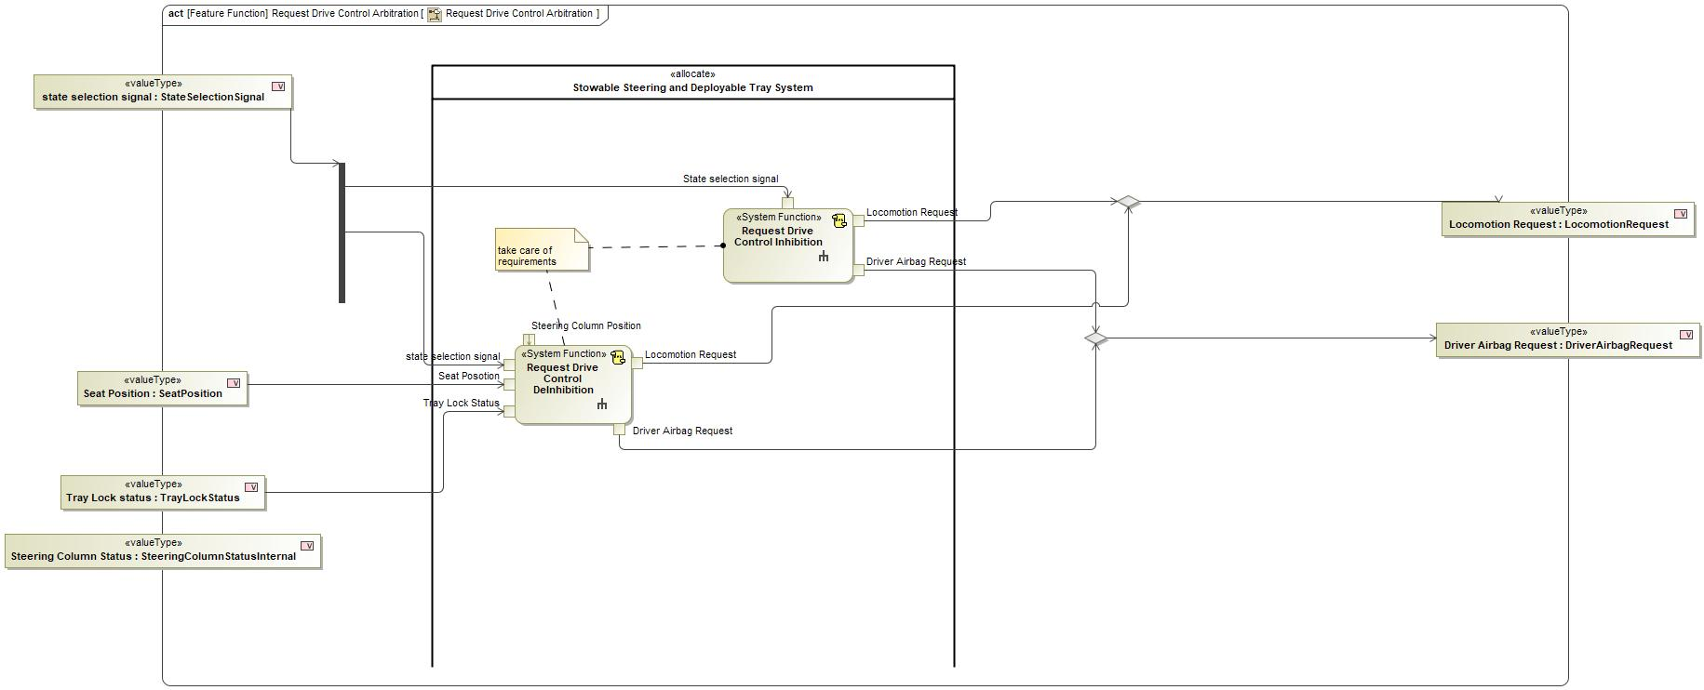
Figure 2: Activity Diagram of “Request Drive Control Arbitration” calling “Request Drive Control DeInhibition”

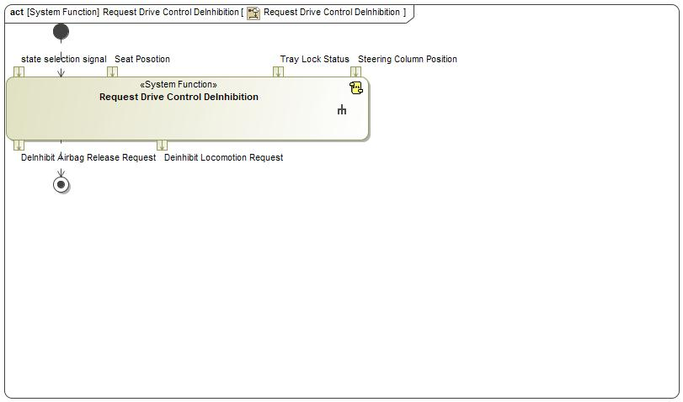
Figure 2: Activity Diagram of “Request Drive Control DeInhibition” calling “Request Drive Control DeInhibition”

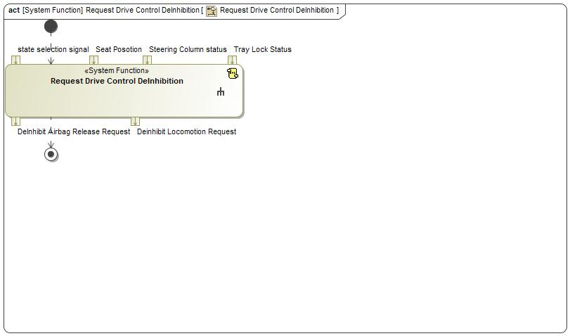
Figure 2: Activity Diagram of “Request Drive Control DeInhibition” calling “Request Drive Control DeInhibition”

Figure 2: Activity Diagram of “Request Drive Control DeInhibition” calling “Request Drive Control DeInhibition”

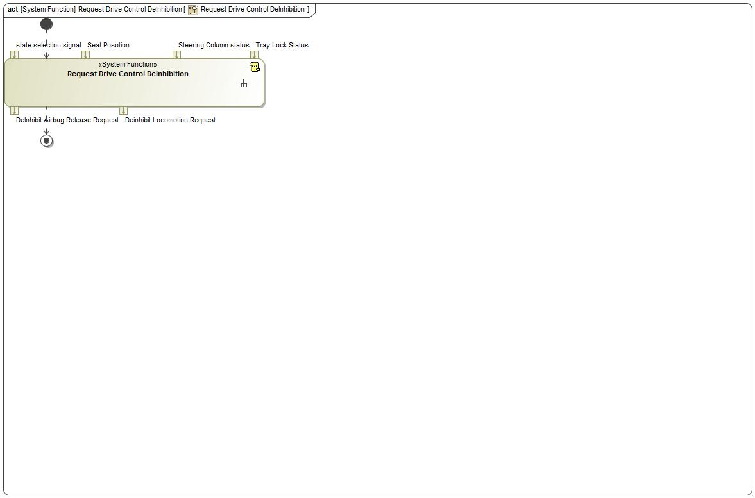
Figure 2: Activity Diagram of “Request Drive Control DeInhibition” calling “Request Drive Control DeInhibition”

Function Interfaces

Logical Inputs
Signal Name | Description
state selection signal  Type:  StateSelectionSignal | Signal Description:  Signal which contains the Mode that User selected after the Vehicle status is Valid  Received from:  - Activity Parameter Node: state selection signal  - Activity Parameter Node: State Selection Signal  - Activity Parameter Node: state selection signal
Tray Lock Status  Type:  TrayLockStatus | Signal Description:  Tray lock status is given by Tray Lock sensor  Received from:  - Activity Parameter Node: Tray Lock status  - Actuate Tray
Seat Posotion  Type:  SeatPosition | Signal Description:  Current Seat Position from the Driver Seat System  Received from:  - Activity Parameter Node: Seat Position  - Activity Parameter Node: Seat Position  - Activity Parameter Node: Seat Position
Steering Column Position  Type:  SteeringColumnPosition | Signal Description:  Position of the Steering Column provided by the steering column system  Received from:  - Activity Parameter Node: Steering Column Position  - Activity Parameter Node: Steering Column Tele position

Logical Outputs
Signal Name | Description
DeInhibit Airbag Release Request  Type:  DriverAirbagRequest | Signal Description:  Request sent to the Driver Airbag system / Passive Restraint System for either Inhibit or Deinhibit  Sent to:  - Activity Parameter Node: Driver Airbag Request  - Activity Parameter Node: Driver Airbag Request  - Activity Parameter Node: Driver Airbag Request
Deinhibit Locomotion Request  Type:  LocomotionRequest | Signal Description:  Request to Powertrain / Locomotion to Inhibit /Deinhibit  Sent to:  - Activity Parameter Node: Locomotion Request  - Activity Parameter Node: Locomotion Request  - Activity Parameter Node: Locomotion Request

Logical Parameters

Not supported by MagicDraw report generation.

Function Modeling

Use Cases

Not supported by MagicDraw report generation.

State Charts / Activity Diagrams / Sequence Diagrams / Decision Tables

Figure 3: Request Drive Control DeInhibition

Function Requirements

Functional Requirements

Normal Operation

No Normal Operation Requirements specified.

Error Handling

No Error Handling Requirements specified.

Non-Functional Requirements

Request Drive Control DeInhition
When Request Drive Control DeInhibition function receives StateSelectionSignal = DRIVE, it shall verify SeatPosition= AT_DRIVE , TrayStatus= LOCKED , SteeringColumnStatus= Deployed and then set
LocomotionRequest=DEINHIBIT_LOCOMOTION_REQUEST
DriverAirbagRequest=DEINHIBIT_DRIVER_AIRBAG_REQUEST

Requirement ID:
Rationale
Acceptance Criteria
Notes
Source |  |  |  |  |  | Owner
Source Req. |  |  |  |  |  | V&V Method
Type |  |  |  | Priority |  | Status
Req. Template Version |  | 6.0 | End of Requirement

Functional Safety Requirements

No Functional Safety Requirements specified.

ASIL Decomposition of Functional Safety Requirements

No Functional Safety Requirements with ASIL Decompositions specified.

Other Requirements

Design Requirements

No Design Requirements specified.

Request Drive Control Inhibition

Function Overview

Description

Function is allocated to:
- Stowable Steering and Deployable Tray System <<Logical>>

Depending upon State Selection Signal this function sends a request to Inhibit Drive Control

Variants

Not supported by MagicDraw report generation.

Input Requirements

Not supported by MagicDraw report generation.

Assumptions

No assumptions specified for this function.

References

Ford Documents
List here all Ford internal documents, which are directly related to the feature.

Reference | Title | Doc. ID | Revision
Table 5: Ford internal Documents (not specified in model)

External Documents and Publications
The list of external documents could include books, reports and online sources.

Reference | Document / Publication
Table 7: External documents and publications (not specified in model)

Glossary
See Appendix for Definitions and Abbreviations.

Function Scope

The – “Request Drive Control Inhibition” function is called by the following functions:
- – “Inhibit and Verify Drive Control”
- – “Make Rest space Available”
- – “Make Work Space Available”
- – “Request Drive Control Arbitration”
- – “Request Drive Control Inhibition”

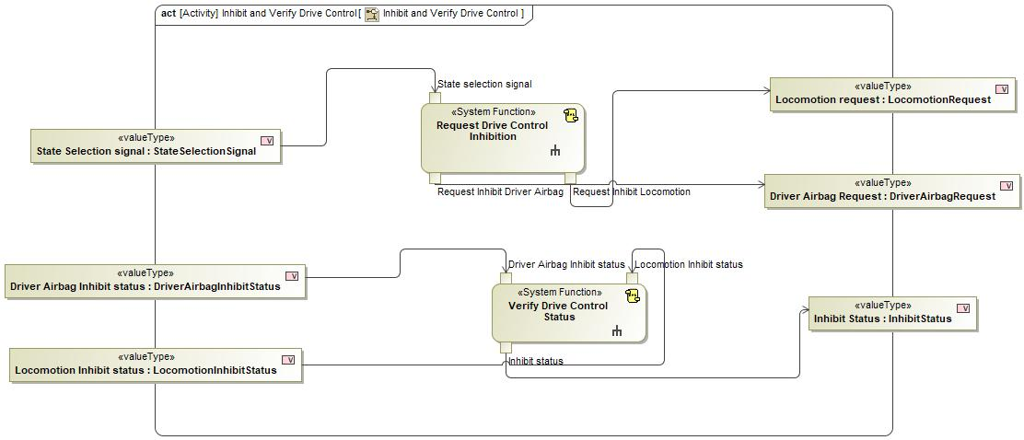
Figure 2: Activity Diagram of “Inhibit and Verify Drive Control” calling “Request Drive Control Inhibition”

Figure 2: Activity Diagram of “Make Rest space Available” calling “Request Drive Control Inhibition”

Figure 2: Activity Diagram of “Make Work Space Available” calling “Request Drive Control Inhibition”

Figure 2: Activity Diagram of “Request Drive Control Arbitration” calling “Request Drive Control Inhibition”

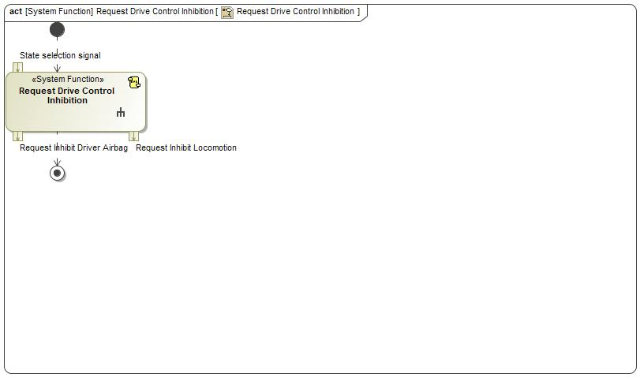
Figure 2: Activity Diagram of “Request Drive Control Inhibition” calling “Request Drive Control Inhibition”

Function Interfaces

Logical Inputs
Signal Name | Description
State selection signal  Type:  StateSelectionSignal | Signal Description:  Signal which contains the Mode that User selected after the Vehicle status is Valid  Received from:  - Activity Parameter Node: state selection signal  - Activity Parameter Node: State Selection signal  - Activity Parameter Node: State Selection Signal  - Activity Parameter Node: state selection signal

Logical Outputs
Signal Name | Description
Request Inhibit Locomotion  Type:  LocomotionRequest | Signal Description:  Request to Powertrain / Locomotion to Inhibit /Deinhibit  Sent to:  - Activity Parameter Node: Locomotion request  - Activity Parameter Node: Locomotion Request  - Activity Parameter Node: Locomotion Request  - Activity Parameter Node: Locomotion Request
Request Inhibit Driver Airbag  Type:  DriverAirbagRequest | Signal Description:  Request sent to the Driver Airbag system / Passive Restraint System for either Inhibit or Deinhibit  Sent to:  - Activity Parameter Node: Driver Airbag Request  - Activity Parameter Node: Driver Airbag Request  - Activity Parameter Node: Driver Airbag Request  - Activity Parameter Node: Driver Airbag Request

Logical Parameters

Not supported by MagicDraw report generation.

Function Modeling

Use Cases

Not supported by MagicDraw report generation.

State Charts / Activity Diagrams / Sequence Diagrams / Decision Tables

Figure 3: Request Drive Control Inhibition

Function Requirements

Functional Requirements

Normal Operation

No Normal Operation Requirements specified.

Error Handling

No Error Handling Requirements specified.

Non-Functional Requirements

Request Drive Control Inhibition
When Request Drive Control Inhibition function receives StateSelectionSignal = WORK
or StateSelectionSignal = REST or StateSelectionSignal = PLAY, it shall set LocomotionRequest=INHIBIT_LOCOMOTION_REQUEST
DriverAirbagRequest=INHIBIT_DRIVER_AIRBAG_REQUEST

Requirement ID:
Rationale
Acceptance Criteria
Notes
Source |  |  |  |  |  | Owner
Source Req. |  |  |  |  |  | V&V Method
Type |  |  |  | Priority |  | Status
Req. Template Version |  | 6.0 | End of Requirement

Functional Safety Requirements

No Functional Safety Requirements specified.

ASIL Decomposition of Functional Safety Requirements

No Functional Safety Requirements with ASIL Decompositions specified.

Other Requirements

Design Requirements

No Design Requirements specified.

Request Locomotion Disabling

Function Overview

Description

Function is allocated to:
- Request Locomotion Inhibit <<Logical>>
- Stowable Feature Controller <<Logical>>

Depending upon State Selection Signal this function sends a request to Inhibit Locomotion

Variants

Not supported by MagicDraw report generation.

Input Requirements

Not supported by MagicDraw report generation.

Assumptions

No assumptions specified for this function.

References

Ford Documents
List here all Ford internal documents, which are directly related to the feature.

Reference | Title | Doc. ID | Revision
Table 5: Ford internal Documents (not specified in model)

External Documents and Publications
The list of external documents could include books, reports and online sources.

Reference | Document / Publication
Table 7: External documents and publications (not specified in model)

Glossary
See Appendix for Definitions and Abbreviations.

Function Scope

The – “Request Locomotion Disabling” function is called by the following functions:
- – “Request Drive Control Inhibition”

Figure 2: Activity Diagram of “Request Drive Control Inhibition” calling “Request Locomotion Disabling”

Function Interfaces

Logical Inputs
Signal Name | Description
state selection signal  Type:  StateSelectionSignal | Signal Description:  Signal which contains the Mode that User selected after the Vehicle status is Valid  Received from:  - Activity Parameter Node: State selection signal

Logical Outputs
Signal Name | Description
Request Inhibit Locomotion  Type:  LocomotionRequest | Signal Description:  Request to Powertrain / Locomotion to Inhibit /Deinhibit  Sent to:  - Activity Parameter Node: Request Inhibit Locomotion

Logical Parameters

Not supported by MagicDraw report generation.

Function Modeling

Use Cases

Not supported by MagicDraw report generation.

State Charts / Activity Diagrams / Sequence Diagrams / Decision Tables

No diagrams internal to function specified.

Function Requirements

Functional Requirements

Normal Operation

The Request Locomotion Disabling function Request Inhibit Locomotion Definition
The Request Locomotion Disabling function shall set the Request Inhibit Locomotion to INHIBIT_LOCOMOTION_REQUEST, DEINHIBIT_LOCOMOTION_REQUEST

Requirement ID:
Rationale
Acceptance Criteria
Notes
Source |  |  |  |  |  | Owner
Source Req. | - Provide Locomotion Inhibit/Deinhibit Functionality |  |  |  |  | V&V Method
Type |  |  |  | Priority |  | Status
Req. Template Version |  | 6.0 | End of Requirement

Request Locomotion Disabling Inhibit
The Request Locomotion Disabling function shall set Request Inhibit Locomotion to INHIBIT_LOCOMOTION_REQUEST when State Selection Signal is NOT set to DRIVE.

Requirement ID:
Rationale
Acceptance Criteria
Notes
Source |  |  |  |  |  | Owner
Source Req. | - Provide Locomotion Inhibit/Deinhibit Functionality |  |  |  |  | V&V Method
Type |  |  |  | Priority |  | Status
Req. Template Version |  | 6.0 | End of Requirement

Error Handling

No Error Handling Requirements specified.

Non-Functional Requirements

No Non-Functional Requirements specified.

Functional Safety Requirements

No Functional Safety Requirements specified.

ASIL Decomposition of Functional Safety Requirements

No Functional Safety Requirements with ASIL Decompositions specified.

Other Requirements

Design Requirements

No Design Requirements specified.

Request Locomotion Enabling

Function Overview

Description

Function is allocated to:
- Request Locomotion Inhibit Release <<Logical>>
- Stowable Feature Controller <<Logical>>

Depending upon State Selection Signal this function sends a request to DeInhibit Locomotion

Variants

Not supported by MagicDraw report generation.

Input Requirements

Not supported by MagicDraw report generation.

Assumptions

No assumptions specified for this function.

References

Ford Documents
List here all Ford internal documents, which are directly related to the feature.

Reference | Title | Doc. ID | Revision
Table 5: Ford internal Documents (not specified in model)

External Documents and Publications
The list of external documents could include books, reports and online sources.

Reference | Document / Publication
Table 7: External documents and publications (not specified in model)

Glossary
See Appendix for Definitions and Abbreviations.

Function Scope

The – “Request Locomotion Enabling” function is called by the following functions:
- – “Request Drive Control DeInhibition”

Figure 2: Activity Diagram of “Request Drive Control DeInhibition” calling “Request Locomotion Enabling”

Function Interfaces

Logical Inputs
Signal Name | Description
Drivability Status  Type:  Drivability Status | Signal Description:  The logical signal which validates all systems component status and has the calculated the validity to enter into drive mode  Received from:  - Evaluate Drivability status

Logical Outputs
Signal Name | Description
DeiInhibit Locomotion Request  Type:  LocomotionRequest | Signal Description:  Request to Powertrain / Locomotion to Inhibit /Deinhibit  Sent to:  - Activity Parameter Node: Deinhibit Locomotion Request

Logical Parameters

Not supported by MagicDraw report generation.

Function Modeling

Use Cases

Not supported by MagicDraw report generation.

State Charts / Activity Diagrams / Sequence Diagrams / Decision Tables

No diagrams internal to function specified.

Function Requirements

Functional Requirements

Normal Operation

Request Locomotion Disabling De-Inhibit
The Request Locomotion Disabling function shall set Request Inhibit Locomotion to DEINHIBIT_LOCOMOTION_REQUEST when State Selection Signal is set to DRIVE.

Requirement ID:
Rationale
Acceptance Criteria
Notes
Source |  |  |  |  |  | Owner
Source Req. | - Provide Locomotion Inhibit/Deinhibit Functionality |  |  |  |  | V&V Method
Type |  |  |  | Priority |  | Status
Req. Template Version |  | 6.0 | End of Requirement

Request Locomotion Enabling Inhibit
The Request Locomotion Disabling function shall set Request Inhibit Locomotion to INHIBIT_LOCOMOTION_REQUEST when State Selection Signal is NOT set to DRIVE.

Requirement ID:
Rationale
Acceptance Criteria
Notes
Source |  |  |  |  |  | Owner
Source Req. | - Request Drive Control Inhibition |  |  |  |  | V&V Method
Type |  |  |  | Priority |  | Status
Req. Template Version |  | 6.0 | End of Requirement

Request Locomotion Enabling De-Inhibit
The Request Locomotion Enabling function shall set Request Inhibit Locomotion to DEINHIBIT_LOCOMOTION_REQUEST when State Selection Signal is set to DRIVE.

Requirement ID:
Rationale
Acceptance Criteria
Notes
Source |  |  |  |  |  | Owner
Source Req. | - Request Drive Control DeInhition |  |  |  |  | V&V Method
Type |  |  |  | Priority |  | Status
Req. Template Version |  | 6.0 | End of Requirement

The Request Locomotion Enabling function Request Inhibit Locomotion Definition
The Request Locomotion Enabling function shall set the Request Inhibit Locomotion to INHIBIT_LOCOMOTION_REQUEST, DEINHIBIT_LOCOMOTION_REQUEST

Requirement ID:
Rationale
Acceptance Criteria
Notes
Source |  |  |  |  |  | Owner
Source Req. | - Request Drive Control Inhibition |  |  |  |  | V&V Method
Type |  |  |  | Priority |  | Status
Req. Template Version |  | 6.0 | End of Requirement

Error Handling

No Error Handling Requirements specified.

Non-Functional Requirements

No Non-Functional Requirements specified.

Functional Safety Requirements

No Functional Safety Requirements specified.

ASIL Decomposition of Functional Safety Requirements

No Functional Safety Requirements with ASIL Decompositions specified.

Other Requirements

Design Requirements

No Design Requirements specified.

Request Seat Arbitration

Function Overview

Description

Function is allocated to:
- Stowable Steering and Deployable Tray System <<Logical>>

This System Function responsible for preparing the Seat to Arbitrate and send the respective request to Driver Seat System

Variants

Not supported by MagicDraw report generation.

Input Requirements

Not supported by MagicDraw report generation.

Assumptions

No assumptions specified for this function.

References

Ford Documents
List here all Ford internal documents, which are directly related to the feature.

Reference | Title | Doc. ID | Revision
Table 5: Ford internal Documents (not specified in model)

External Documents and Publications
The list of external documents could include books, reports and online sources.

Reference | Document / Publication
Table 7: External documents and publications (not specified in model)

Glossary
See Appendix for Definitions and Abbreviations.

Function Scope

The – “Request Seat Arbitration” function is called by the following functions:
- – “Drive to Rest”
- – “From work to drive mode”
- – “Make Rest space Available”
- – “Make Work Space Available”
- – “Request Work Mode”
- – “Rest to Drive”
- – “Rest to Work”
- – “Work to Rest”

Figure 2: Activity Diagram of “Drive to Rest” calling “Request Seat Arbitration”

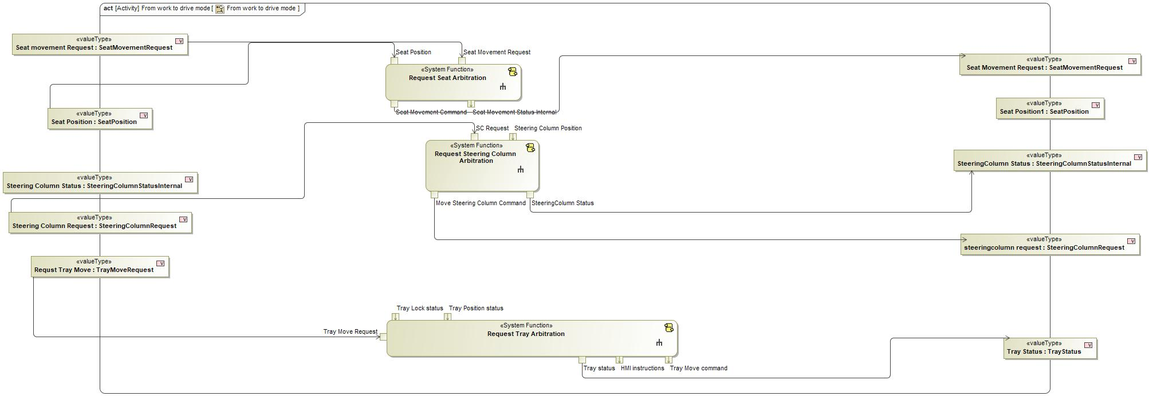
Figure 2: Activity Diagram of “From work to drive mode” calling “Request Seat Arbitration”

Figure 2: Activity Diagram of “Make Rest space Available” calling “Request Seat Arbitration”

Figure 2: Activity Diagram of “Make Work Space Available” calling “Request Seat Arbitration”

Figure 2: Activity Diagram of “Request Work Mode” calling “Request Seat Arbitration”

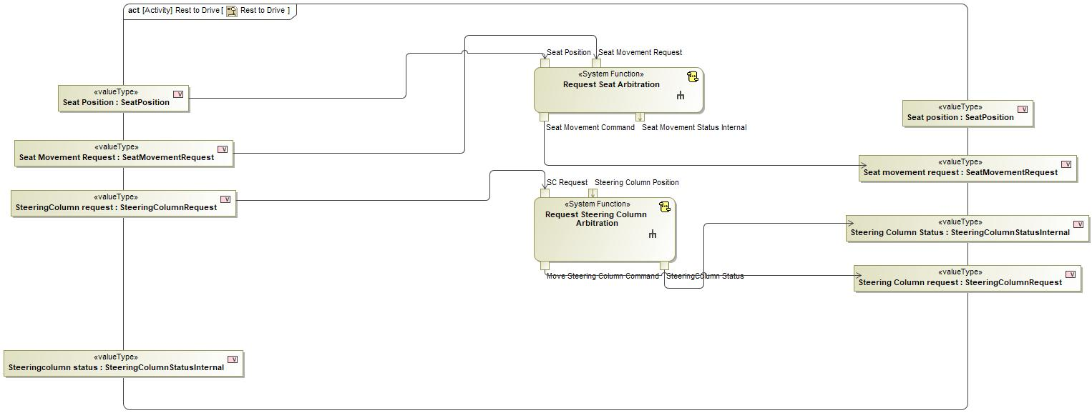
Figure 2: Activity Diagram of “Rest to Drive” calling “Request Seat Arbitration”

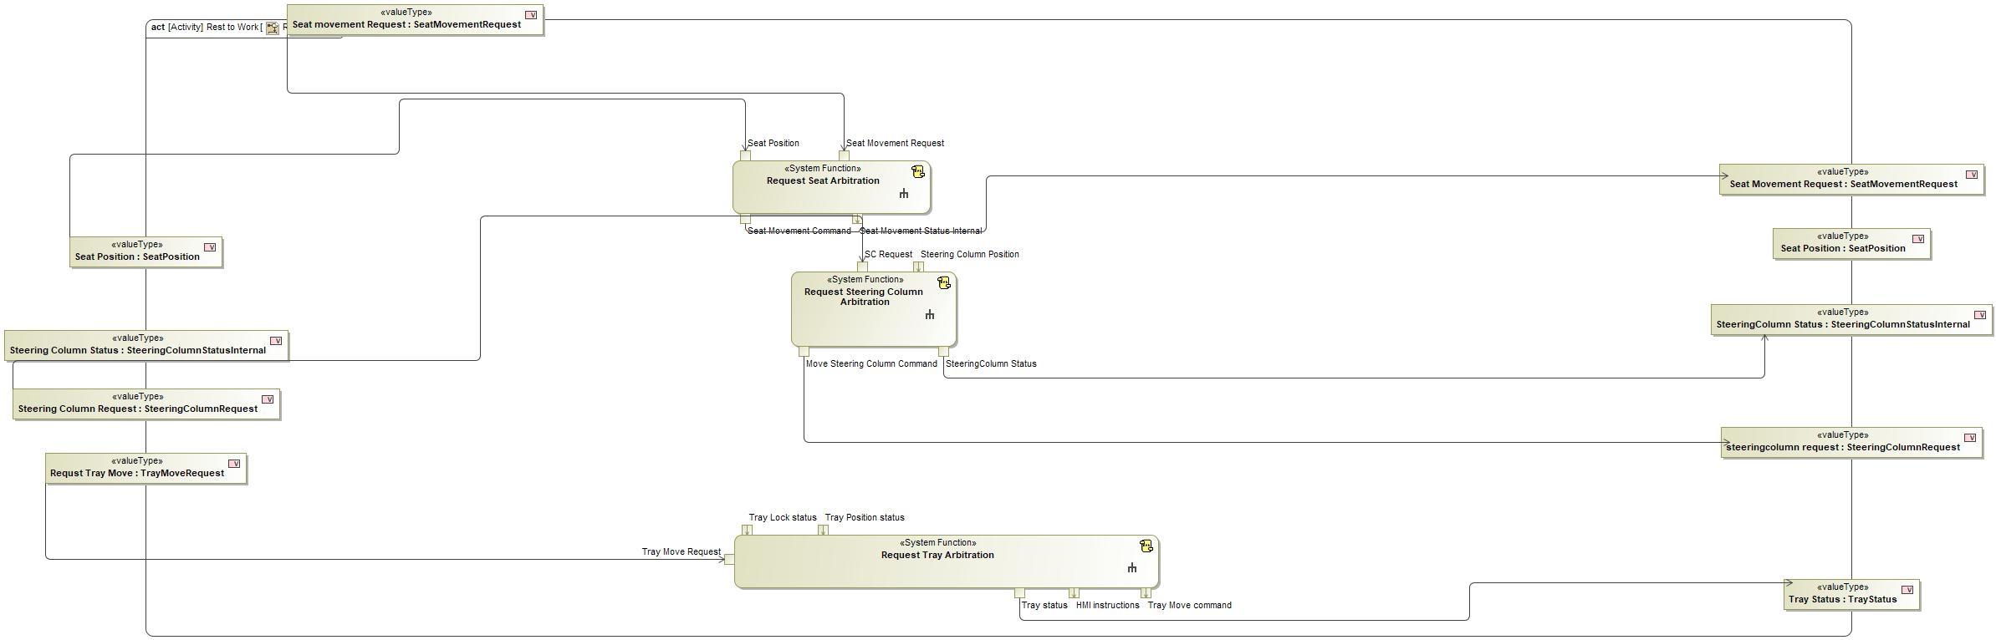
Figure 2: Activity Diagram of “Rest to Work” calling “Request Seat Arbitration”

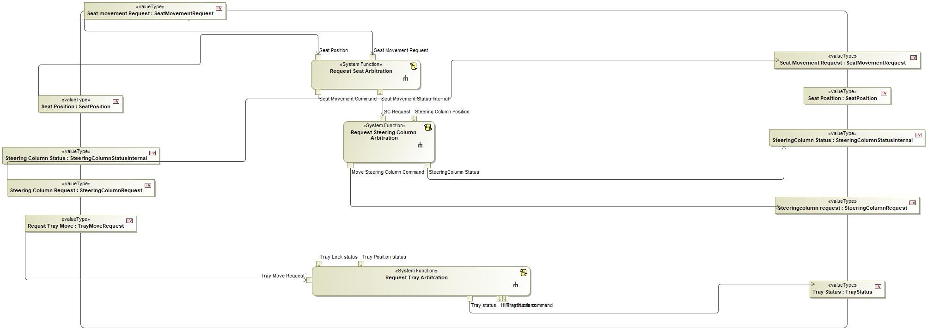
Figure 2: Activity Diagram of “Work to Rest” calling “Request Seat Arbitration”

Function Interfaces

Logical Inputs
Signal Name | Description
Seat Movement Request  Type:  SeatMovementRequest | Signal Description:  Command to Move seat which goes to the Driver seat System  Received from:  - Activity Parameter Node: Seat Movement Request  - Control SSC Functionality  - Activity Parameter Node: Seat movement Request  - Activity Parameter Node: Seat movement Request  - Activity Parameter Node: Seat Movement Request  - Activity Parameter Node: Seat movement Request  - Activity Parameter Node: Seat movement Request
Seat Position  Type:  SeatPosition | Signal Description:  Current Seat Position from the Driver Seat System  Received from:  - Activity Parameter Node: Seat Position  - Activity Parameter Node: Seat Position  - Activity Parameter Node: Seat Position  - Activity Parameter Node: Seat Position  - Activity Parameter Node: Seat Position  - Activity Parameter Node: Seat Position  - Activity Parameter Node: Seat Position  - Activity Parameter Node: Seat Position

Logical Outputs
Signal Name | Description
Seat Movement Command  Type:  SeatMovementRequest | Signal Description:  Command to Move seat which goes to the Driver seat System  Sent to:  - Activity Parameter Node: Seat Movement Command  - Activity Parameter Node: Seat movement request  - Activity Parameter Node: Seat Movement Command  - Activity Parameter Node: Seat Movement Command  - Activity Parameter Node: Seat Movement Command  - Activity Parameter Node: Seat Movement Command  - Activity Parameter Node: Seat movement request  - Activity Parameter Node: Seat Movement Command
Seat Movement Status Internal  Type:  SeatMovementStatusInternal | Signal Description:  Status of the Seat movement according to the current position and external position  Sent to:  - Check for Transition Termination

Logical Parameters

Not supported by MagicDraw report generation.

Function Modeling

Use Cases

Not supported by MagicDraw report generation.

State Charts / Activity Diagrams / Sequence Diagrams / Decision Tables

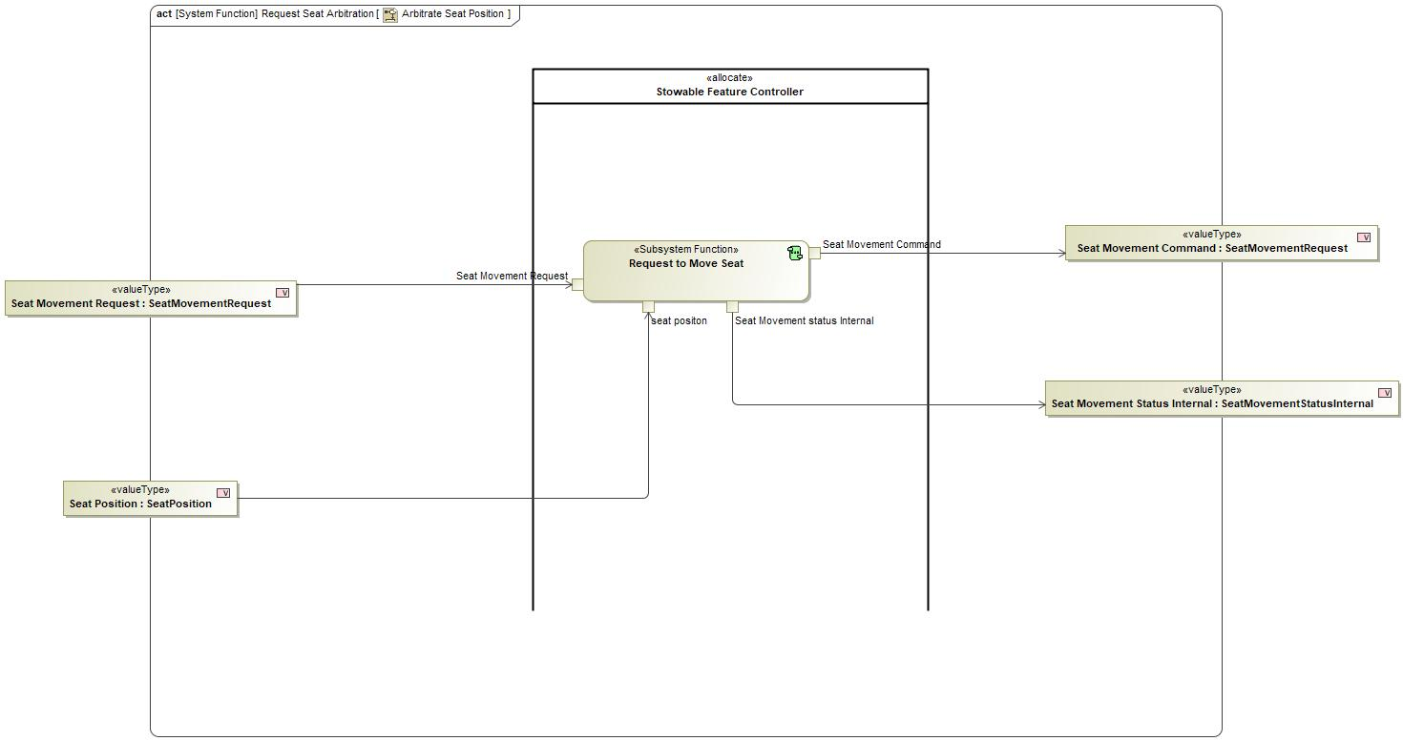
Figure 3: Arbitrate Seat Position

Function Requirements

Functional Requirements

Normal Operation

Request Seat Arbitration
When Request Seat Arbitration Function receives state selection signal , it shall set Seat Movement Command as follows
1. StateSelectionSignal==WORK , SeatMovementCommand=WORK
2.StateSelectionSignal==PLAY , SeatMovementCommand=PLAY
3.StateSelectionSignal==REST , SeatMovementCommand=REST
4.StateSelectionSignal==DRIVE , SeatMovementCommand=DRIVE

Requirement ID:
Rationale
Acceptance Criteria
Notes
Source |  |  |  |  |  | Owner
Source Req. |  |  |  |  |  | V&V Method
Type |  |  |  | Priority |  | Status
Req. Template Version |  | 6.0 | End of Requirement

Drive seat PreSet Positions
Driver seat system shall support 4 positions for different Modes of Operation ; Drive Mode seat position , Play Mode seat Position , Work Mode seat position and Rest Mode seat position

Requirement ID:
Rationale
Acceptance Criteria
Notes
Source |  |  |  |  |  | Owner
Source Req. |  |  |  |  |  | V&V Method
Type |  |  |  | Priority |  | Status
Req. Template Version |  | 6.0 | End of Requirement

Set Seat Movement status
While Activated, Request Seat Arbitration function shall Monitor the Seat Position through SeatPosition and set SeatMovementStatus to
1.SEAT_MOVED
2.SEAT_MOVING
3.SEAT_FAILED_TO_MOVE

Requirement ID:
Rationale
Acceptance Criteria
Notes
Source |  |  |  |  |  | Owner
Source Req. |  |  |  |  |  | V&V Method
Type |  |  |  | Priority |  | Status
Req. Template Version |  | 6.0 | End of Requirement

Error Handling

No Error Handling Requirements specified.

Non-Functional Requirements

No Non-Functional Requirements specified.

Functional Safety Requirements

No Functional Safety Requirements specified.

ASIL Decomposition of Functional Safety Requirements

No Functional Safety Requirements with ASIL Decompositions specified.

Other Requirements

Design Requirements

No Design Requirements specified.

Request Steering Column Arbitration

Function Overview

Description

Function is allocated to:
- Stowable Steering and Deployable Tray System <<Logical>>

A System Function responsible for preparing the Steering Column to Arbitrate and send the respective command to Arbitrate Steering Column to next functions

Variants

Not supported by MagicDraw report generation.

Input Requirements

Not supported by MagicDraw report generation.

Assumptions

No assumptions specified for this function.

References

Ford Documents
List here all Ford internal documents, which are directly related to the feature.

Reference | Title | Doc. ID | Revision
Table 5: Ford internal Documents (not specified in model)

External Documents and Publications
The list of external documents could include books, reports and online sources.

Reference | Document / Publication
Table 7: External documents and publications (not specified in model)

Glossary
See Appendix for Definitions and Abbreviations.

Function Scope

The – “Request Steering Column Arbitration” function is called by the following functions:
- – “Drive to Rest”
- – “From work to drive mode”
- – “Make Rest space Available”
- – “Make Work Space Available”
- – “Request Work Mode”
- – “Rest to Drive”
- – “Rest to Work”
- – “Work to Rest”

Figure 2: Activity Diagram of “Drive to Rest” calling “Request Steering Column Arbitration”

Figure 2: Activity Diagram of “From work to drive mode” calling “Request Steering Column Arbitration”

Figure 2: Activity Diagram of “Make Rest space Available” calling “Request Steering Column Arbitration”

Figure 2: Activity Diagram of “Make Work Space Available” calling “Request Steering Column Arbitration”

Figure 2: Activity Diagram of “Request Work Mode” calling “Request Steering Column Arbitration”

Figure 2: Activity Diagram of “Rest to Drive” calling “Request Steering Column Arbitration”

Figure 2: Activity Diagram of “Rest to Work” calling “Request Steering Column Arbitration”

Figure 2: Activity Diagram of “Work to Rest” calling “Request Steering Column Arbitration”

Function Interfaces

Logical Inputs
Signal Name | Description
Steering Column Position  Type:  SteeringColumnPosition | Signal Description:  Position of the Steering Column provided by the steering column system  Received from:  - Activity Parameter Node: Steering Column Position  - Activity Parameter Node: Steering Column Tele position
SC Request  Type:  SteeringColumnRequest | Signal Description:  Request to Move steering Column with respect to selected Mode  Received from:  - Activity Parameter Node: Steering Column Request  - Activity Parameter Node: Steering Column Request  - Activity Parameter Node: Steering Column Request  - Control SSC Functionality  - Activity Parameter Node: SteeringColumn request  - Activity Parameter Node: Steering Column Request  - Activity Parameter Node: SteeringColumn request

Logical Outputs
Signal Name | Description
Move Steering Column Command  Type:  SteeringColumnRequest | Signal Description:  Request to Move steering Column with respect to selected Mode  Sent to:  - Activity Parameter Node: steeringcolumn request  - Activity Parameter Node: Steering Column request  - Activity Parameter Node: Steering Column request  - Activity Parameter Node: steeringcolumn request  - Activity Parameter Node: steeringcolumn request  - Activity Parameter Node: Steering Column Command  - Activity Parameter Node: steeringcolumn request  - Activity Parameter Node: Steering Column Command
SteeringColumn Status  Type:  SteeringColumnStatusInternal | Signal Description:  Status of SteeringColumn based on Feature Decisions and current steering Column Position  Sent to:  - Activity Parameter Node: SteeringColumn Status  - Activity Parameter Node: SteeringColumn Status  - Check for Transition Termination  - Activity Parameter Node: SteeringColumn Status  - Activity Parameter Node: SteeringColumn Status  - Activity Parameter Node: Steering Column Status  - Activity Parameter Node: Steering Column Status

Logical Parameters

Not supported by MagicDraw report generation.

Function Modeling

Use Cases

Not supported by MagicDraw report generation.

State Charts / Activity Diagrams / Sequence Diagrams / Decision Tables

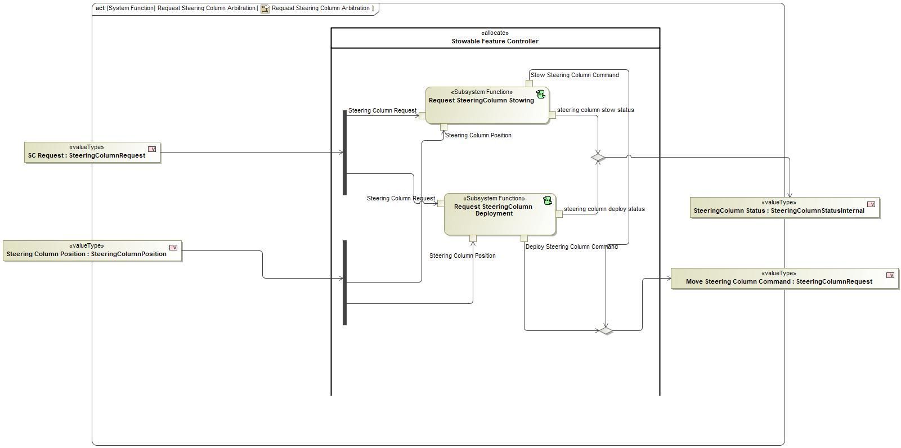
Figure 3: Request Steering Column Arbitration

Function Requirements

Functional Requirements

Normal Operation

Request Steering Column Arbitration
When Request Steering Column Arbitration function receives StateSelectionSignal = WORK or StateSelectionSignal = PLAY or StateSelectionSignal = REST , it shall verify
SteeringColumnRakePosition=STOWED , SteeringColumnTelePosition=STOWED it shall set SteeringColumnCommand = DEPLOY_RAKE and SteeringColumnCommand = DEPLOY_DEPLOY and SteeringColumnStatus=STEERING_COLUMN_DEPLOYING

Requirement ID:
Rationale
Acceptance Criteria
Notes
Source |  |  |  |  |  | Owner
Source Req. |  |  |  |  |  | V&V Method
Type |  |  |  | Priority |  | Status
Req. Template Version |  | 6.0 | End of Requirement

Error Handling

No Error Handling Requirements specified.

Non-Functional Requirements

No Non-Functional Requirements specified.

Functional Safety Requirements

No Functional Safety Requirements specified.

ASIL Decomposition of Functional Safety Requirements

No Functional Safety Requirements with ASIL Decompositions specified.

Other Requirements

Design Requirements

No Design Requirements specified.

Request SteeringColumn Deployment

Function Overview

Description

Function is allocated to:
- Deploy Steering Column <<Logical>>
- Stowable Feature Controller <<Logical>>

This Sub System Function is responsible for sending Steering Column Stow Request based on its Inputs requests

Variants

Not supported by MagicDraw report generation.

Input Requirements

Not supported by MagicDraw report generation.

Assumptions

No assumptions specified for this function.

References

Ford Documents
List here all Ford internal documents, which are directly related to the feature.

Reference | Title | Doc. ID | Revision
Table 5: Ford internal Documents (not specified in model)

External Documents and Publications
The list of external documents could include books, reports and online sources.

Reference | Document / Publication
Table 7: External documents and publications (not specified in model)

Glossary
See Appendix for Definitions and Abbreviations.

Function Scope

The – “Request SteeringColumn Deployment” function is called by the following functions:
- – “Request Steering Column Arbitration”

Figure 2: Activity Diagram of “Request Steering Column Arbitration” calling “Request SteeringColumn Deployment”

Function Interfaces

Logical Inputs
Signal Name | Description
Steering Column Request  Type:  SteeringColumnRequest | Signal Description:  Request to Move steering Column with respect to selected Mode  Received from:  - Activity Parameter Node: SC Request
Steering Column Position  Type:  SteeringColumnPosition | Signal Description:  Position of the Steering Column provided by the steering column system  Received from:  - Activity Parameter Node: Steering Column Position

Logical Outputs
Signal Name | Description
steering column deploy status  Type:  SteeringColumnStatusInternal | Signal Description:  Status of SteeringColumn based on Feature Decisions and current steering Column Position  Sent to:  - Activity Parameter Node: SteeringColumn Status
Deploy Steering Column Command  Type:  SteeringColumnRequest | Signal Description:  Request to Move steering Column with respect to selected Mode  Sent to:  - Activity Parameter Node: Move Steering Column Command

Logical Parameters

Not supported by MagicDraw report generation.

Function Modeling

Use Cases

Not supported by MagicDraw report generation.

State Charts / Activity Diagrams / Sequence Diagrams / Decision Tables

No diagrams internal to function specified.

Function Requirements

Functional Requirements

Normal Operation

Request SteeringColumn Deployment Function Steering Column Deploy Status Deployment Commenced
The Request SteeringColumn Deployment Function shall set Steering Column Deploy Status to STEERING_COLUMN_DEPLOYING when Inhibit Status is set to INHIBITED and Steering Column Tele Position is set to STOWED and Steering Column Rake Position is set to IN_MOTION.

Requirement ID:
Rationale
Acceptance Criteria
Notes
Source |  |  |  |  |  | Owner
Source Req. | - Column Movement Functionality |  |  |  |  | V&V Method
Type |  |  |  | Priority |  | Status
Req. Template Version |  | 6.0 | End of Requirement

Request SteeringColumn Deployment Function Steering Column Deploy Status Start Deployment
The Request SteeringColumn Deployment Function shall set Steering Column Deploy Status to STEERING_COLUMN_DEPLOYING when Inhibit Status is set to NOT_INHIBITED and both Steering Column Tele Position and Steering Column Rake Position is set to DEPLOYED or either Steering Column Tele Position or Steering Column Rake Positionis is set to ERROR.

Requirement ID:
Rationale
Acceptance Criteria
Notes
Source |  |  |  |  |  | Owner
Source Req. | - Column Movement Functionality |  |  |  |  | V&V Method
Type |  |  |  | Priority |  | Status
Req. Template Version |  | 6.0 | End of Requirement

Request Actuate Function Actuate Steering Column Command Definition
The Request Actuation Function Actuate Steering Column Command shall indicate DEPLOY, STOW and NONE states.

Requirement ID:
Rationale
Acceptance Criteria
Notes
Source |  |  |  |  |  | Owner
Source Req. | - Column Movement Functionality |  |  |  |  | V&V Method
Type |  |  |  | Priority |  | Status
Req. Template Version |  | 6.0 | End of Requirement

Request SteeringColumn Deployment Function Deploy Steering Column Command Commence Deploy
The Request SteeringColumn Deployment Function shall set Deploy Steering Column Command to DEPLOY when Inhibit Status is set to INHIBITED and Steering Column Tele Position is set to IN_MOTION.

Requirement ID:
Rationale
Acceptance Criteria
Notes
Source |  |  |  |  |  | Owner
Source Req. | - Column Movement Functionality |  |  |  |  | V&V Method
Type |  |  |  | Priority |  | Status
Req. Template Version |  | 6.0 | End of Requirement

Request Actuation Function Actuate Steering Column Command
The Request Actuation Function Actuate Steering Column Command shall be set to the Move Steering Column Command input when the Actuate Signal is set to ACTUATE

Requirement ID:
Rationale
Acceptance Criteria
Notes
Source |  |  |  |  |  | Owner
Source Req. | - Column Movement Functionality |  |  |  |  | V&V Method
Type |  |  |  | Priority |  | Status
Req. Template Version |  | 6.0 | End of Requirement

Request SteeringColumn Deployment Function Steering Column Deploy Status Normal Deployment Completion
The Request SteeringColumn Deployment Function shall set Steering Column Deploy Status to STEERING_COLUMN_DEPLOYED when Inhibit Status is set to NOT_INHIBITED and Steering Column Tele Position is set to DEPLOYED and Steering Column Rake Position is set to DEPLOYED.

Requirement ID:
Rationale
Acceptance Criteria
Notes
Source |  |  |  |  |  | Owner
Source Req. | - Column Movement Functionality |  |  |  |  | V&V Method
Type |  |  |  | Priority |  | Status
Req. Template Version |  | 6.0 | End of Requirement

Request SteeringColumn Deployment Function Steering Column Deploy Status Rake Position Error
The Request SteeringColumn Deployment Function shall set Steering Column Deploy Status to STEERING_COLUMN_FAILED_TO_DEPLOY when Inhibit Status is set to INHIBITED and Steering Column Tele Position is set to DEPLOYED and Steering Column Rake Position is set to STOWED

Requirement ID:
Rationale
Acceptance Criteria
Notes
Source |  |  |  |  |  | Owner
Source Req. | - Column Movement Functionality |  |  |  |  | V&V Method
Type |  |  |  | Priority |  | Status
Req. Template Version |  | 6.0 | End of Requirement

Request SteeringColumn Deployment Function Deploy Steering Column Command Rake Position Error
The Request SteeringColumn Deployment Function shall set Deploy Steering Column Command to NONE when Inhibit Status is set to INHIBITED and Steering Column Tele Position is set to DEPLOYED and Steering Column Rake Position is set to STOWED

Requirement ID:
Rationale
Acceptance Criteria
Notes
Source |  |  |  |  |  | Owner
Source Req. | - Column Movement Functionality |  |  |  |  | V&V Method
Type |  |  |  | Priority |  | Status
Req. Template Version |  | 6.0 | End of Requirement

Request SteeringColumn Deployment Function Steering Column Deploy Status Tele Position Error
The Request SteeringColumn Deployment Function shall set Steering Column Deploy Status to STEERING_COLUMN_FAILED_TO_DEPLOY when Inhibit Status is set to INHIBITED and Steering Column Tele Position is set to STOWED and Steering Column Rake Position is set to DEPLOYED.

Requirement ID:
Rationale
Acceptance Criteria
Notes
Source |  |  |  |  |  | Owner
Source Req. | - Column Movement Functionality |  |  |  |  | V&V Method
Type |  |  |  | Priority |  | Status
Req. Template Version |  | 6.0 | End of Requirement

Request SteeringColumn Deployment Function Deploy Steering Column Command Deployment Completing
The Request SteeringColumn Deployment Function shall set Deploy Steering Column Command to DEPLOYT when Inhibit Status is set to INHIBITED and Steering Column Tele Position is set to DEPLOYED and Steering Column Rake Position is set to IN_MOTION.

Requirement ID:
Rationale
Acceptance Criteria
Notes
Source |  |  |  |  |  | Owner
Source Req. | - Column Movement Functionality |  |  |  |  | V&V Method
Type |  |  |  | Priority |  | Status
Req. Template Version |  | 6.0 | End of Requirement

Request SteeringColumn Deployment Function Deploy Steering Column Command Tele Position Error
The Request SteeringColumn Deployment Function shall set Deploy Steering Column Command to NONE when Inhibit Status is set to INHIBITED and Steering Column Tele Position is set to STOWED and Steering Column Rake Position is set to DEPLOYED.

Requirement ID:
Rationale
Acceptance Criteria
Notes
Source |  |  |  |  |  | Owner
Source Req. | - Column Movement Functionality |  |  |  |  | V&V Method
Type |  |  |  | Priority |  | Status
Req. Template Version |  | 6.0 | End of Requirement

Request SteeringColumn Deployment Function Deploy Steering Column Command Deployment Completed
The Request SteeringColumn Deployment Function shall set Deploy Steering Column Command to NONE when Inhibit Status is set to INHIBITED and Steering Column Tele Position is set to DEPLOYED and Steering Column Rake Position is set to DEPLOYED.

Requirement ID:
Rationale
Acceptance Criteria
Notes
Source |  |  |  |  |  | Owner
Source Req. | - Column Movement Functionality |  |  |  |  | V&V Method
Type |  |  |  | Priority |  | Status
Req. Template Version |  | 6.0 | End of Requirement

Request SteeringColumn Deployment Function Deploy Steering Column Command Normal Deployment Completion
The Request SteeringColumn Deployment Function shall set Deploy Steering Column Command to NONE when Inhibit Status is set to NOT_INHIBITED and Steering Column Tele Position is set to DEPLOYED and Steering Column Rake Position is set to DEPLOYED.

Requirement ID:
Rationale
Acceptance Criteria
Notes
Source |  |  |  |  |  | Owner
Source Req. | - Column Movement Functionality |  |  |  |  | V&V Method
Type |  |  |  | Priority |  | Status
Req. Template Version |  | 6.0 | End of Requirement

Request SteeringColumn Deployment Function Steering Column Deploy Status Commence Deploy
The Request SteeringColumn Deployment Function shall set Steering Column Deploy Status to STEERING_COLUMN_DEPLOYING when Inhibit Status is set to INHIBITED and Steering Column Tele Position is set to IN_MOTION.

Requirement ID:
Rationale
Acceptance Criteria
Notes
Source |  |  |  |  |  | Owner
Source Req. | - Column Movement Functionality |  |  |  |  | V&V Method
Type |  |  |  | Priority |  | Status
Req. Template Version |  | 6.0 | End of Requirement

Request SteeringColumn Deployment Function Steering Column Deploy Status Position Error
The Request SteeringColumn Deployment Function shall set Steering Column Deploy Status to STEERING_COLUMN_FAILED_TO_DEPLOY when Steering Column Tele Position is set to ERROR or Steering Column Rake Position is set to ERROR

Requirement ID:
Rationale
Acceptance Criteria
Notes
Source |  |  |  |  |  | Owner
Source Req. | - Column Movement Functionality |  |  |  |  | V&V Method
Type |  |  |  | Priority |  | Status
Req. Template Version |  | 6.0 | End of Requirement

Request SteeringColumn Deployment Function Deploy Steering Column Command Movement Starting
The Request SteeringColumn Deployment Function shall set Deploy Steering Column Command to DEPLOY when Inhibit Status is set to INHIBITED and Steering Column Tele Position is set to STOWED and Steering Column Rake Position is set to STOWED.

Requirement ID:
Rationale
Acceptance Criteria
Notes
Source |  |  |  |  |  | Owner
Source Req. | - Column Movement Functionality |  |  |  |  | V&V Method
Type |  |  |  | Priority |  | Status
Req. Template Version |  | 6.0 | End of Requirement

Execute Request SteeringColumn Deployment Function
The Request SteeringColumn Deployment function shall execute only when State Selection Signal is set to DRIVE.

Requirement ID:
Rationale
Acceptance Criteria
Notes
Source |  |  |  |  |  | Owner
Source Req. | - Column Movement Functionality |  |  |  |  | V&V Method
Type |  |  |  | Priority |  | Status
Req. Template Version |  | 6.0 | End of Requirement

Request SteeringColumn Deployment Function Steering Column Deploy Status Deployment Completed
The Request SteeringColumn Deployment Function shall set Steering Column Deploy Status to STEERING_COLUMN_DEPLOYED when Inhibit Status is set to INHIBITED and Steering Column Tele Position is set to DEPLOYED and Steering Column Rake Position is set to DEPLOYED.

Requirement ID:
Rationale
Acceptance Criteria
Notes
Source |  |  |  |  |  | Owner
Source Req. | - Column Movement Functionality |  |  |  |  | V&V Method
Type |  |  |  | Priority |  | Status
Req. Template Version |  | 6.0 | End of Requirement

Request SteeringColumn Deployment Function Steering Column Deploy Status Deployment Completing
The Request SteeringColumn Deployment Function shall set Steering Column Deploy Status to STEERING_COLUMN_DEPLOYING when Inhibit Status is set to INHIBITED and Steering Column Tele Position is set to DEPLOYED and Steering Column Rake Position is set to IN_MOTION.

Requirement ID:
Rationale
Acceptance Criteria
Notes
Source |  |  |  |  |  | Owner
Source Req. | - Column Movement Functionality |  |  |  |  | V&V Method
Type |  |  |  | Priority |  | Status
Req. Template Version |  | 6.0 | End of Requirement

Request Actuation Function Actuate Steering Column Command Default
The Request Actuation Function Actuate Steering Column Command shall be set to DEPLOY when the Actuate Signal is set to TERMINATE

Requirement ID:
Rationale
Acceptance Criteria
Notes
Source |  |  |  |  |  | Owner
Source Req. | - Column Movement Functionality |  |  |  |  | V&V Method
Type |  |  |  | Priority |  | Status
Req. Template Version |  | 6.0 | End of Requirement

Request SteeringColumn Deployment Function Deploy Steering Column Command Position Error
The Request SteeringColumn Deployment Function shall set Deploy Steering Column Command to NONE when Steering Column Tele Position is set to ERROR or Steering Column Rake Position is set to ERROR

Requirement ID:
Rationale
Acceptance Criteria
Notes
Source |  |  |  |  |  | Owner
Source Req. | - Column Movement Functionality |  |  |  |  | V&V Method
Type |  |  |  | Priority |  | Status
Req. Template Version |  | 6.0 | End of Requirement

Request SteeringColumn Deployment Function Deploy Steering Column Command Start Deployment
The Request SteeringColumn Deployment Function shall set Deploy Steering Column Command to DEPLOY when Inhibit Status is set to NOT_INHIBITED and both Steering Column Tele Position and Steering Column Rake Position is set to DEPLOYED or either Steering Column Tele Position or Steering Column Rake Positionis is set to ERROR.

Requirement ID:
Rationale
Acceptance Criteria
Notes
Source |  |  |  |  |  | Owner
Source Req. | - Column Movement Functionality |  |  |  |  | V&V Method
Type |  |  |  | Priority |  | Status
Req. Template Version |  | 6.0 | End of Requirement

Request SteeringColumn Deployment Function Deploy Steering Column Command Deployment Commenced
The Request SteeringColumn Deployment Function shall set Deploy Steering Column Command to DEPLOY when Inhibit Status is set to INHIBITED and Steering Column Tele Position is set to STOWED and Steering Column Rake Position is set to IN_MOTION.

Requirement ID:
Rationale
Acceptance Criteria
Notes
Source |  |  |  |  |  | Owner
Source Req. | - Column Movement Functionality |  |  |  |  | V&V Method
Type |  |  |  | Priority |  | Status
Req. Template Version |  | 6.0 | End of Requirement

Request SteeringColumn Deployment Function Steering Column Deploy Status Movement Starting
The Request SteeringColumn Deployment Function shall set Steering Column Deploy Status to STEERING_COLUMN_DEPLOYING when Inhibit Status is set to INHIBITED and Steering Column Tele Position is set to STOWED and Steering Column Rake Position is set to STOWED.

Requirement ID:
Rationale
Acceptance Criteria
Notes
Source |  |  |  |  |  | Owner
Source Req. | - Column Movement Functionality |  |  |  |  | V&V Method
Type |  |  |  | Priority |  | Status
Req. Template Version |  | 6.0 | End of Requirement

Error Handling

No Error Handling Requirements specified.

Non-Functional Requirements

No Non-Functional Requirements specified.

Functional Safety Requirements

No Functional Safety Requirements specified.

ASIL Decomposition of Functional Safety Requirements

No Functional Safety Requirements with ASIL Decompositions specified.

Other Requirements

Design Requirements

No Design Requirements specified.

Request SteeringColumn Stowing

Function Overview

Description

Function is allocated to:
- Stow Steering Column <<Logical>>
- Stowable Feature Controller <<Logical>>

This Sub System Function is responsible for sending Steering Column Stow Request based on its Inputs requests

Variants

Not supported by MagicDraw report generation.

Input Requirements

Not supported by MagicDraw report generation.

Assumptions

No assumptions specified for this function.

References

Ford Documents
List here all Ford internal documents, which are directly related to the feature.

Reference | Title | Doc. ID | Revision
Table 5: Ford internal Documents (not specified in model)

External Documents and Publications
The list of external documents could include books, reports and online sources.

Reference | Document / Publication
Table 7: External documents and publications (not specified in model)

Glossary
See Appendix for Definitions and Abbreviations.

Function Scope

The – “Request SteeringColumn Stowing” function is called by the following functions:
- – “Request Steering Column Arbitration”

Figure 2: Activity Diagram of “Request Steering Column Arbitration” calling “Request SteeringColumn Stowing”

Function Interfaces

Logical Inputs
Signal Name | Description
Steering Column Request  Type:  SteeringColumnRequest | Signal Description:  Request to Move steering Column with respect to selected Mode  Received from:  - Activity Parameter Node: SC Request
Steering Column Position  Type:  SteeringColumnPosition | Signal Description:  Position of the Steering Column provided by the steering column system  Received from:  - Activity Parameter Node: Steering Column Position

Logical Outputs
Signal Name | Description
steering column stow status  Type:  SteeringColumnStatusInternal | Signal Description:  Status of SteeringColumn based on Feature Decisions and current steering Column Position  Sent to:  - Activity Parameter Node: SteeringColumn Status
Stow Steering Column Command  Type:  SteeringColumnRequest | Signal Description:  Request to Move steering Column with respect to selected Mode  Sent to:  - Activity Parameter Node: Move Steering Column Command

Logical Parameters

Not supported by MagicDraw report generation.

Function Modeling

Use Cases

Not supported by MagicDraw report generation.

State Charts / Activity Diagrams / Sequence Diagrams / Decision Tables

No diagrams internal to function specified.

Function Requirements

Functional Requirements

Normal Operation

Request SteeringColumn Stowing Function Steering Column Stow Status Begin Stowing
The Request SteeringColumn Stowing Function shall set Steering Column Stow Status to STEERING_COLUMN_STOWING when Inhibit Status is set to INHIBITED and Steering Column Tele Position is set to DEPLOYED and Steering Column Rake Position is set to DEPLOYED.

Requirement ID:
Rationale
Acceptance Criteria
Notes
Source |  |  |  |  |  | Owner
Source Req. | - Column Movement Functionality |  |  |  |  | V&V Method
Type |  |  |  | Priority |  | Status
Req. Template Version |  | 6.0 | End of Requirement

Request SteeringColumn Stowing Function Steering Column Stow Status Rake Stow Commenced
The Request SteeringColumn Stowing Function shall set Steering Column Stow Status to STEERING_COLUMN_STOWING when Inhibit Status is set to INHIBITED and Steering Column Tele Position is set to DEPLOYED and Steering Column Rake Position is set to IN_MOTION.

Requirement ID:
Rationale
Acceptance Criteria
Notes
Source |  |  |  |  |  | Owner
Source Req. | - Column Movement Functionality |  |  |  |  | V&V Method
Type |  |  |  | Priority |  | Status
Req. Template Version |  | 6.0 | End of Requirement

Request Actuate Function Actuate Steering Column Command Definition
The Request Actuation Function Actuate Steering Column Command shall indicate DEPLOY, STOW and NONE states.

Requirement ID:
Rationale
Acceptance Criteria
Notes
Source |  |  |  |  |  | Owner
Source Req. | - Column Movement Functionality |  |  |  |  | V&V Method
Type |  |  |  | Priority |  | Status
Req. Template Version |  | 6.0 | End of Requirement

Request SteeringColumn Stowing Function Stow Steering Column Command Tele Position Error
The Request SteeringColumn Stowing Function shall set Stow Steering Column Command to NONE when Inhibit Status is set to INHIBITED and Steering Column Tele Position is set to DEPLOYED and Steering Column Rake Position is set to STOWED

Requirement ID:
Rationale
Acceptance Criteria
Notes
Source |  |  |  |  |  | Owner
Source Req. | - Column Movement Functionality |  |  |  |  | V&V Method
Type |  |  |  | Priority |  | Status
Req. Template Version |  | 6.0 | End of Requirement

Request SteeringColumn Stowing Function Steering Column Stow Status Deployed
The Request SteeringColumn Stowing Function shall set Steering Column Stow Status to STEERING_COLUMN_DEPLOYED when Inhibit Status is set to NOT_INHIBITED and Steering Column Tele Position is set to DEPLOYED and Steering Column Rake Position is set to DEPLOYED.

Requirement ID:
Rationale
Acceptance Criteria
Notes
Source |  |  |  |  |  | Owner
Source Req. | - Column Movement Functionality |  |  |  |  | V&V Method
Type |  |  |  | Priority |  | Status
Req. Template Version |  | 6.0 | End of Requirement

Request SteeringColumn Stowing Function Steering Column Stow Status Stow Near Completion
The Request SteeringColumn Stowing Function shall set Steering Column Stow Status to STEERING_COLUMN_FAILED_TO_STOW when Steering Column Tele Position is set to ERROR or Steering Column Rake Position is set to ERROR

Requirement ID:
Rationale
Acceptance Criteria
Notes
Source |  |  |  |  |  | Owner
Source Req. | - Column Movement Functionality |  |  |  |  | V&V Method
Type |  |  |  | Priority |  | Status
Req. Template Version |  | 6.0 | End of Requirement

Request SteeringColumn Stowing Function Stow Steering Column Command Rake Position Error
The Request SteeringColumn Stowing Function shall set Stow Steering Column Command to NONE when Steering Column Tele Position is set to ERROR or Steering Column Rake Position is set to ERROR

Requirement ID:
Rationale
Acceptance Criteria
Notes
Source |  |  |  |  |  | Owner
Source Req. | - Column Movement Functionality |  |  |  |  | V&V Method
Type |  |  |  | Priority |  | Status
Req. Template Version |  | 6.0 | End of Requirement

Request SteeringColumn Stowing Function Steering Column Stow Status Failed to Stow Tele Position Error
The Request SteeringColumn Stowing Function shall set Steering Column Stow Status to STEERING_COLUMN_FAILED_TO_STOW when Inhibit Status is set to INHIBITED and Steering Column Tele Position is set to DEPLOYED and Steering Column Rake Position is set to STOWED

Requirement ID:
Rationale
Acceptance Criteria
Notes
Source |  |  |  |  |  | Owner
Source Req. | - Column Movement Functionality |  |  |  |  | V&V Method
Type |  |  |  | Priority |  | Status
Req. Template Version |  | 6.0 | End of Requirement

Request SteeringColumn Stowing Function Stow Steering Column Command DEPLOY Case
The Request SteeringColumn Stowing Function shall set Stow Steering Column Command to DEPLOY when Inhibit Status is set to NOT_INHIBITED and both Steering Column Tele Position and Steering Column Rake Position is set to DEPLOYED or either Steering Column Tele Position or Steering Column Rake Positionis is set to ERROR.

Requirement ID:
Rationale
Acceptance Criteria
Notes
Source |  |  |  |  |  | Owner
Source Req. | - Column Movement Functionality |  |  |  |  | V&V Method
Type |  |  |  | Priority |  | Status
Req. Template Version |  | 6.0 | End of Requirement

Request SteeringColumn Stowing Function Steering Column Stow Status Failed to Stow Rake Position Error
The Request SteeringColumn Stowing Function shall set Steering Column Stow Status to STEERING_COLUMN_FAILED_TO_STOW when Steering Column Tele Position is set to ERROR or Steering Column Rake Position is set to ERROR

Requirement ID:
Rationale
Acceptance Criteria
Notes
Source |  |  |  |  |  | Owner
Source Req. | - Column Movement Functionality |  |  |  |  | V&V Method
Type |  |  |  | Priority |  | Status
Req. Template Version |  | 6.0 | End of Requirement

Request SteeringColumn Stowing Function Stow Steering Column Command Rake Error
The Request SteeringColumn Stowing Function shall set Stow Steering Column Command to NONE when Inhibit Status is set to INHIBITED and Steering Column Tele Position is set to STOWED and Steering Column Rake Position is set to DEPLOYED.

Requirement ID:
Rationale
Acceptance Criteria
Notes
Source |  |  |  |  |  | Owner
Source Req. | - Column Movement Functionality |  |  |  |  | V&V Method
Type |  |  |  | Priority |  | Status
Req. Template Version |  | 6.0 | End of Requirement

Request SteeringColumn Stowing Function Stow Steering Column Command Stow Near Completion
The Request SteeringColumn Stowing Function shall set Stow Steering Column Command to STOW when Inhibit Status is set to INHIBITED and Steering Column Tele Position is set to STOWED and Steering Column Rake Position is set to IN_MOTION.

Requirement ID:
Rationale
Acceptance Criteria
Notes
Source |  |  |  |  |  | Owner
Source Req. | - Column Movement Functionality |  |  |  |  | V&V Method
Type |  |  |  | Priority |  | Status
Req. Template Version |  | 6.0 | End of Requirement

Request SteeringColumn Stowing Function Steering Column Stow Status Rake Error
The Request SteeringColumn Stowing Function shall set Steering Column Stow Status to STEERING_COLUMN_FAILED_TO_STOW when Inhibit Status is set to INHIBITED and Steering Column Tele Position is set to STOWED and Steering Column Rake Position is set to DEPLOYED.

Requirement ID:
Rationale
Acceptance Criteria
Notes
Source |  |  |  |  |  | Owner
Source Req. | - Column Movement Functionality |  |  |  |  | V&V Method
Type |  |  |  | Priority |  | Status
Req. Template Version |  | 6.0 | End of Requirement

Request SteeringColumn Stowing Function Steering Column Deployment Status Definition
The Request SteeringColumn Stowing functions Stow Steering Column Command shall indicate Steering Column DEPLOYED, FAILED_TO_DEPLOY, STOWED, FAILED_TO_STOW, DEPLOYING, STOWING

Requirement ID:
Rationale
Acceptance Criteria
Notes
Source |  |  |  |  |  | Owner
Source Req. | - Column Movement Functionality |  |  |  |  | V&V Method
Type |  |  |  | Priority |  | Status
Req. Template Version |  | 6.0 | End of Requirement

Request SteeringColumn Stowing Function Steering Column Stow Status Definition
The Request SteeringColumn Stowing functions Stow Steering Column Command shall indicate Steering Column DEPLOYED, FAILED_TO_DEPLOY, STOWED, FAILED_TO_STOW, DEPLOYING, STOWING

Requirement ID:
Rationale
Acceptance Criteria
Notes
Source |  |  |  |  |  | Owner
Source Req. | - Column Movement Functionality |  |  |  |  | V&V Method
Type |  |  |  | Priority |  | Status
Req. Template Version |  | 6.0 | End of Requirement

Request SteeringColumn Stowing Function Steering Column Stow Status Deploying
The Request SteeringColumn Stowing Function shall set Steering Column Stow Status to STEERING_COLUMN_DEPLOYING when Inhibit Status is set to NOT_INHIBITED and both Steering Column Tele Position and Steering Column Rake Position is set to DEPLOYED or either Steering Column Tele Position or Steering Column Rake Positionis is set to ERROR.

Requirement ID:
Rationale
Acceptance Criteria
Notes
Source |  |  |  |  |  | Owner
Source Req. | - Column Movement Functionality |  |  |  |  | V&V Method
Type |  |  |  | Priority |  | Status
Req. Template Version |  | 6.0 | End of Requirement

Request Actuation Function Actuate Steering Column Command
The Request Actuation Function Actuate Steering Column Command shall be set to the Move Steering Column Command input when the Actuate Signal is set to ACTUATE

Requirement ID:
Rationale
Acceptance Criteria
Notes
Source |  |  |  |  |  | Owner
Source Req. | - Column Movement Functionality |  |  |  |  | V&V Method
Type |  |  |  | Priority |  | Status
Req. Template Version |  | 6.0 | End of Requirement

Request SteeringColumn Stowing Function Steering Column Stow Status Tele Stow Near Completion
The Request SteeringColumn Stowing Function shall set Steering Column Stow Status to STEERING_COLUMN_STOWING when Inhibit Status is set to INHIBITED and Steering Column Tele Position is set to IN_MOTION.

Requirement ID:
Rationale
Acceptance Criteria
Notes
Source |  |  |  |  |  | Owner
Source Req. | - Column Movement Functionality |  |  |  |  | V&V Method
Type |  |  |  | Priority |  | Status
Req. Template Version |  | 6.0 | End of Requirement

Request SteeringColumn Stowing Function Stow Steering Column Command Tele Stow Near Completion
The Request SteeringColumn Stowing Function shall set Stow Steering Column Command to STOW when Inhibit Status is set to INHIBITED and Steering Column Tele Position is set to IN_MOTION.

Requirement ID:
Rationale
Acceptance Criteria
Notes
Source |  |  |  |  |  | Owner
Source Req. | - Column Movement Functionality |  |  |  |  | V&V Method
Type |  |  |  | Priority |  | Status
Req. Template Version |  | 6.0 | End of Requirement

Request SteeringColumn Stowing Function Stow Steering Column Command Movement Done
The Request SteeringColumn Stowing Function shall set Stow Steering Column Command to NONE when Inhibit Status is set to INHIBITED and Steering Column Tele Position is set to STOWED and Steering Column Rake Position is set to STOWED.

Requirement ID:
Rationale
Acceptance Criteria
Notes
Source |  |  |  |  |  | Owner
Source Req. | - Column Movement Functionality |  |  |  |  | V&V Method
Type |  |  |  | Priority |  | Status
Req. Template Version |  | 6.0 | End of Requirement

Request SteeringColumn Stowing functions Stow Steering Column Command Definition
The Request SteeringColumn Stowing functions Stow Steering Column Command shall indicate DEPLOY, STOW and NONE. NONE shall indicate a halt to movement.

Requirement ID:
Rationale
Acceptance Criteria
Notes
Source |  |  |  |  |  | Owner
Source Req. | - Column Movement Functionality |  |  |  |  | V&V Method
Type |  |  |  | Priority |  | Status
Req. Template Version |  | 6.0 | End of Requirement

Request SteeringColumn Stowing Function Stow Steering Column Command DEPLOYED Case
The Request SteeringColumn Stowing Function shall set Stow Steering Column Command to NONE when Inhibit Status is set to NOT_INHIBITED and Steering Column Tele Position is set to DEPLOYED and Steering Column Rake Position is set to DEPLOYED.

Requirement ID:
Rationale
Acceptance Criteria
Notes
Source |  |  |  |  |  | Owner
Source Req. | - Column Movement Functionality |  |  |  |  | V&V Method
Type |  |  |  | Priority |  | Status
Req. Template Version |  | 6.0 | End of Requirement

Request SteeringColumn Stowing Function Stow Steering Column Command Rake Stow Commenced
The Request SteeringColumn Stowing Function shall set Stow Steering Column Command to STOW when Inhibit Status is set to INHIBITED and Steering Column Tele Position is set to DEPLOYED and Steering Column Rake Position is set to IN_MOTION.

Requirement ID:
Rationale
Acceptance Criteria
Notes
Source |  |  |  |  |  | Owner
Source Req. | - Column Movement Functionality |  |  |  |  | V&V Method
Type |  |  |  | Priority |  | Status
Req. Template Version |  | 6.0 | End of Requirement

Request SteeringColumn Stowing Function Stow Steering Column Command Begin Stowing
The Request SteeringColumn Stowing Function shall set Stow Steering Column Command to STOW when Inhibit Status is set to INHIBITED and Steering Column Tele Position is set to DEPLOYED and Steering Column Rake Position is set to DEPLOYED.

Requirement ID:
Rationale
Acceptance Criteria
Notes
Source |  |  |  |  |  | Owner
Source Req. | - Column Movement Functionality |  |  |  |  | V&V Method
Type |  |  |  | Priority |  | Status
Req. Template Version |  | 6.0 | End of Requirement

Execute Request SteeringColumn Stowing Function
The Request SteeringColumn Stowing function shall execute only when State Selection Signal is set to NOT_DRIVE.

Requirement ID:
Rationale
Acceptance Criteria
Notes
Source |  |  |  |  |  | Owner
Source Req. | - Column Movement Functionality |  |  |  |  | V&V Method
Type |  |  |  | Priority |  | Status
Req. Template Version |  | 6.0 | End of Requirement

Error Handling

No Error Handling Requirements specified.

Non-Functional Requirements

No Non-Functional Requirements specified.

Functional Safety Requirements

No Functional Safety Requirements specified.

ASIL Decomposition of Functional Safety Requirements

No Functional Safety Requirements with ASIL Decompositions specified.

Other Requirements

Design Requirements

No Design Requirements specified.

Request to Move Seat

Function Overview

Description

Function is allocated to:
- Request Maneuver Driver Seat To Stored Position <<Logical>>
- Stowable Feature Controller <<Logical>>

This Sub System Function is responsible for sending Seat Movement Request based on its Inputs requests

Variants

Not supported by MagicDraw report generation.

Input Requirements

Not supported by MagicDraw report generation.

Assumptions

No assumptions specified for this function.

References

Ford Documents
List here all Ford internal documents, which are directly related to the feature.

Reference | Title | Doc. ID | Revision
Table 5: Ford internal Documents (not specified in model)

External Documents and Publications
The list of external documents could include books, reports and online sources.

Reference | Document / Publication
Table 7: External documents and publications (not specified in model)

Glossary
See Appendix for Definitions and Abbreviations.

Function Scope

The – “Request to Move Seat” function is called by the following functions:
- – “Request Seat Arbitration”

Figure 2: Activity Diagram of “Arbitrate Seat Position” calling “Request to Move Seat”

Function Interfaces

Logical Inputs
Signal Name | Description
Seat Movement Request  Type:  SeatMovementRequest | Signal Description:  Command to Move seat which goes to the Driver seat System  Received from:  - Activity Parameter Node: Seat Movement Request
seat positon  Type:  SeatPosition | Signal Description:  Current Seat Position from the Driver Seat System  Received from:  - Activity Parameter Node: Seat Position

Logical Outputs
Signal Name | Description
Seat Movement Command  Type:  SeatMovementRequest | Signal Description:  Command to Move seat which goes to the Driver seat System  Sent to:  - Activity Parameter Node: Seat Movement Command
Seat Movement status Internal  Type:  SeatMovementStatusInternal | Signal Description:  Status of the Seat movement according to the current position and external position  Sent to:  - Activity Parameter Node: Seat Movement Status Internal

Logical Parameters

Not supported by MagicDraw report generation.

Function Modeling

Use Cases

Not supported by MagicDraw report generation.

State Charts / Activity Diagrams / Sequence Diagrams / Decision Tables

No diagrams internal to function specified.

Function Requirements

Functional Requirements

Normal Operation

Request to Move Seat Seat Movement Command Definition
The Request to Move Seat function Shall Set Seat Movement Command to WORK, PLAY, REST or DRIVE

Requirement ID:
Rationale
Acceptance Criteria
Notes
Source |  |  |  |  |  | Owner
Source Req. | - Set Seat Movement status |  |  |  |  | V&V Method
Type |  |  |  | Priority |  | Status
Req. Template Version |  | 6.0 | End of Requirement

Request to Move Seat Normal Command
The Request to Move Seat function shall set Seat Movment Command to the equivilent State Selection Signal input or DRIVE, REST, PLAY, WORK.

Requirement ID:
Rationale
Acceptance Criteria
Notes
Source |  |  |  |  |  | Owner
Source Req. | - Set Seat Movement status |  |  |  |  | V&V Method
Type |  |  |  | Priority |  | Status
Req. Template Version |  | 6.0 | End of Requirement

Error Handling

No Error Handling Requirements specified.

Non-Functional Requirements

No Non-Functional Requirements specified.

Functional Safety Requirements

No Functional Safety Requirements specified.

ASIL Decomposition of Functional Safety Requirements

No Functional Safety Requirements with ASIL Decompositions specified.

Other Requirements

Design Requirements

No Design Requirements specified.

Request Tray Arbitration

Function Overview

Description

Function is allocated to:
- Stowable Steering and Deployable Tray System <<Logical>>

This System Function is responsible for preparing the Tray to Arbitrate and send the respective command for Arbitrating tray to other functions

Variants

Not supported by MagicDraw report generation.

Input Requirements

Not supported by MagicDraw report generation.

Assumptions

No assumptions specified for this function.

References

Ford Documents
List here all Ford internal documents, which are directly related to the feature.

Reference | Title | Doc. ID | Revision
Table 5: Ford internal Documents (not specified in model)

External Documents and Publications
The list of external documents could include books, reports and online sources.

Reference | Document / Publication
Table 7: External documents and publications (not specified in model)

Glossary
See Appendix for Definitions and Abbreviations.

Function Scope

The – “Request Tray Arbitration” function is called by the following functions:
- – “From work to drive mode”
- – “Make Work Space Available”
- – “Request Work Mode”
- – “Rest to Work”
- – “Work to Rest”
- – “WorkToandFroRest”

Figure 2: Activity Diagram of “From work to drive mode” calling “Request Tray Arbitration”

Figure 2: Activity Diagram of “Make Work Space Available” calling “Request Tray Arbitration”

Figure 2: Activity Diagram of “Request Work Mode” calling “Request Tray Arbitration”

Figure 2: Activity Diagram of “Rest to Work” calling “Request Tray Arbitration”

Figure 2: Activity Diagram of “Work to Rest” calling “Request Tray Arbitration”

Description of “WorkToandFroRest” diagram:
Feature behavior from work to rest mode

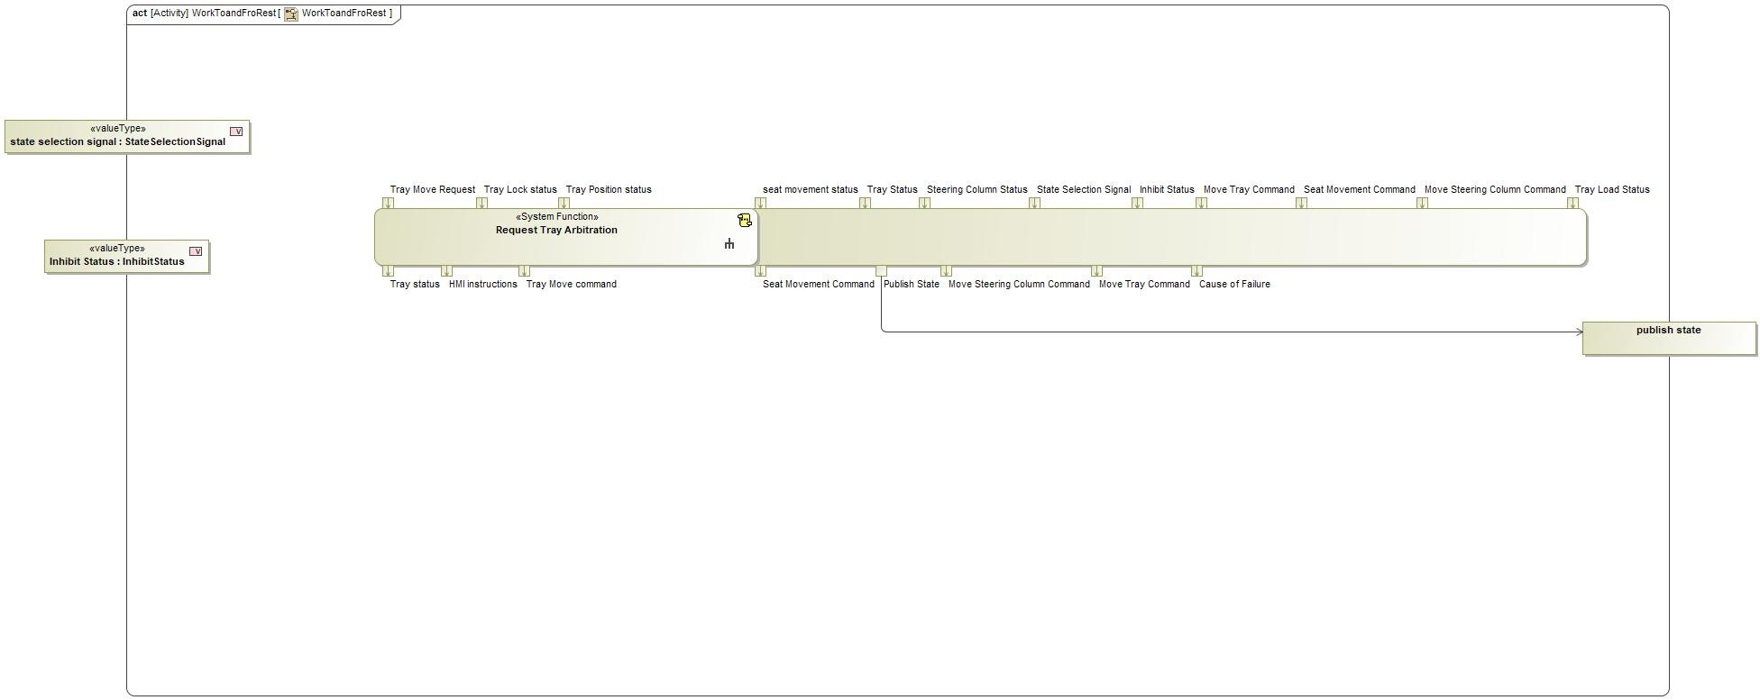
Figure 2: Activity Diagram of “WorkToandFroRest” calling “Request Tray Arbitration”

Function Interfaces

Logical Inputs
Signal Name | Description
Tray Move Request  Type:  TrayMoveRequest | Signal Description:  Internal Request of Feature Controller to Move Tray Table  Received from:  - Activity Parameter Node: Requst Tray Move  - Activity Parameter Node: Requst Tray Move  - Control SSC Functionality  - Activity Parameter Node: Requst Tray Move  - Activity Parameter Node: Requst Tray Move
Tray Position status  Type:  TrayPostionStatus | Signal Description:  Tray Position status is the feedback for Tray position given by Tray position Sensor  Received from:  - Actuate Tray
Tray Lock status  Type:  TrayLockStatus | Signal Description:  Tray lock status is given by Tray Lock sensor  Received from:  - Actuate Tray

Logical Outputs
Signal Name | Description
Tray status  Type:  TrayStatus | Signal Description:  This status is decided and fed by the Feature systems based on Requests and Input feedbacks fed  Sent to:  - Activity Parameter Node: Tray Status  - Activity Parameter Node: Tray Status  - Check for Transition Termination  - Activity Parameter Node: Tray Status  - Activity Parameter Node: Tray Status
Tray Move command  Type:  TrayMoveCommand | Signal Description:  Tray Move Command is the command signal which has various Tray Control requests in it.  Sent to:  - Actuate Tray
HMI instructions  Type:  HMIInsWar | Signal Description:  HMI Instructions to Stow and Warning display if Tray is not pushed in properly  Sent to:  - Manage Feature Arbitration Feedback

Logical Parameters

Not supported by MagicDraw report generation.

Function Modeling

Use Cases

Not supported by MagicDraw report generation.

State Charts / Activity Diagrams / Sequence Diagrams / Decision Tables

Figure 3: Request Tray Arbitration

Function Requirements

Functional Requirements

Normal Operation

Request Tray Arbitration
When Request Tray Arbitration function receives StateSelectionSignal = WORK, it shall verify TrayObstructionStatus= NO_OBSTACLE_DETECTED , TrayPositionStatus= STOWED , TrayLockStatus=LOCKED and then set
TrayMoveCommand= DEPLOY && TrayMoveCommand= UNLOCK && TrayStatus= DEPLOYING and Look for HMIInsWar while stowing if requested

Requirement ID:
Rationale
Acceptance Criteria
Notes
Source |  |  |  |  |  | Owner
Source Req. |  |  |  |  |  | V&V Method
Type |  |  |  | Priority |  | Status
Req. Template Version |  | 6.0 | End of Requirement

Error Handling

No Error Handling Requirements specified.

Non-Functional Requirements

No Non-Functional Requirements specified.

Functional Safety Requirements

No Functional Safety Requirements specified.

ASIL Decomposition of Functional Safety Requirements

No Functional Safety Requirements with ASIL Decompositions specified.

Other Requirements

Design Requirements

No Design Requirements specified.

Request Tray Deployment

Function Overview

Description

Function is allocated to:
- Command Tray Table Deploy <<Logical>>
- Stowable Feature Controller <<Logical>>

This System Function is responsible for preparing the Tray to Arbitrate and send the respective command to Arbitrate tray to next functions

Variants

Not supported by MagicDraw report generation.

Input Requirements

Not supported by MagicDraw report generation.

Assumptions

No assumptions specified for this function.

References

Ford Documents
List here all Ford internal documents, which are directly related to the feature.

Reference | Title | Doc. ID | Revision
Table 5: Ford internal Documents (not specified in model)

External Documents and Publications
The list of external documents could include books, reports and online sources.

Reference | Document / Publication
Table 7: External documents and publications (not specified in model)

Glossary
See Appendix for Definitions and Abbreviations.

Function Scope

The – “Request Tray Deployment” function is called by the following functions:
- – “Request Tray Arbitration”

Figure 2: Activity Diagram of “Request Tray Arbitration” calling “Request Tray Deployment”

Function Interfaces

Logical Inputs
Signal Name | Description
Tray Deploy Request  Type:  TrayMoveRequest | Signal Description:  Internal Request of Feature Controller to Move Tray Table  Received from:  - Check Tray Status

Logical Outputs
Signal Name | Description
Deploy Tray Command  Type:  TrayMoveCommand | Signal Description:  Tray Move Command is the command signal which has various Tray Control requests in it.  Sent to:  - Activity Parameter Node: Tray Move Command

Logical Parameters

Not supported by MagicDraw report generation.

Function Modeling

Use Cases

Not supported by MagicDraw report generation.

State Charts / Activity Diagrams / Sequence Diagrams / Decision Tables

No diagrams internal to function specified.

Function Requirements

Functional Requirements

Normal Operation

Deploy/Stow Tray Command Output Definition
The Request Tray Deployment/Stowing function(s) Shall Set Stow/Deploy Tray Command to NONE or Halt, Deploy or STOW

Requirement ID:
Rationale
Acceptance Criteria
Notes
Source |  |  |  |  |  | Owner
Source Req. | - Request Tray Arbitration |  |  |  |  | V&V Method
Type |  |  |  | Priority |  | Status
Req. Template Version |  | 6.0 | End of Requirement

Request Tray Deployment/Stowing function Deploy/Stow Tray Command Error Detected
The Request Tray Deployment/Stowing function(s) Shall Set Stow/Deploy Tray Command to NONE when Tray Table Position is set to ERROR

Requirement ID:
Rationale
Acceptance Criteria
Notes
Source |  |  |  |  |  | Owner
Source Req. | - Request Tray Arbitration |  |  |  |  | V&V Method
Type |  |  |  | Priority |  | Status
Req. Template Version |  | 6.0 | End of Requirement

Request Tray Deployment function Deploy Tray Command Normal Tray Deployment Completed
The Request Tray Deployment/Stowing function(s) Shall Set Stow/Deploy Tray Command is set to NONE when Tray Table Position is set to DEPLOYED AND Tray Obstruction Status is set to NO_OBSTACLE_DETECTED

Requirement ID:
Rationale
Acceptance Criteria
Notes
Source |  |  |  |  |  | Owner
Source Req. | - Request Tray Arbitration |  |  |  |  | V&V Method
Type |  |  |  | Priority |  | Status
Req. Template Version |  | 6.0 | End of Requirement

Request Tray Deployment function Deploy Tray Command Normal Tray Deployment Start
The Request Tray Deployment function Shall Set Deploy Tray Command is set to DEPLOY when State Selection Signal is set to NOT_DRIVE AND Tray Table Position is set to STOWED AND Tray Obstruction Status is set to NO_OBSTACLE_DETECTED

Requirement ID:
Rationale
Acceptance Criteria
Notes
Source |  |  |  |  |  | Owner
Source Req. | - Request Tray Arbitration |  |  |  |  | V&V Method
Type |  |  |  | Priority |  | Status
Req. Template Version |  | 6.0 | End of Requirement

Error Handling

No Error Handling Requirements specified.

Non-Functional Requirements

No Non-Functional Requirements specified.

Functional Safety Requirements

No Functional Safety Requirements specified.

ASIL Decomposition of Functional Safety Requirements

No Functional Safety Requirements with ASIL Decompositions specified.

Other Requirements

Design Requirements

No Design Requirements specified.

Request Tray Lock

Function Overview

Description

Function is allocated to:
- Lock Tray Table <<Logical>>
- Stowable Feature Controller <<Logical>>

A subsystem Function which sends Tray Lock request based on its inputs

Variants

Not supported by MagicDraw report generation.

Input Requirements

Not supported by MagicDraw report generation.

Assumptions

No assumptions specified for this function.

References

Ford Documents
List here all Ford internal documents, which are directly related to the feature.

Reference | Title | Doc. ID | Revision
Table 5: Ford internal Documents (not specified in model)

External Documents and Publications
The list of external documents could include books, reports and online sources.

Reference | Document / Publication
Table 7: External documents and publications (not specified in model)

Glossary
See Appendix for Definitions and Abbreviations.

Function Scope

The – “Request Tray Lock” function is called by the following functions:
- – “Request Tray Arbitration”

Figure 2: Activity Diagram of “Request Tray Arbitration” calling “Request Tray Lock”

Function Interfaces

Logical Inputs
Signal Name | Description
Tray Move request  Type:  TrayMoveRequest | Signal Description:  Internal Request of Feature Controller to Move Tray Table  Received from:  - Check Tray Status

Logical Outputs
Signal Name | Description
Request Lock Tray  Type:  TrayMoveCommand | Signal Description:  Tray Move Command is the command signal which has various Tray Control requests in it.  Sent to:  - Activity Parameter Node: Tray Move Command

Logical Parameters

Not supported by MagicDraw report generation.

Function Modeling

Use Cases

Not supported by MagicDraw report generation.

State Charts / Activity Diagrams / Sequence Diagrams / Decision Tables

No diagrams internal to function specified.

Function Requirements

Functional Requirements

Normal Operation

Request Tray Lock Normal Unlock
The Request Tray Lock function shall set Request Lock Tray to UNLOCK when State Selection Signal is set to DRIVE and Tray Lock Status is set to TRAY_UNLOCKED

Requirement ID:
Rationale
Acceptance Criteria
Notes
Source |  |  |  |  |  | Owner
Source Req. | - Tray Lock Functionality |  |  |  |  | V&V Method
Type |  |  |  | Priority |  | Status
Req. Template Version |  | 6.0 | End of Requirement

Request Tray Lock Not Drive
The Request Tray Lock function shall set Request Lock Tray to NONE when State Selection Signal is set to NOT DRIVE

Requirement ID:
Rationale
Acceptance Criteria
Notes
Source |  |  |  |  |  | Owner
Source Req. | - Tray Lock Functionality |  |  |  |  | V&V Method
Type |  |  |  | Priority |  | Status
Req. Template Version |  | 6.0 | End of Requirement

Request Tray Failure to Unlock
The Request Tray Lock function shall set Request Lock Tray to NONE when State Selection Signal is set to DRIVE and Tray Lock Status is set to TRAY_FAILED_TO_UNLOCKED

Requirement ID:
Rationale
Acceptance Criteria
Notes
Source |  |  |  |  |  | Owner
Source Req. | - Tray Lock Functionality |  |  |  |  | V&V Method
Type |  |  |  | Priority |  | Status
Req. Template Version |  | 6.0 | End of Requirement

Request Tray Lock Normal Lock
The Request Tray Lock function shall set Request Lock Tray to LOCK when State Selection Signal is set to DRIVE and Tray Lock Status is set to TRAY_LOCKED

Requirement ID:
Rationale
Acceptance Criteria
Notes
Source |  |  |  |  |  | Owner
Source Req. | - Tray Lock Functionality |  |  |  |  | V&V Method
Type |  |  |  | Priority |  | Status
Req. Template Version |  | 6.0 | End of Requirement

Request Tray Failure to Lock
The Request Tray Lock function shall set Request Lock Tray to NONE when State Selection Signal is set to DRIVE and Tray Lock Status is set to TRAY_FAILED_TO_LOCK

Requirement ID:
Rationale
Acceptance Criteria
Notes
Source |  |  |  |  |  | Owner
Source Req. | - Tray Lock Functionality |  |  |  |  | V&V Method
Type |  |  |  | Priority |  | Status
Req. Template Version |  | 6.0 | End of Requirement

Error Handling

No Error Handling Requirements specified.

Non-Functional Requirements

No Non-Functional Requirements specified.

Functional Safety Requirements

No Functional Safety Requirements specified.

ASIL Decomposition of Functional Safety Requirements

No Functional Safety Requirements with ASIL Decompositions specified.

Other Requirements

Design Requirements

No Design Requirements specified.

Request Tray Unlock

Function Overview

Description

Function is allocated to:
- Stowable Feature Controller <<Logical>>
- Unlock Tray Table <<Logical>>

A subsystem Function which sends Tray Unlock request based on its inputs

Variants

Not supported by MagicDraw report generation.

Input Requirements

Not supported by MagicDraw report generation.

Assumptions

No assumptions specified for this function.

References

Ford Documents
List here all Ford internal documents, which are directly related to the feature.

Reference | Title | Doc. ID | Revision
Table 5: Ford internal Documents (not specified in model)

External Documents and Publications
The list of external documents could include books, reports and online sources.

Reference | Document / Publication
Table 7: External documents and publications (not specified in model)

Glossary
See Appendix for Definitions and Abbreviations.

Function Scope

The – “Request Tray Unlock” function is called by the following functions:
- – “Request Tray Arbitration”

Figure 2: Activity Diagram of “Request Tray Arbitration” calling “Request Tray Unlock”

Function Interfaces

Logical Inputs
Signal Name | Description
tray unlock request  Type:  TrayMoveRequest | Signal Description:  Internal Request of Feature Controller to Move Tray Table  Received from:  - Check Tray Status

Logical Outputs
Signal Name | Description
Tray Move command  Type:  TrayMoveCommand | Signal Description:  Tray Move Command is the command signal which has various Tray Control requests in it.  Sent to:  - Activity Parameter Node: Tray Move Command

Logical Parameters

Not supported by MagicDraw report generation.

Function Modeling

Use Cases

Not supported by MagicDraw report generation.

State Charts / Activity Diagrams / Sequence Diagrams / Decision Tables

No diagrams internal to function specified.

Function Requirements

Functional Requirements

Normal Operation

UnLock Tray Request Definition
The Request Tray Unlock function Shall Set Unlock Tray Request to LOCK, UNLOCK or NONE

Requirement ID:
Rationale
Acceptance Criteria
Notes
Source |  |  |  |  |  | Owner
Source Req. | - Tray Lock Functionality |  |  |  |  | V&V Method
Type |  |  |  | Priority |  | Status
Req. Template Version |  | 6.0 | End of Requirement

Request Tray Unlock Pass Through
The Request Tray Unlock function shall pass through the Tray Lock Status value unchanged to the Tray Lock Status output.

Requirement ID:
Rationale
Acceptance Criteria
Notes
Source |  |  |  |  |  | Owner
Source Req. | - Tray Lock Functionality |  |  |  |  | V&V Method
Type |  |  |  | Priority |  | Status
Req. Template Version |  | 6.0 | End of Requirement

Normal Unlock Tray Request
The Request Tray Unlock function shall set Unlock Tray Request to UNLOCK when Tray Lock Status is set to TRAY_UNLOCKED and State Selection Signal is set to WORK.

Requirement ID:
Rationale
Acceptance Criteria
Notes
Source |  |  |  |  |  | Owner
Source Req. | - Tray Lock Functionality |  |  |  |  | V&V Method
Type |  |  |  | Priority |  | Status
Req. Template Version |  | 6.0 | End of Requirement

Normal Lock Tray Request
The Request Tray Unlock function shall set Unlock Tray Request to LOCK when Tray Lock Status is set to TRAY_LOCKED and State Selection Signal is set to WORK.

Requirement ID:
Rationale
Acceptance Criteria
Notes
Source |  |  |  |  |  | Owner
Source Req. | - Tray Lock Functionality |  |  |  |  | V&V Method
Type |  |  |  | Priority |  | Status
Req. Template Version |  | 6.0 | End of Requirement

Unlock Tray Table
When stowing of the Tray Table is commanded, the Unlock Tray Table function shall use the obstacle status to provide a status used to determine if stowing of the Tray Table shall proceed.

Requirement ID:
Rationale
Acceptance Criteria
Notes
Source |  |  |  |  |  | Owner
Source Req. | - Tray Lock Functionality |  |  |  |  | V&V Method
Type |  |  |  | Priority |  | Status
Req. Template Version |  | 6.0 | End of Requirement

Failed Tray Request
The Request Tray Unlock function shall set Unlock Tray Request to NONE when Tray Lock Status is set to either TRAY_FAILED_TO_LOCK or TRAY_FAILED_TO_UNLOCK and State Selection Signal is set to WORK.

Requirement ID:
Rationale
Acceptance Criteria
Notes
Source |  |  |  |  |  | Owner
Source Req. | - Tray Lock Functionality |  |  |  |  | V&V Method
Type |  |  |  | Priority |  | Status
Req. Template Version |  | 6.0 | End of Requirement

Not Work Tray Lock Request
The Request Tray Unlock function shall set Unlock Tray Request to NONE when State Selection Signal is set to NOT_WORK.

Requirement ID:
Rationale
Acceptance Criteria
Notes
Source |  |  |  |  |  | Owner
Source Req. | - Tray Lock Functionality |  |  |  |  | V&V Method
Type |  |  |  | Priority |  | Status
Req. Template Version |  | 6.0 | End of Requirement

Error Handling

No Error Handling Requirements specified.

Non-Functional Requirements

No Non-Functional Requirements specified.

Functional Safety Requirements

No Functional Safety Requirements specified.

ASIL Decomposition of Functional Safety Requirements

No Functional Safety Requirements with ASIL Decompositions specified.

Other Requirements

Design Requirements

No Design Requirements specified.

Verify Drive Control Status

Function Overview

Description

Function is allocated to:
- Stowable Steering and Deployable Tray System <<Logical>>

System Function responsible for Verify the Drive Control Status Before Actuating the feature

Variants

Not supported by MagicDraw report generation.

Input Requirements

Not supported by MagicDraw report generation.

Assumptions

No assumptions specified for this function.

References

Ford Documents
List here all Ford internal documents, which are directly related to the feature.

Reference | Title | Doc. ID | Revision
Table 5: Ford internal Documents (not specified in model)

External Documents and Publications
The list of external documents could include books, reports and online sources.

Reference | Document / Publication
Table 7: External documents and publications (not specified in model)

Glossary
See Appendix for Definitions and Abbreviations.

Function Scope

The – “Verify Drive Control Status” function is called by the following functions:
- – “Inhibit and Verify Drive Control”
- – “Make Rest space Available”
- – “Make Work Space Available”

Figure 2: Activity Diagram of “Inhibit and Verify Drive Control” calling “Verify Drive Control Status”

Figure 2: Activity Diagram of “Make Rest space Available” calling “Verify Drive Control Status”

Figure 2: Activity Diagram of “Make Work Space Available” calling “Verify Drive Control Status”

Function Interfaces

Logical Inputs
Signal Name | Description
Locomotion Inhibit status  Type:  LocomotionInhibitStatus | Signal Description:  Status of the Locomotion Inhibition  Received from:  - Activity Parameter Node: Locomotion Inhibit status  - Activity Parameter Node: Locomotion Inhibit status  - Activity Parameter Node: Locomotion Inhibit Status
Driver Airbag Inhibit status  Type:  DriverAirbagInhibitStatus | Signal Description:  Status of the Driver Airbag Inhibition  Received from:  - Activity Parameter Node: Driver Airbag Inhibit Status  - Activity Parameter Node: Driver Airbag Inhibit status  - Activity Parameter Node: Driver Airbag Inhibit status

Logical Outputs
Signal Name | Description
Inhibit status  Type:  InhibitStatus | Signal Description:  Inhibit status of driver control which is verified by the feature systems  Sent to:  - Control SSC Functionality  - Activity Parameter Node: Inhibit Status

Logical Parameters

Not supported by MagicDraw report generation.

Function Modeling

Use Cases

Not supported by MagicDraw report generation.

State Charts / Activity Diagrams / Sequence Diagrams / Decision Tables

Figure 3: Verify Drive Control Status

Function Requirements

Functional Requirements

Normal Operation

Verify Deinhibit status
when deinhibit drive mode is requested, Verify Drive control status function shall monitor and update drive mode inhibition status as follows:
1. if LocomotionInhibitStatus==DEINHIBITED and DriverAirbagInhibitStatus==DEINHIBITED , set InhibitStatus=DC_INHIBITED
2. Otherwise, set InhibitStatus=DC_FAIL_TO_DEINHIBIT

Requirement ID:
Rationale
Acceptance Criteria
Notes
Source |  |  |  |  |  | Owner
Source Req. |  |  |  |  |  | V&V Method
Type |  |  |  | Priority |  | Status
Req. Template Version |  | 6.0 | End of Requirement

Error Handling

No Error Handling Requirements specified.

Non-Functional Requirements

Verify Inhibit status
when inhibit drive mode is requested, Verify Drive control status function shall monitor and update drive mode inhibition status as follows:
1. if LocomotionInhibitStatus==INHIBITED and DriverAirbagInhibitStatus==INHIBITED , set InhibitStatus=DC_INHIBITED
2. Otherwise, set InhibitStatus=DC_FAIL_TO_INHIBIT

Requirement ID:
Rationale
Acceptance Criteria
Notes
Source |  |  |  |  |  | Owner
Source Req. |  |  |  |  |  | V&V Method
Type |  |  |  | Priority |  | Status
Req. Template Version |  | 6.0 | End of Requirement

Drive Control Inhibit Status Verification
Stowable Steering and Deployable Tray System shall Verify the Inhibit status of Drive Control before entering Play , Work or Rest Modes

Requirement ID:
Rationale
Acceptance Criteria
Notes
Source |  |  |  |  |  | Owner
Source Req. |  |  |  |  |  | V&V Method
Type |  |  |  | Priority |  | Status
Req. Template Version |  | 6.0 | End of Requirement

Functional Safety Requirements

No Functional Safety Requirements specified.

ASIL Decomposition of Functional Safety Requirements

No Functional Safety Requirements with ASIL Decompositions specified.

Other Requirements

Design Requirements

No Design Requirements specified.

Verify Feature Status

Function Overview

Description

Function is allocated to:
- Stowable Steering and Deployable Tray System <<Logical>>

This Function verifies the User Input , vehicle Status and Vehicle Configuration and provides State Selection signal and HMI Feedback

Variants

Not supported by MagicDraw report generation.

Input Requirements

Not supported by MagicDraw report generation.

Assumptions

No assumptions specified for this function.

References

Ford Documents
List here all Ford internal documents, which are directly related to the feature.

Reference | Title | Doc. ID | Revision
Table 5: Ford internal Documents (not specified in model)

External Documents and Publications
The list of external documents could include books, reports and online sources.

Reference | Document / Publication
Table 7: External documents and publications (not specified in model)

Glossary
See Appendix for Definitions and Abbreviations.

Function Scope

The – “Verify Feature Status” function is called by the following functions:
- – “Check Feature Status”

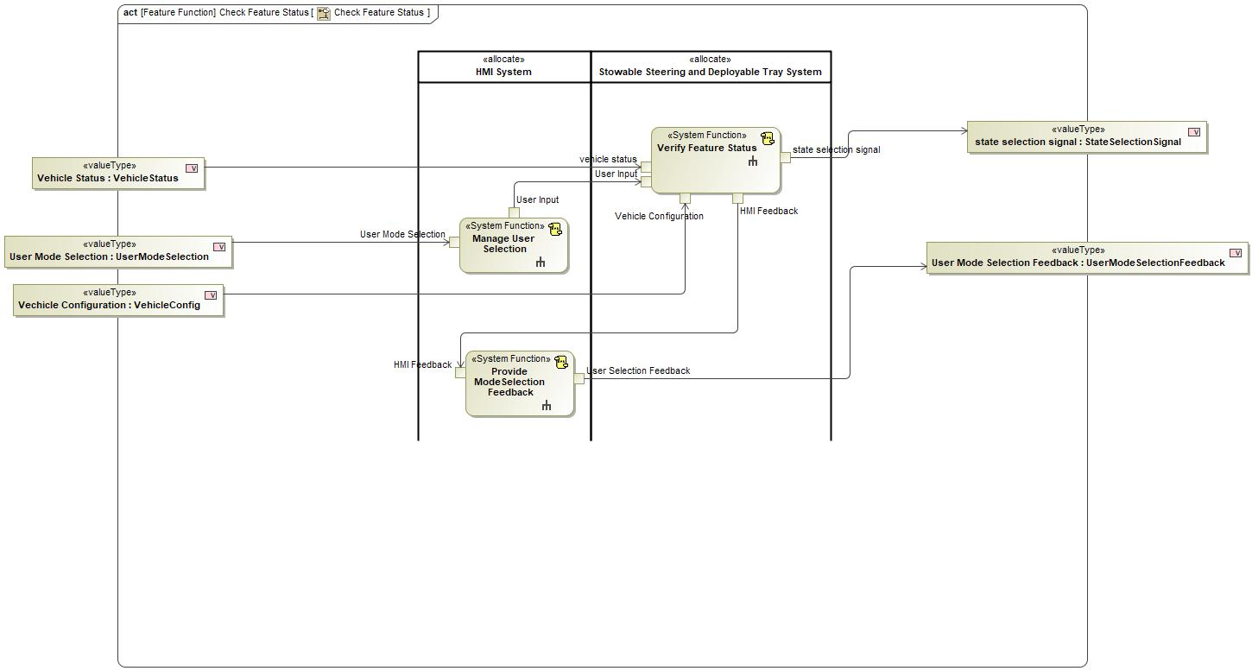
Figure 2: Activity Diagram of “Check Feature Status” calling “Verify Feature Status”

Function Interfaces

Logical Inputs
Signal Name | Description
vehicle status  Type:  VehicleStatus | Signal Description:  This Signal is the collectivity approval signal which includes Parking status, battery state of charge and Vehicle Speed  Received from:  - Activity Parameter Node: Vehicle Status
Vehicle Configuration  Type:  VehicleConfig | Signal Description:  Configuration of the Feature and Vehicle Specific  Received from:  - Activity Parameter Node: Vehicle Configuration
User Input  Type:  UserInput | Signal Description:  Input given by user through HMI  Received from:  - Manage User Selection

Logical Outputs
Signal Name | Description
state selection signal  Type:  StateSelectionSignal | Signal Description:  Signal which contains the Mode that User selected after the Vehicle status is Valid  Sent to:  - Activity Parameter Node: state selection signal
HMI Feedback  Type:  HMIFeedback | Signal Description:  Feedback given to HMI  Sent to:  - Provide ModeSelection Feedback

Logical Parameters

Not supported by MagicDraw report generation.

Function Modeling

Use Cases

Not supported by MagicDraw report generation.

State Charts / Activity Diagrams / Sequence Diagrams / Decision Tables

Figure 3: Verify Feature Status

Function Requirements

Functional Requirements

Normal Operation

Accept User Input
HMI System shall allow selection of "Work Mode", "Rest Mode", "Play Mode" and "Drive Mode".

Requirement ID:
Rationale
Acceptance Criteria
Notes | Tray Table Mode deploys the Tray Table. Rest Mode keeps the Tray Table stowed. Drive Mode is the normal vehicle drive state with normal seat position.
Source |  |  |  |  |  | Owner
Source Req. |  |  |  |  |  | V&V Method
Type |  |  |  | Priority |  | Status
Req. Template Version |  | 6.0 | End of Requirement

Error Handling

No Error Handling Requirements specified.

Non-Functional Requirements

Verify Feature Status
When Activated, Verify Feature status functions shall read UserInput, VehicleStatus and VehicleConfig it shall set the StateSelectionSignal and HMIFeedback Accordingly

Requirement ID:
Rationale
Acceptance Criteria
Notes
Source |  |  |  |  |  | Owner
Source Req. |  |  |  |  |  | V&V Method
Type |  |  |  | Priority |  | Status
Req. Template Version |  | 6.0 | End of Requirement

Functional Safety Requirements

No Functional Safety Requirements specified.

ASIL Decomposition of Functional Safety Requirements

No Functional Safety Requirements with ASIL Decompositions specified.

Other Requirements

Design Requirements

No Design Requirements specified.

Open Concerns
#Hint: The following list presents open concerns, which have to be discussed or clarified over the course of the on-going requirements engineering.

ID | Concern Description | e-Tracker / Reference | Responsible | Status | Solution
1
Table 8: Open Concerns (Not supported by MagicDraw report generation.)

Revision History
#Hint: A new version number is assigned to a document with a given revision each time it is checked in to Team Center (TCSE). After release of a revision, the document cannot be edited and no new versions can be created on that revision. When updating the document after that, a new revision has to be created and new versions on that revision will be created upon checking in.

No Revision History found.

Appendix

Data Dictionary

Logical Signals
#Macro: Add Ins -> Add Requirement macro (select “Logical Signal” as type)

CauseOfFailure
Cause for which status is not appropriate in the vehicle to arbitrate the feature mode

ASIL
Encoding Type Name
Note: An encoding is either discrete or continuous. Delete fields below which are not needed
Value  (Continuous Encoding) | Min Value
Value  (Continuous Encoding) | Max Value
Value  (Continuous Encoding) | Resolution
Value  (Continuous Encoding) | Offset
Value
(Discrete
Encoding)
Unit

Drivability Status
The logical signal which validates all systems component status and has the calculated the validity to enter into drive mode

ASIL
Encoding Type Name
Note: An encoding is either discrete or continuous. Delete fields below which are not needed
Value  (Continuous Encoding) | Min Value
Value  (Continuous Encoding) | Max Value
Value  (Continuous Encoding) | Resolution
Value  (Continuous Encoding) | Offset
Value
(Discrete
Encoding)
Unit

DriverAirbagInhibitStatus
Status of the Driver Airbag Inhibition

ASIL
Encoding Type Name
Note: An encoding is either discrete or continuous. Delete fields below which are not needed
Value  (Continuous Encoding) | Min Value
Value  (Continuous Encoding) | Max Value
Value  (Continuous Encoding) | Resolution
Value  (Continuous Encoding) | Offset
Value
(Discrete
Encoding)
Unit

DriverAirbagRequest
Request sent to the Driver Airbag system / Passive Restraint System for either Inhibit or Deinhibit

ASIL
Encoding Type Name
Note: An encoding is either discrete or continuous. Delete fields below which are not needed
Value  (Continuous Encoding) | Min Value
Value  (Continuous Encoding) | Max Value
Value  (Continuous Encoding) | Resolution
Value  (Continuous Encoding) | Offset
Value
(Discrete
Encoding)
Unit

HMIFeedback
Feedback given to HMI

ASIL
Encoding Type Name
Note: An encoding is either discrete or continuous. Delete fields below which are not needed
Value  (Continuous Encoding) | Min Value
Value  (Continuous Encoding) | Max Value
Value  (Continuous Encoding) | Resolution
Value  (Continuous Encoding) | Offset
Value
(Discrete
Encoding)
Unit

HMIInsWar
HMI Instructions to Stow and Warning display if Tray is not pushed in properly

ASIL
Encoding Type Name
Note: An encoding is either discrete or continuous. Delete fields below which are not needed
Value  (Continuous Encoding) | Min Value
Value  (Continuous Encoding) | Max Value
Value  (Continuous Encoding) | Resolution
Value  (Continuous Encoding) | Offset
Value
(Discrete
Encoding)
Unit

InhibitStatus
Inhibit status of driver control which is verified by the feature systems

ASIL
Encoding Type Name
Note: An encoding is either discrete or continuous. Delete fields below which are not needed
Value  (Continuous Encoding) | Min Value
Value  (Continuous Encoding) | Max Value
Value  (Continuous Encoding) | Resolution
Value  (Continuous Encoding) | Offset
Value
(Discrete
Encoding)
Unit

LocomotionInhibitStatus
Status of the Locomotion Inhibition

ASIL
Encoding Type Name
Note: An encoding is either discrete or continuous. Delete fields below which are not needed
Value  (Continuous Encoding) | Min Value
Value  (Continuous Encoding) | Max Value
Value  (Continuous Encoding) | Resolution
Value  (Continuous Encoding) | Offset
Value
(Discrete
Encoding)
Unit

LocomotionRequest
Request to Powertrain / Locomotion to Inhibit /Deinhibit

ASIL
Encoding Type Name
Note: An encoding is either discrete or continuous. Delete fields below which are not needed
Value  (Continuous Encoding) | Min Value
Value  (Continuous Encoding) | Max Value
Value  (Continuous Encoding) | Resolution
Value  (Continuous Encoding) | Offset
Value
(Discrete
Encoding)
Unit

ModeAcceptenceStatus
This signal contains the information whats not available in the vehicle configuration

ASIL
Encoding Type Name
Note: An encoding is either discrete or continuous. Delete fields below which are not needed
Value  (Continuous Encoding) | Min Value
Value  (Continuous Encoding) | Max Value
Value  (Continuous Encoding) | Resolution
Value  (Continuous Encoding) | Offset
Value
(Discrete
Encoding)
Unit

SeatMovementRequest
Command to Move seat which goes to the Driver seat System

ASIL
Encoding Type Name
Note: An encoding is either discrete or continuous. Delete fields below which are not needed
Value  (Continuous Encoding) | Min Value
Value  (Continuous Encoding) | Max Value
Value  (Continuous Encoding) | Resolution
Value  (Continuous Encoding) | Offset
Value
(Discrete
Encoding)
Unit

SeatMovementStatusInternal
Status of the Seat movement according to the current position and external position

ASIL
Encoding Type Name
Note: An encoding is either discrete or continuous. Delete fields below which are not needed
Value  (Continuous Encoding) | Min Value
Value  (Continuous Encoding) | Max Value
Value  (Continuous Encoding) | Resolution
Value  (Continuous Encoding) | Offset
Value
(Discrete
Encoding)
Unit

SeatPosition
Current Seat Position from the Driver Seat System

ASIL
Encoding Type Name
Note: An encoding is either discrete or continuous. Delete fields below which are not needed
Value  (Continuous Encoding) | Min Value
Value  (Continuous Encoding) | Max Value
Value  (Continuous Encoding) | Resolution
Value  (Continuous Encoding) | Offset
Value
(Discrete
Encoding)
Unit

StateOfFeature
Current state of Feature and other warnings

ASIL
Encoding Type Name
Note: An encoding is either discrete or continuous. Delete fields below which are not needed
Value  (Continuous Encoding) | Min Value
Value  (Continuous Encoding) | Max Value
Value  (Continuous Encoding) | Resolution
Value  (Continuous Encoding) | Offset
Value
(Discrete
Encoding)
Unit

StateSelectionSignal
Signal which contains the Mode that User selected after the Vehicle status is Valid

ASIL
Encoding Type Name
Note: An encoding is either discrete or continuous. Delete fields below which are not needed
Value  (Continuous Encoding) | Min Value
Value  (Continuous Encoding) | Max Value
Value  (Continuous Encoding) | Resolution
Value  (Continuous Encoding) | Offset
Value
(Discrete
Encoding)
Unit

SteeringColumnPosition
Position of the Steering Column provided by the steering column system

ASIL
Encoding Type Name
Note: An encoding is either discrete or continuous. Delete fields below which are not needed
Value  (Continuous Encoding) | Min Value
Value  (Continuous Encoding) | Max Value
Value  (Continuous Encoding) | Resolution
Value  (Continuous Encoding) | Offset
Value
(Discrete
Encoding)
Unit

SteeringColumnRequest
Request to Move steering Column with respect to selected Mode

ASIL
Encoding Type Name
Note: An encoding is either discrete or continuous. Delete fields below which are not needed
Value  (Continuous Encoding) | Min Value
Value  (Continuous Encoding) | Max Value
Value  (Continuous Encoding) | Resolution
Value  (Continuous Encoding) | Offset
Value
(Discrete
Encoding)
Unit

SteeringColumnStatusInternal
Status of SteeringColumn based on Feature Decisions and current steering Column Position

ASIL
Encoding Type Name
Note: An encoding is either discrete or continuous. Delete fields below which are not needed
Value  (Continuous Encoding) | Min Value
Value  (Continuous Encoding) | Max Value
Value  (Continuous Encoding) | Resolution
Value  (Continuous Encoding) | Offset
Value
(Discrete
Encoding)
Unit

Termination Signal
Logical signal for termination of Mode Arbitration when system did not act according to requests

ASIL
Encoding Type Name
Note: An encoding is either discrete or continuous. Delete fields below which are not needed
Value  (Continuous Encoding) | Min Value
Value  (Continuous Encoding) | Max Value
Value  (Continuous Encoding) | Resolution
Value  (Continuous Encoding) | Offset
Value
(Discrete
Encoding)
Unit

TrayLockStatus
Tray lock status is given by Tray Lock sensor

ASIL
Encoding Type Name
Note: An encoding is either discrete or continuous. Delete fields below which are not needed
Value  (Continuous Encoding) | Min Value
Value  (Continuous Encoding) | Max Value
Value  (Continuous Encoding) | Resolution
Value  (Continuous Encoding) | Offset
Value
(Discrete
Encoding)
Unit

TrayMoveCommand
Tray Move Command is the command signal which has various Tray Control requests in it.

ASIL
Encoding Type Name
Note: An encoding is either discrete or continuous. Delete fields below which are not needed
Value  (Continuous Encoding) | Min Value
Value  (Continuous Encoding) | Max Value
Value  (Continuous Encoding) | Resolution
Value  (Continuous Encoding) | Offset
Value
(Discrete
Encoding)
Unit

TrayMoveRequest
Internal Request of Feature Controller to Move Tray Table

ASIL
Encoding Type Name
Note: An encoding is either discrete or continuous. Delete fields below which are not needed
Value  (Continuous Encoding) | Min Value
Value  (Continuous Encoding) | Max Value
Value  (Continuous Encoding) | Resolution
Value  (Continuous Encoding) | Offset
Value
(Discrete
Encoding)
Unit

TrayPostionStatus
Tray Position status is the feedback for Tray position given by Tray position Sensor

ASIL
Encoding Type Name
Note: An encoding is either discrete or continuous. Delete fields below which are not needed
Value  (Continuous Encoding) | Min Value
Value  (Continuous Encoding) | Max Value
Value  (Continuous Encoding) | Resolution
Value  (Continuous Encoding) | Offset
Value
(Discrete
Encoding)
Unit

TrayStatus
This status is decided and fed by the Feature systems based on Requests and Input feedbacks fed

ASIL
Encoding Type Name
Note: An encoding is either discrete or continuous. Delete fields below which are not needed
Value  (Continuous Encoding) | Min Value
Value  (Continuous Encoding) | Max Value
Value  (Continuous Encoding) | Resolution
Value  (Continuous Encoding) | Offset
Value
(Discrete
Encoding)
Unit

UserInput
Input given by user through HMI

ASIL
Encoding Type Name
Note: An encoding is either discrete or continuous. Delete fields below which are not needed
Value  (Continuous Encoding) | Min Value
Value  (Continuous Encoding) | Max Value
Value  (Continuous Encoding) | Resolution
Value  (Continuous Encoding) | Offset
Value
(Discrete
Encoding)
Unit

VehicleConfig
Configuration of the Feature and Vehicle Specific

ASIL
Encoding Type Name
Note: An encoding is either discrete or continuous. Delete fields below which are not needed
Value  (Continuous Encoding) | Min Value
Value  (Continuous Encoding) | Max Value
Value  (Continuous Encoding) | Resolution
Value  (Continuous Encoding) | Offset
Value
(Discrete
Encoding)
Unit

VehicleStatus
This Signal is the collectivity approval signal which includes Parking status, battery state of charge and Vehicle Speed

ASIL
Encoding Type Name
Note: An encoding is either discrete or continuous. Delete fields below which are not needed
Value  (Continuous Encoding) | Min Value
Value  (Continuous Encoding) | Max Value
Value  (Continuous Encoding) | Resolution
Value  (Continuous Encoding) | Offset
Value
(Discrete
Encoding)
Unit

VehicleStatusValidity
This is the signal which contains the validity of the Vehicle status before Arbitrating into any Mode

ASIL
Encoding Type Name
Note: An encoding is either discrete or continuous. Delete fields below which are not needed
Value  (Continuous Encoding) | Min Value
Value  (Continuous Encoding) | Max Value
Value  (Continuous Encoding) | Resolution
Value  (Continuous Encoding) | Offset
Value
(Discrete
Encoding)
Unit

Logical Parameters
#Macro: Add Ins -> Add Requirement macro (select “Logical Parameter” as type)

Encoding Types
#Macro: Add Ins -> Add Requirement macro (select “Encoding Type” as type)

Glossary
#Hint: Terms, concepts and abbreviations used in the document shall be defined and illustrated here. Note that changes to terms and/or concepts described in this section tend to cause major updates to this document.
The tables below have feature specific definitions and abbreviations. For additional, non-feature specific terms please refer to the RE Glossary

Definitions
#Hint: The table below has definitions and abbreviations relevant for the functions in this document. For additional terms please refer to the RE Glossary

Definition | Description
Deploy | Come out / Move away from Dashboard or Instrument Panel Cluster
Drivability Status | Status to make sure all the component's status are good before allowing the drivability to user for safe drive
Drive Control | Drive Control is the Control status of Locomotion and Passive Restraint ( Drive Airbag))
Drive Mode | The original Mode of the Vehicle in which the work surface for productivity is inside the instrument panel assembly ( stowed and locked) and the Driver seat is at drive seat position and Steering Column is Deployed
Drive state | The original Mode of the Vehicle in which the work surface for productivity is inside the instrument panel assembly ( stowed and locked) and the Driver seat is at drive seat position and Steering Column is Deployed
FuSa | Functional Safety
Rest Mode | The mode in which driver will have Driver seat is moved back (Work mode seat position) and Steering Column is stowed inside( Work Surface will not be Arbitrated)
Rest state | The mode in which driver will have Driver seat is moved back (Work mode seat position) and Steering Column is stowed inside( Work Surface will not be Arbitrated)
Stow | Move in / Move towards to Dashboard or Instrument Panel Cluster
Tray | Work surface where a User / Driver can use
Work Mode | The mode in which driver will have a work surface for productivity and the Driver seat is moved back (Work mode seat position) and Steering Column is stowed inside.
Work state | The mode in which driver will have a work surface for productivity and the Driver seat is moved back (Work mode seat position) and Steering Column is stowed inside.
Table 9: Definitions used in this document

Abbreviations
No acronyms specified.

Document ends here.

